Year 10 |  | Non Linear Relations | Non Calculator
Skills and Knowledge Assessed:  - Graph simple non­linear relations with and without the use of digital technologies and solve simple related equations (ACMNA296)  - Explore the connection between algebraic and graphical representations of relations such as simple quadratics, circles and exponentials using digital technology as appropriate (ACMNA239)  - 10A Describe, interpret and sketch parabolas, hyperbolas, circles and exponential functions and their transformations (ACMNA267) |  |  | Name_________________
Section 1 Short Answer Section
Write all working and answers in the spaces provided on this test paper.

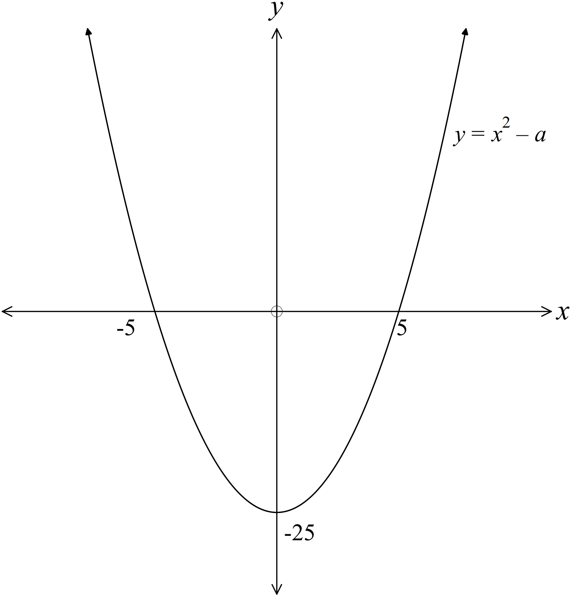The graph of 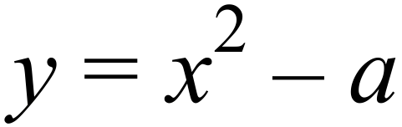 is shown.

What is the value of a?

……………………………………………

…………………………………………….

……………………………………………

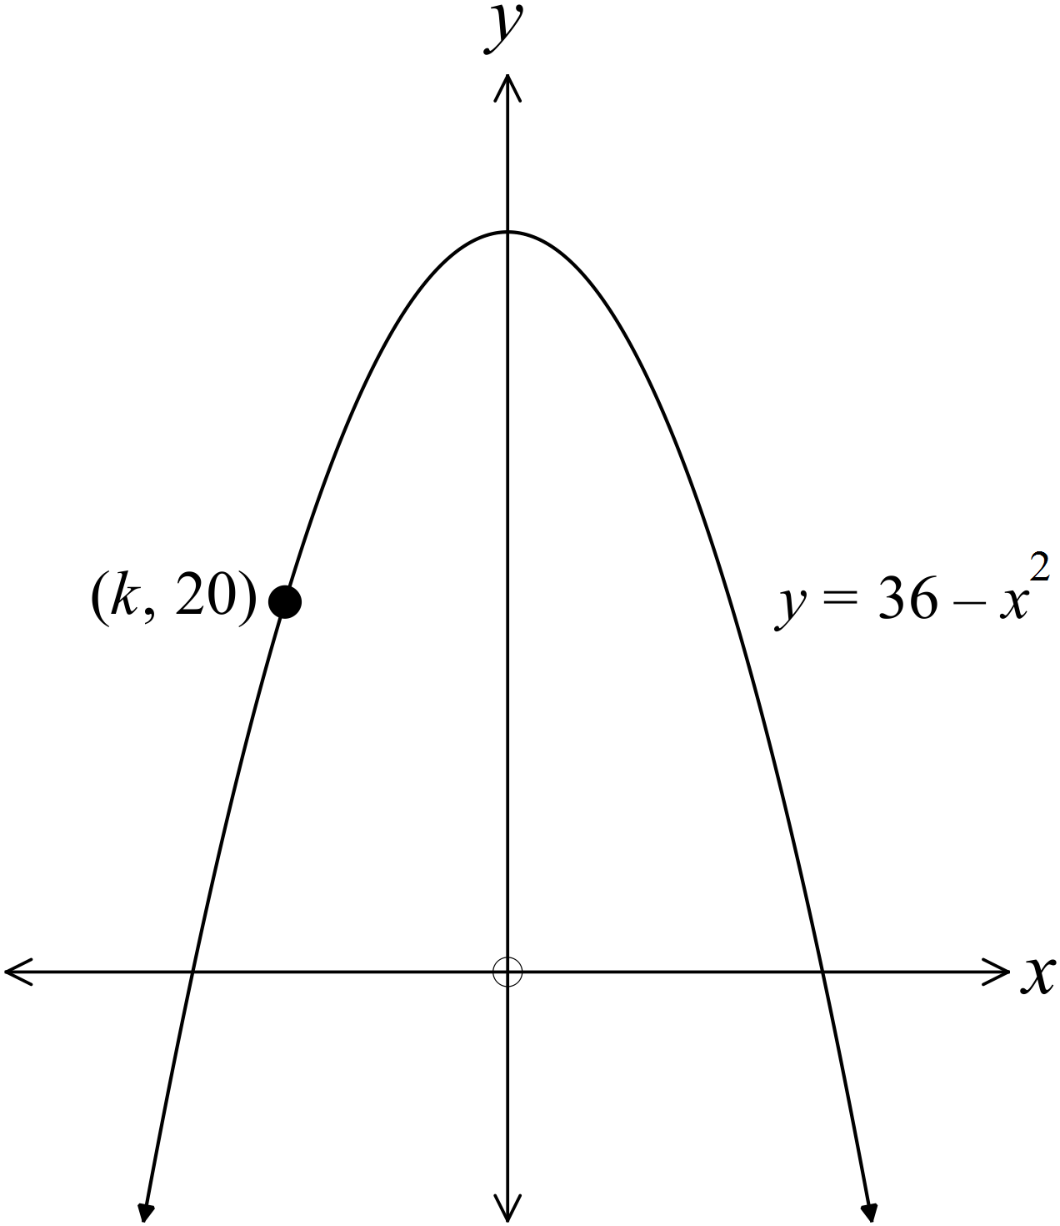The equation of the graph shown is 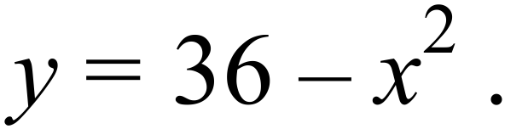
The graph passes through the point 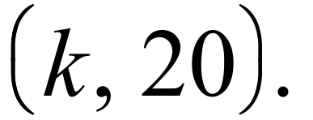

What is the value of k ?

………………………………………………

……………………………………………….

………………………………………………

……………………………………………….

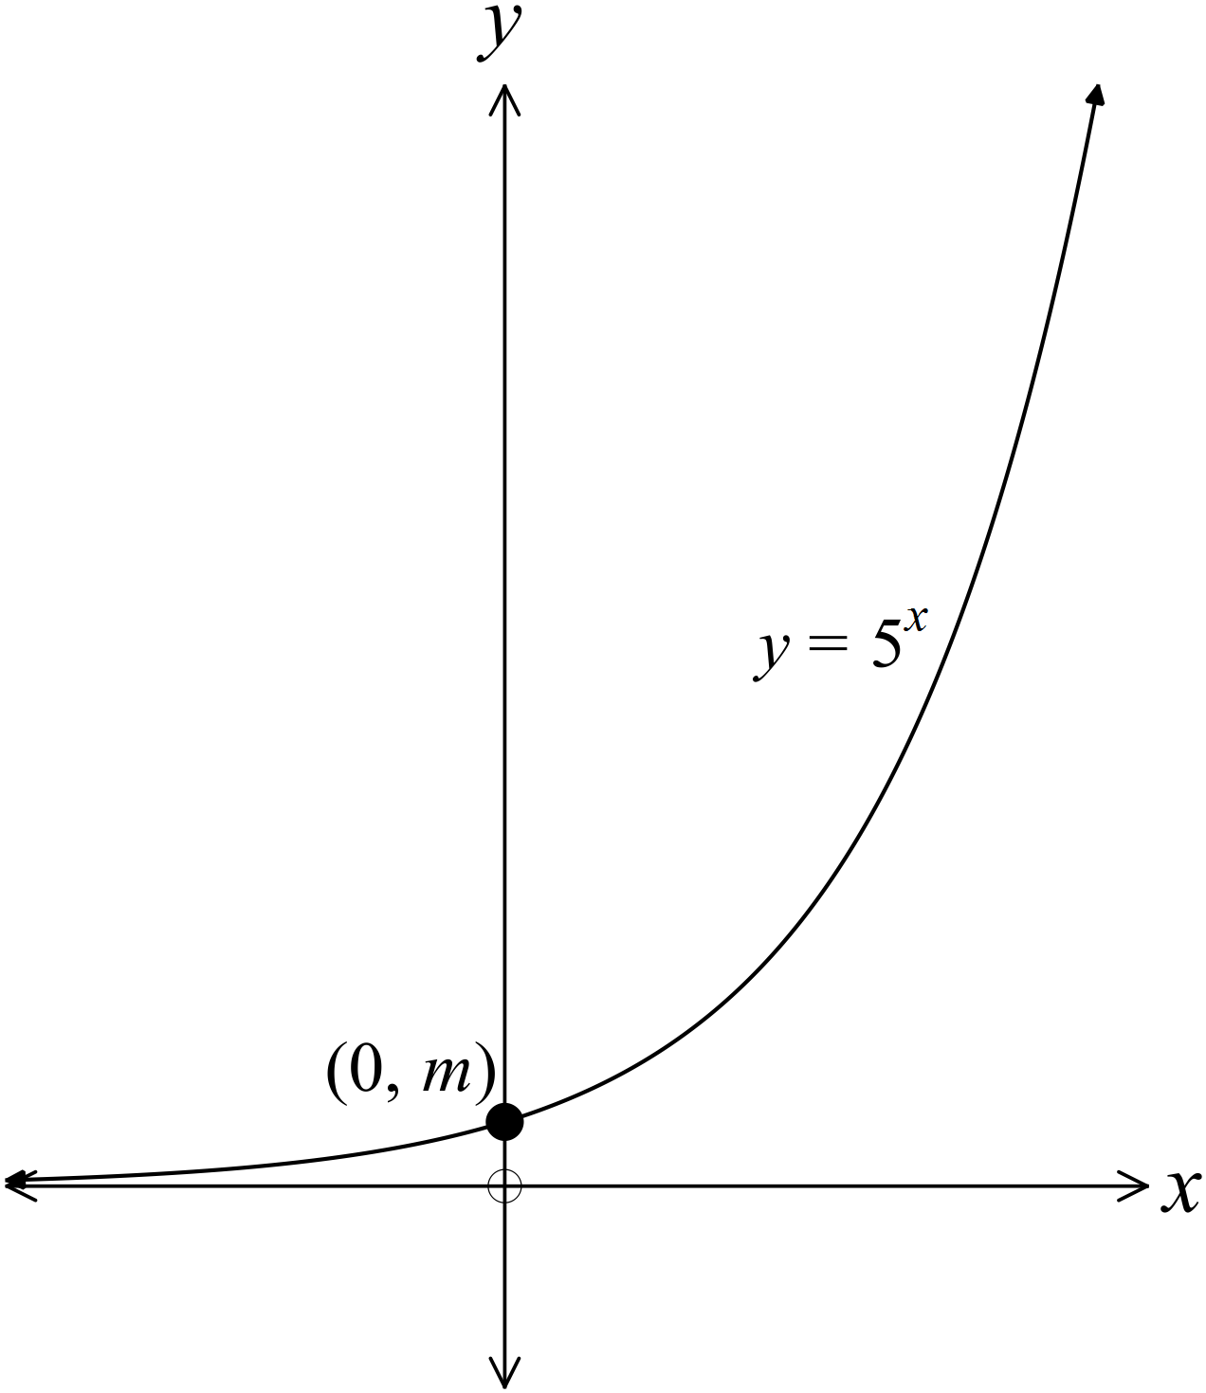The equation of the graph shown is 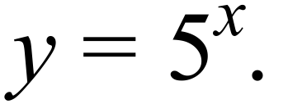
The graph crosses the y axis at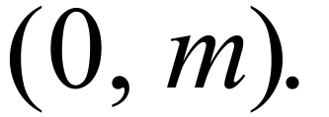

What is the value of m ?

………………………………………………

……………………………………………….

………………………………………………

……………………………………………….

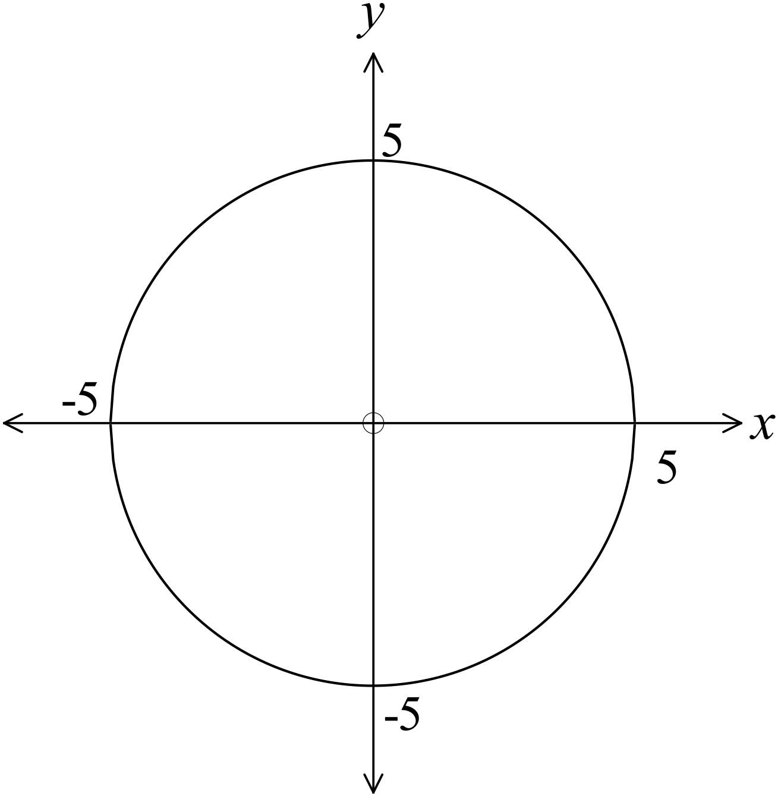The graph shown is a circle with its centre at the origin.

What is the equation of the graph?

………………………………………………

……………………………………………….

………………………………………………

……………………………………………….

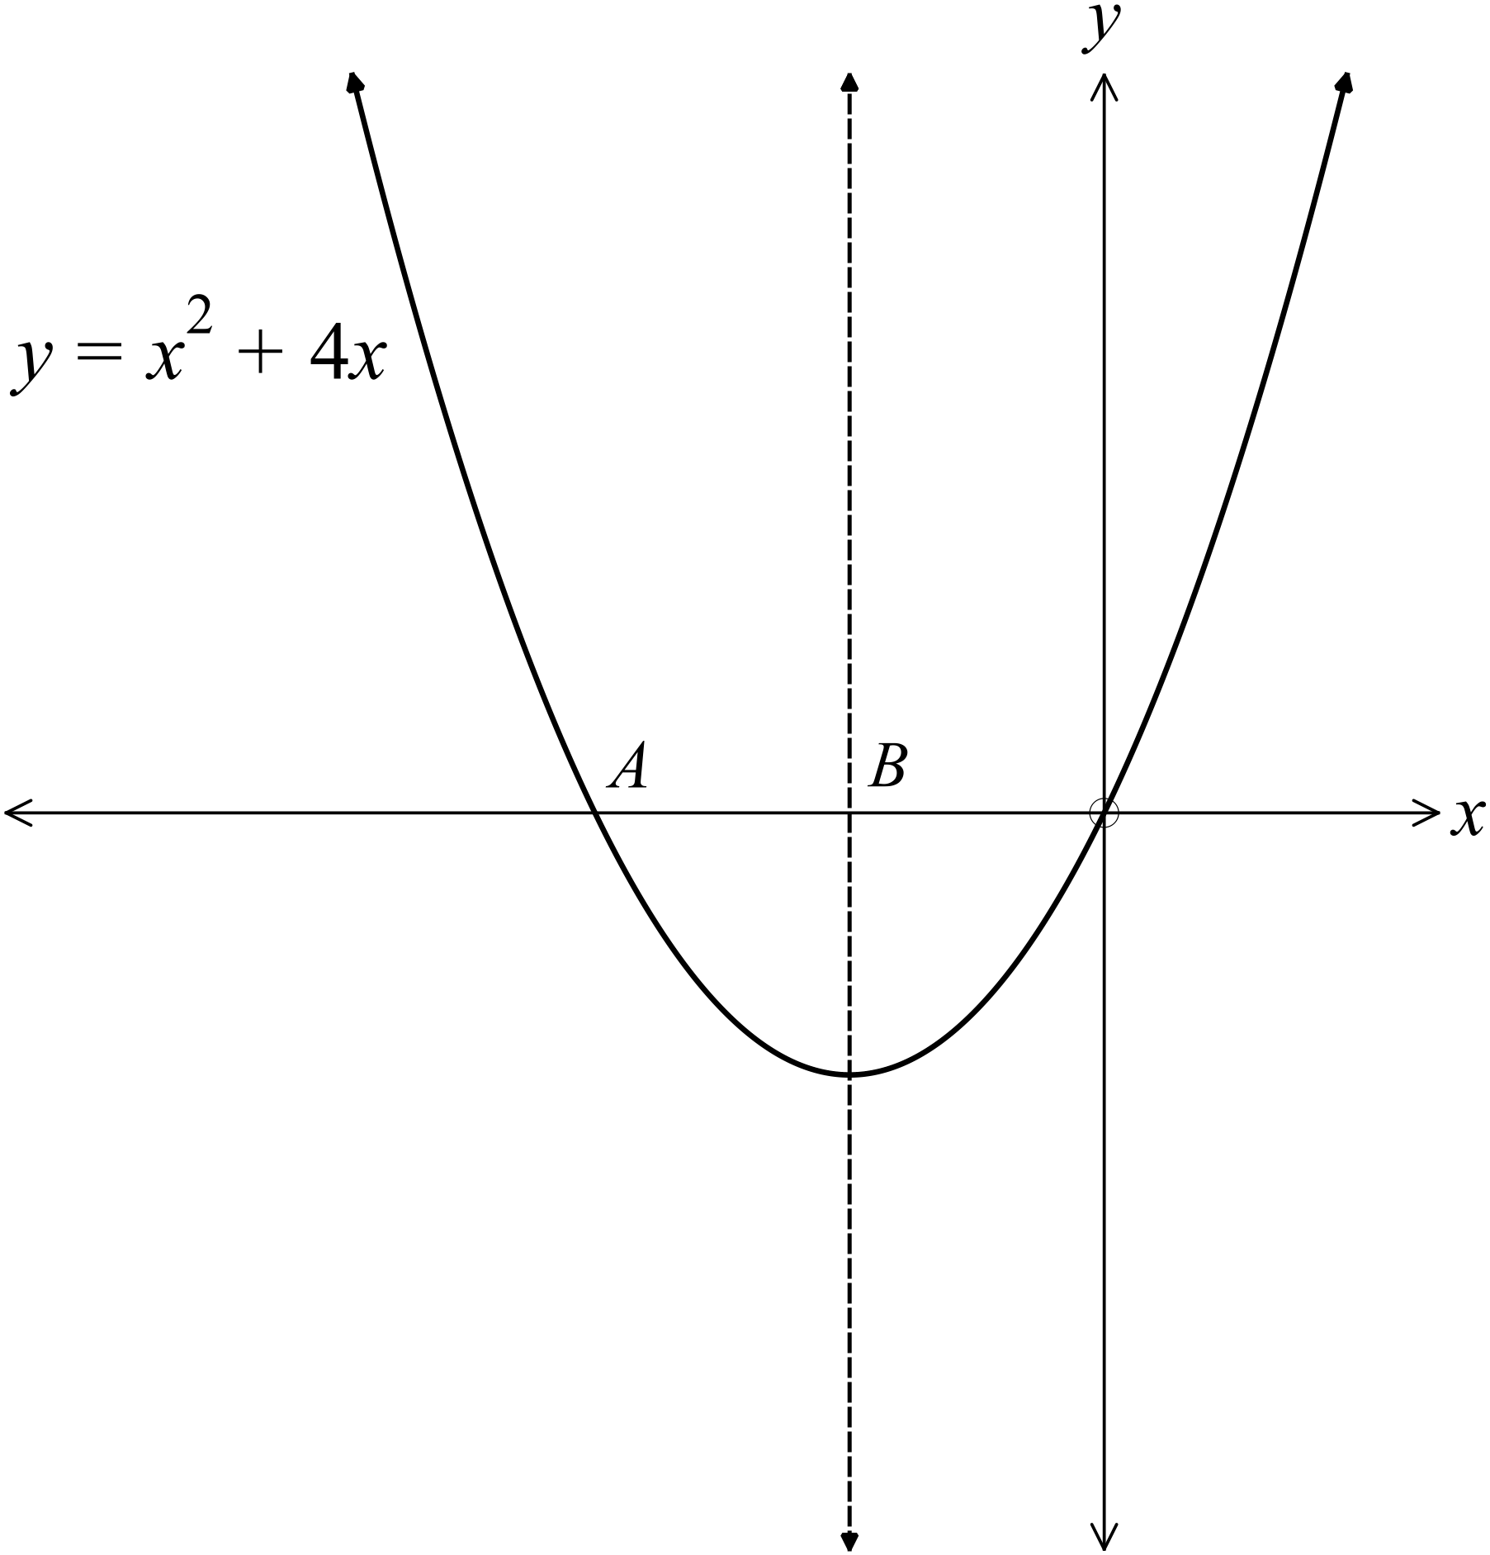The graph of 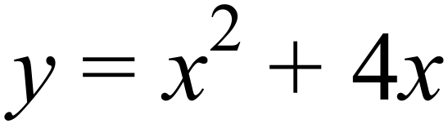 is shown.
The dotted line is its axis of symmetry.

What are the x - ordinates of the points A and B?

…………………………………………

………………………………………….

………………………………………….

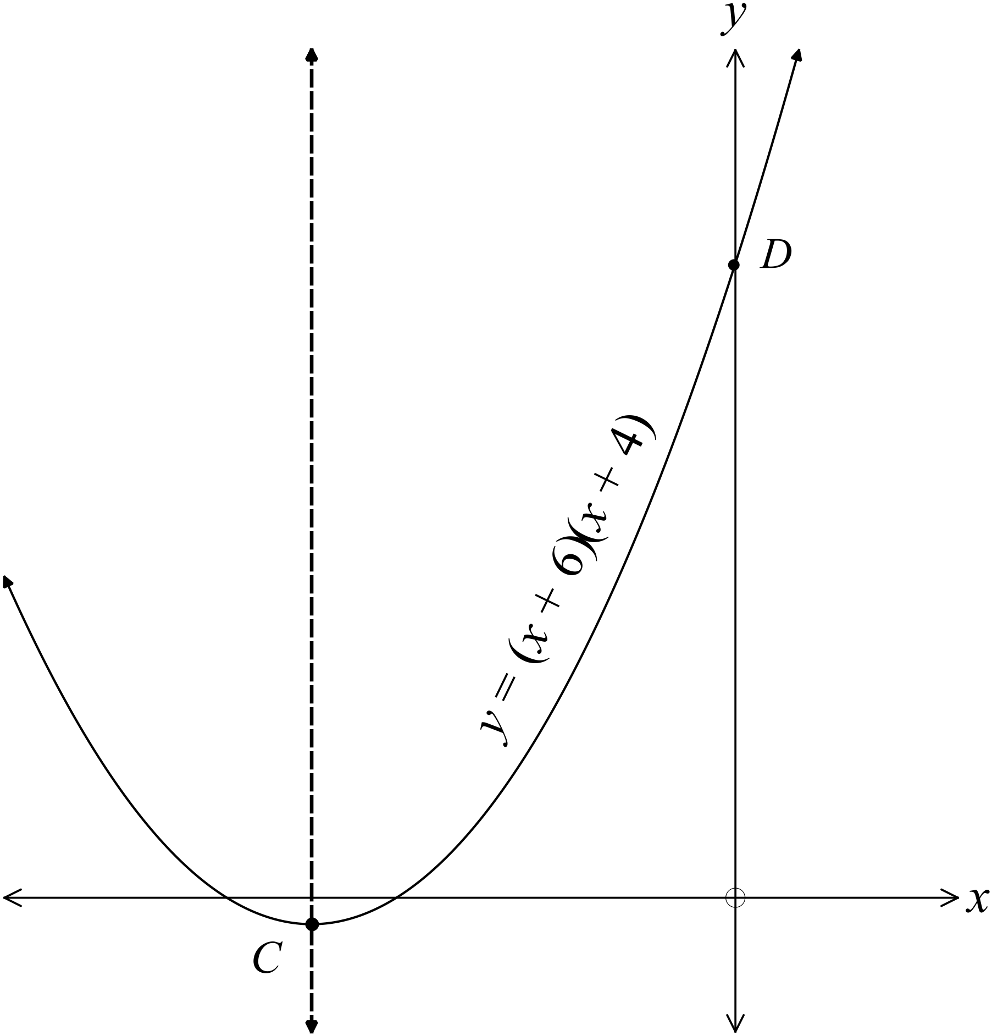The curve below has equation 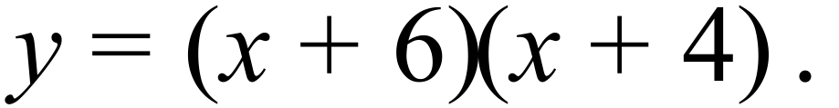
The axis of symmetry is shown by the dotted line.
What are the coordinates of the points C and D ?

………………………………………………

……………………………………………….

………………………………………………

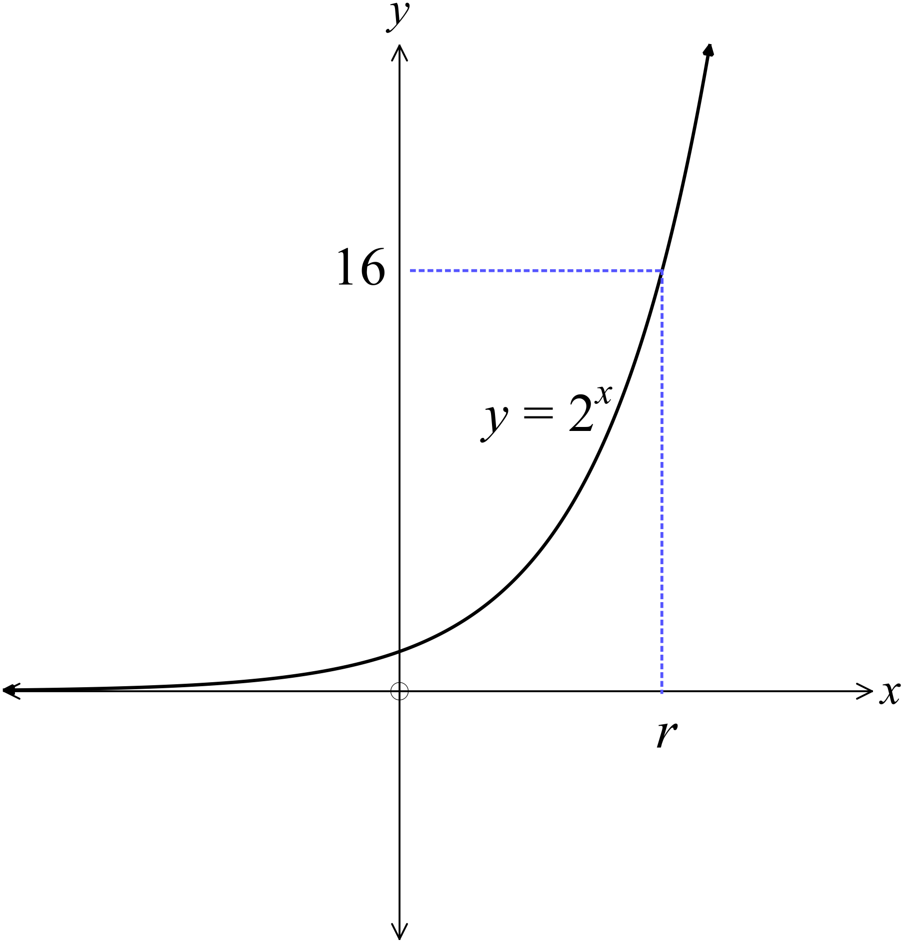The graph of 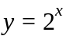 is shown.
What is the value of r?

………………………………………………

……………………………………………….

………………………………………………

……………………………………………….

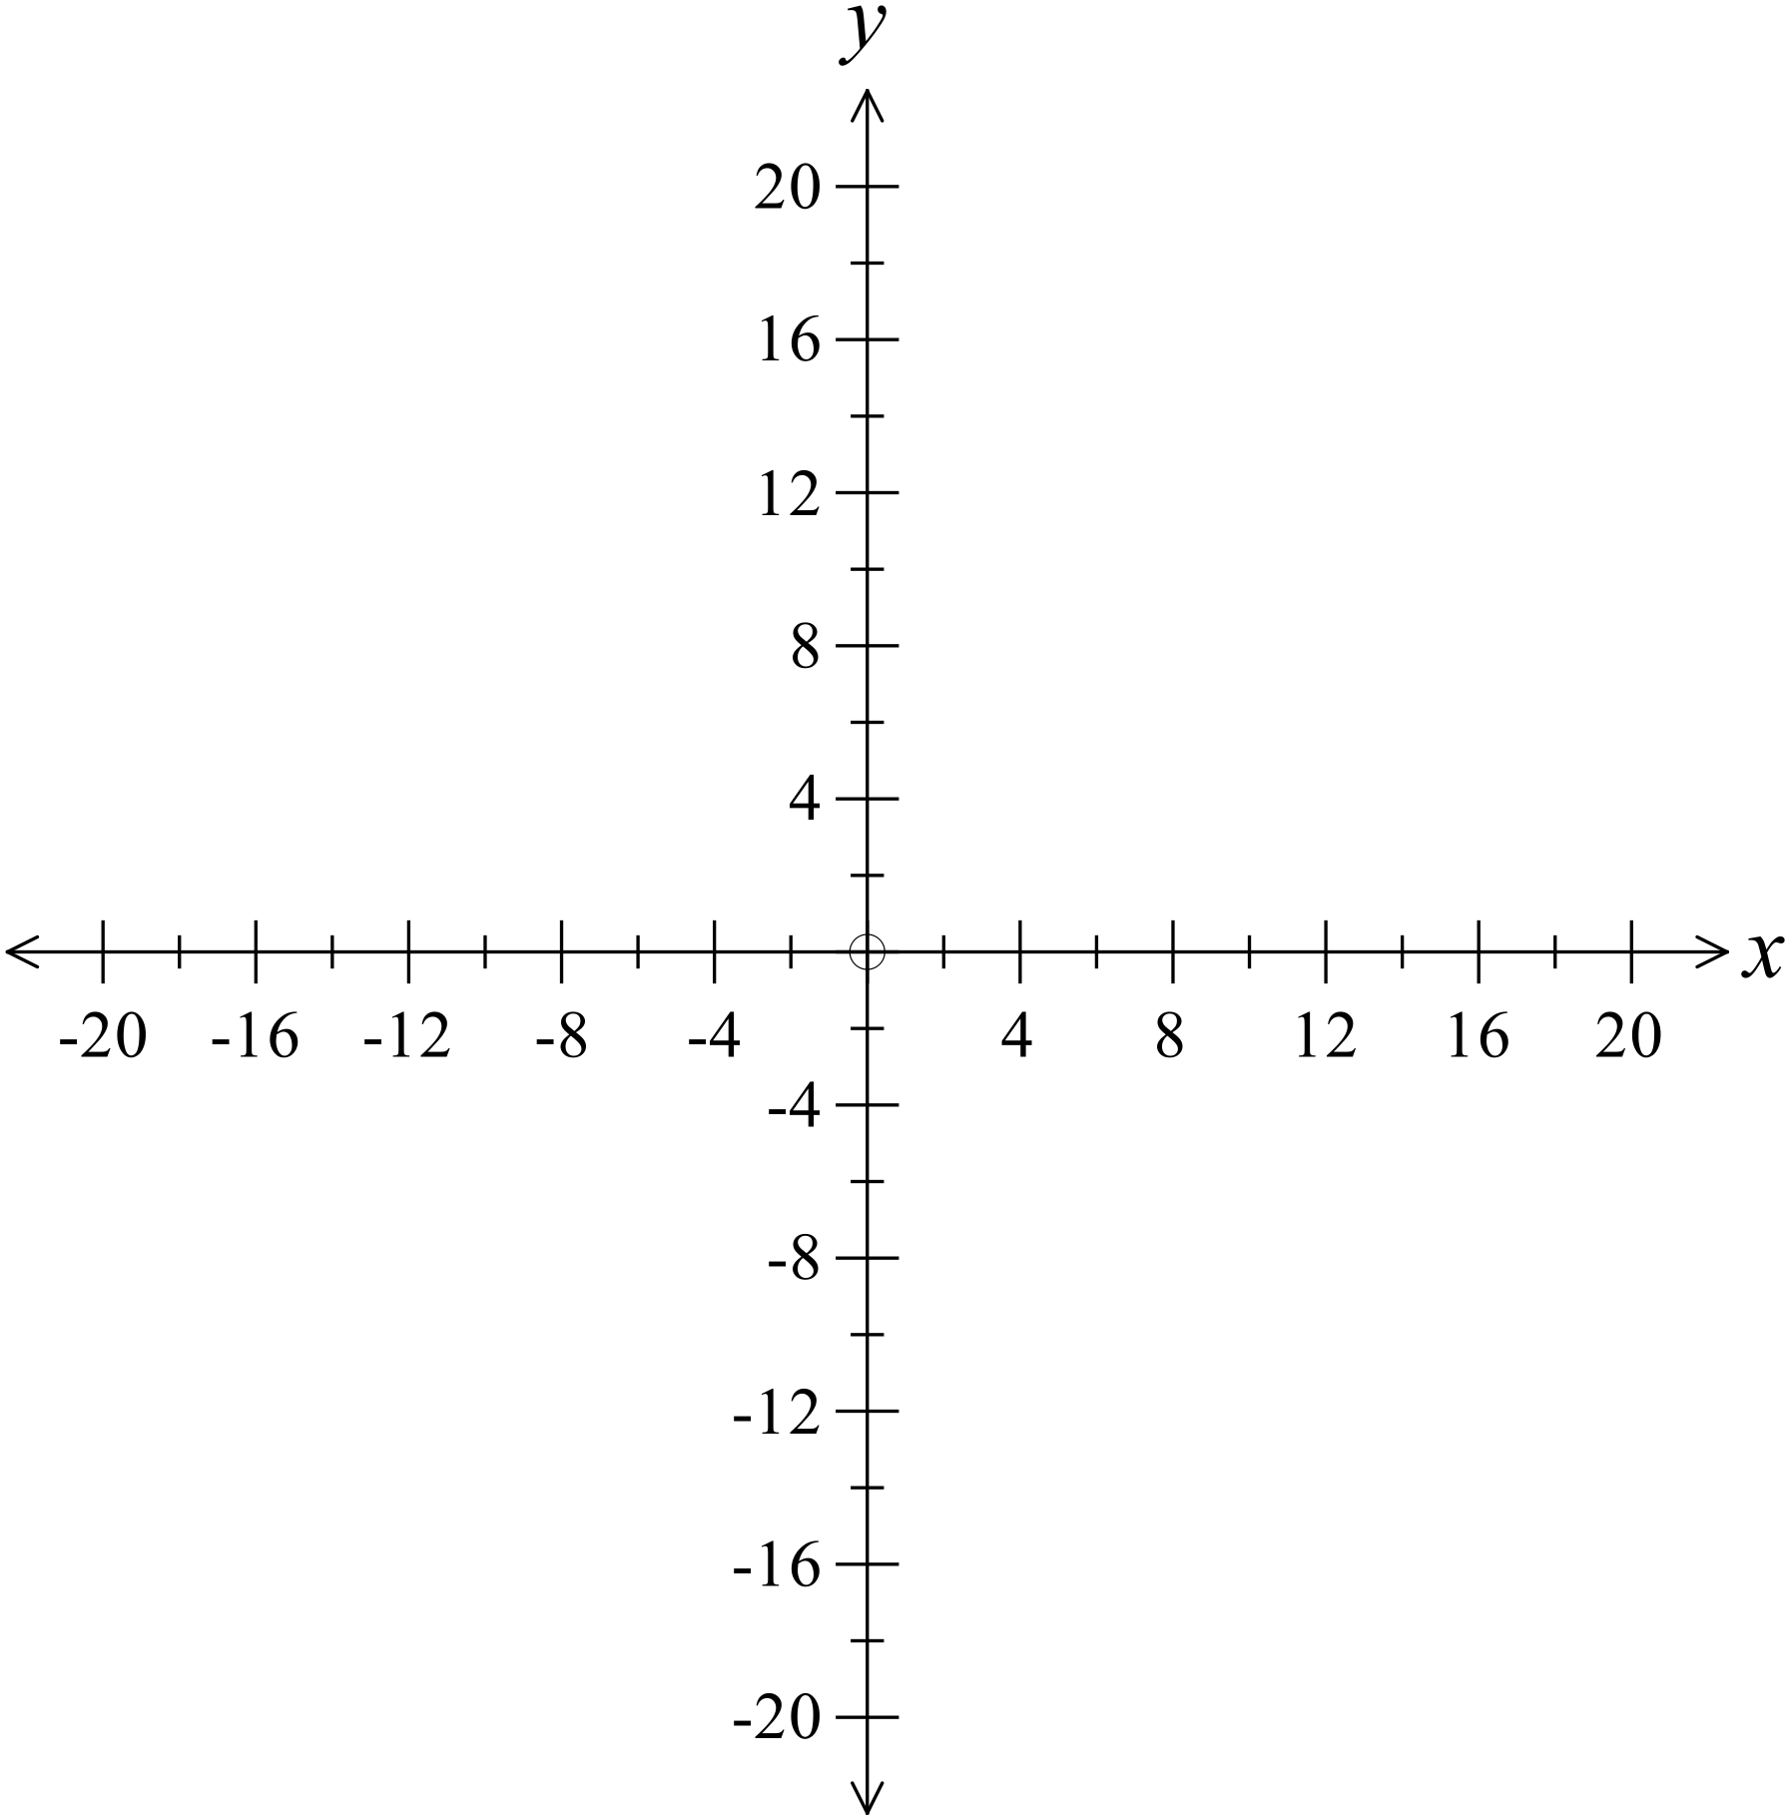Sketch the circle which has an equation 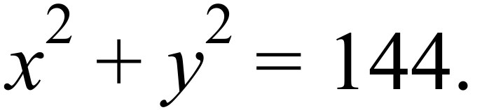

………………………………………………

……………………………………………….

………………………………………………

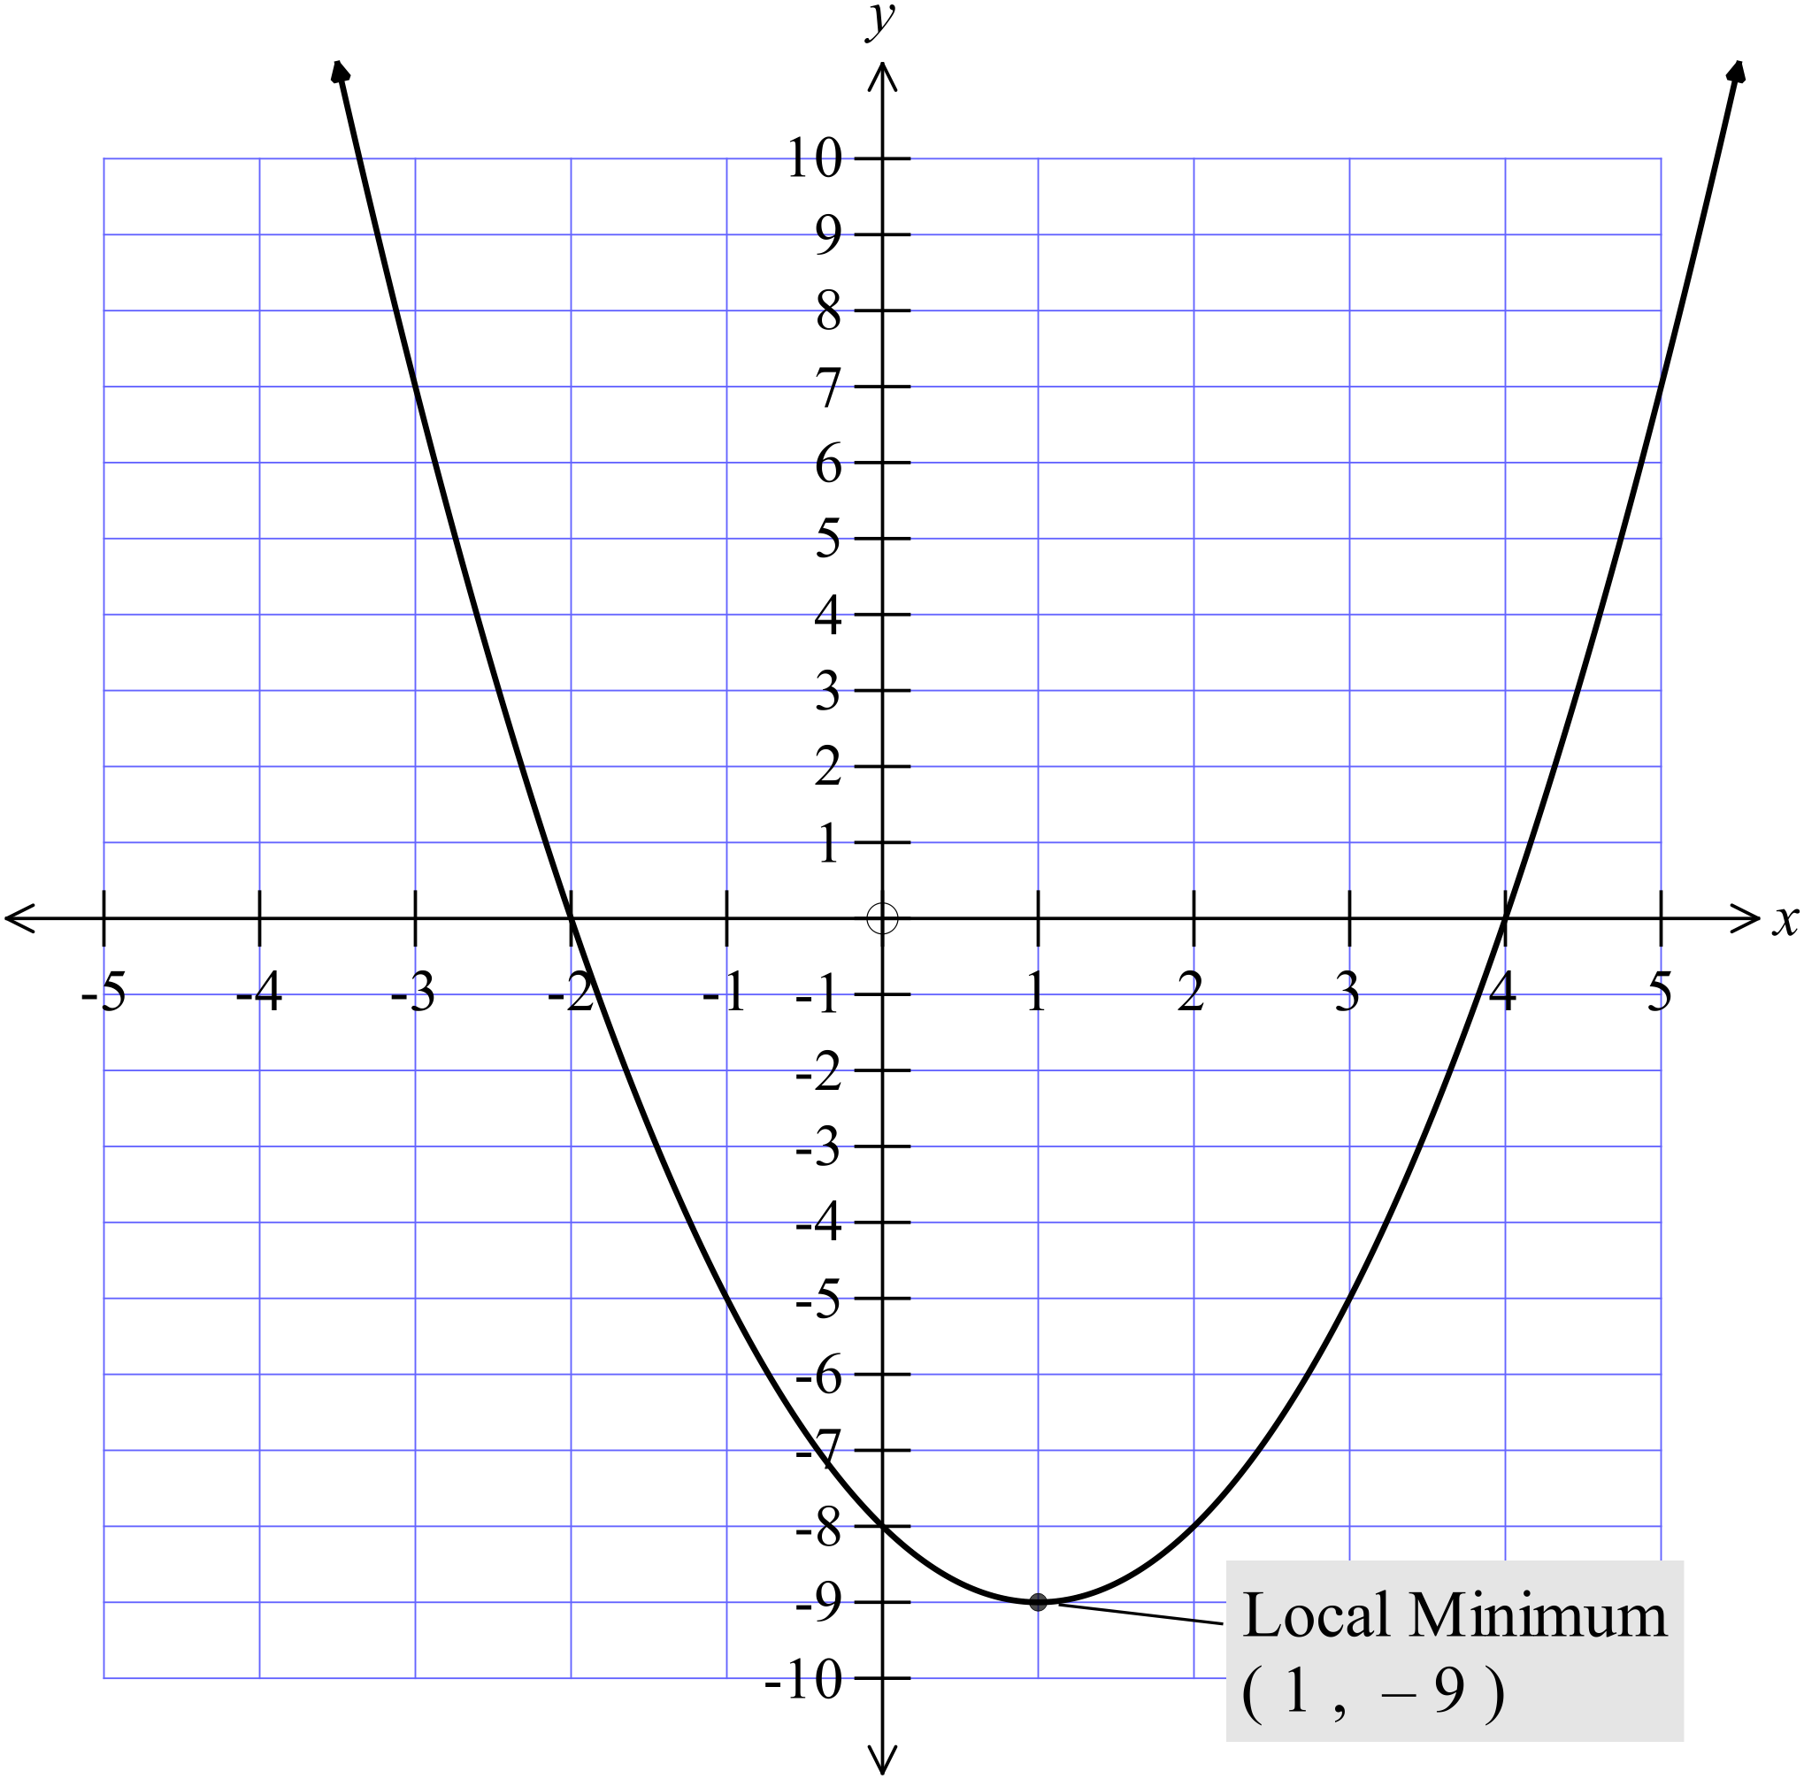The equation of the parabola shown is
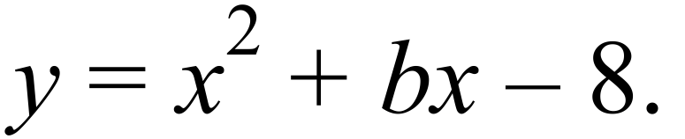

What is the value of b?

………………………………………………

……………………………………………….

………………………………………………

……………………………………………….

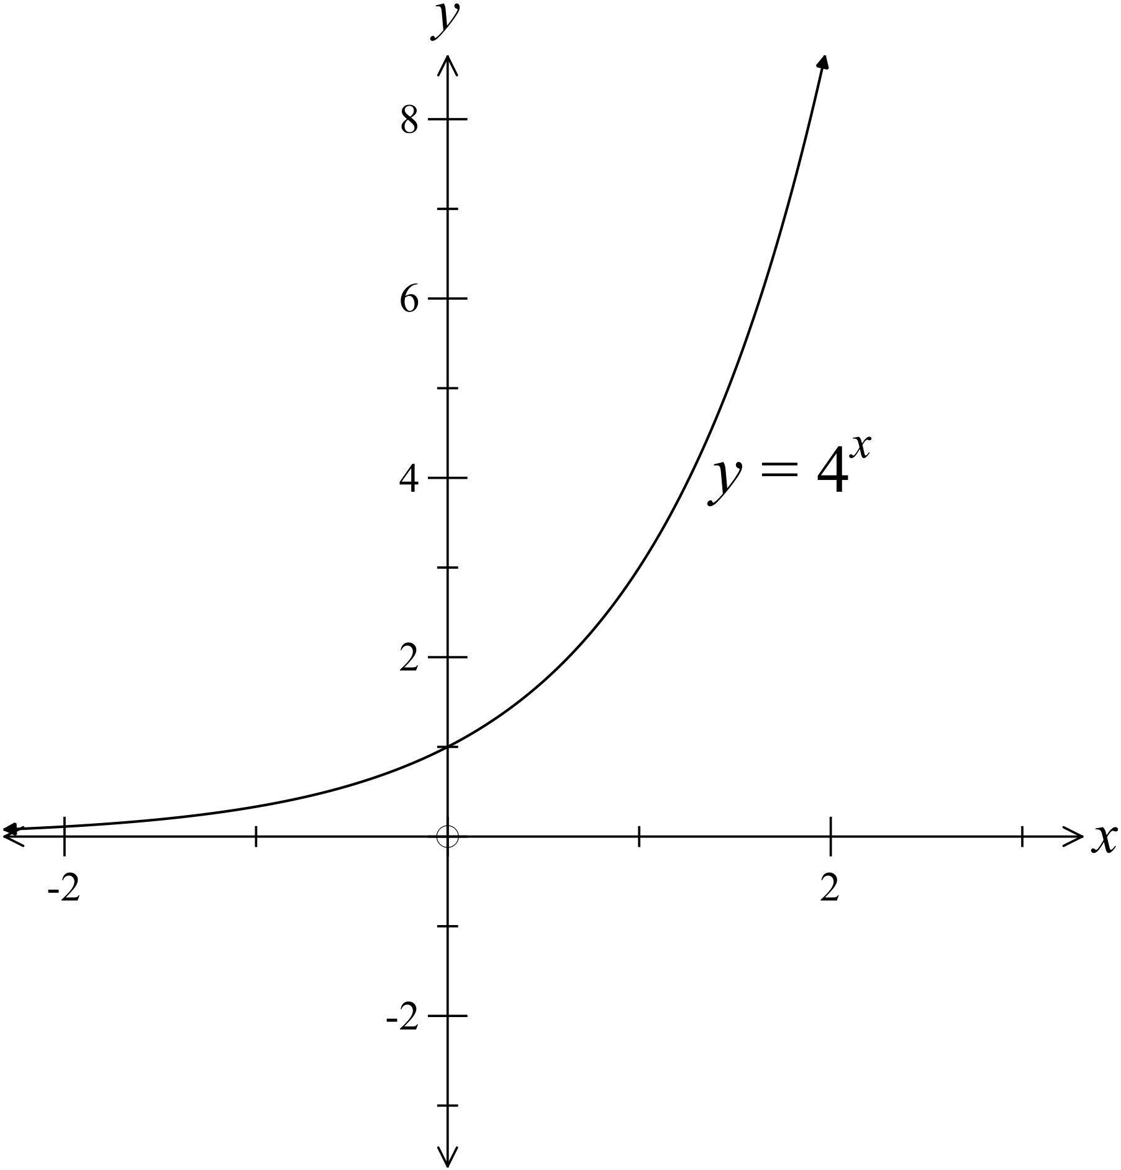The graph of 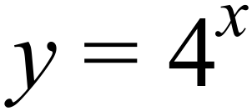 is shown.
Draw a quick sketch, on the same set of axes, of 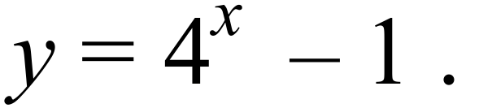

……………………………………………

…………………………………………….

………………………………………………

What is the centre and radius of the circle which has an equation of 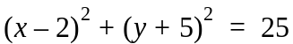

……………………………………………………………………………………………….

……………………………………………………………………………………………….
What is the centre and radius of the circle which has an equation of 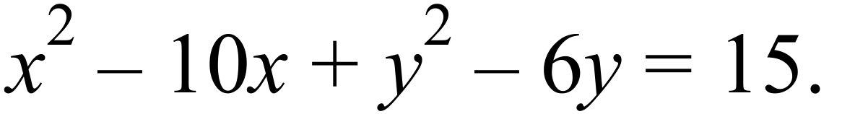

……………………………………………………………………………………………….

……………………………………………………………………………………………….

……………………………………………………………………………………………….

……………………………………………………………………………………………….
Complete the table of values for the equation
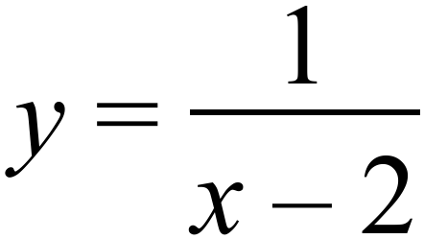

 | -2 | 0 | 1 | 2 | 3 | 4 | 6
 |  |  |  | Undefined

Draw a sketch of using the table in question 14.
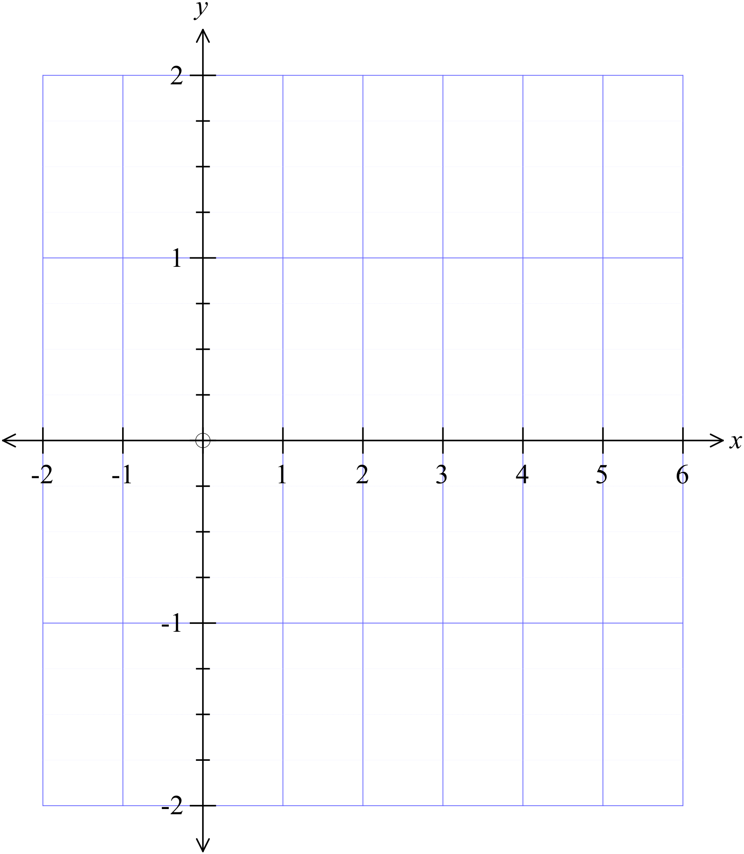

Year 10 |  | Non Linear Relations | Calculator Allowed
 |  | Non Linear Relations | Name_________________
Section 2 Multiple Choice Section
Mark all your answers on the accompanying multiple choice answer sheet, not on this test paper. You may do any working out on this test paper. Calculators are allowed for this section.

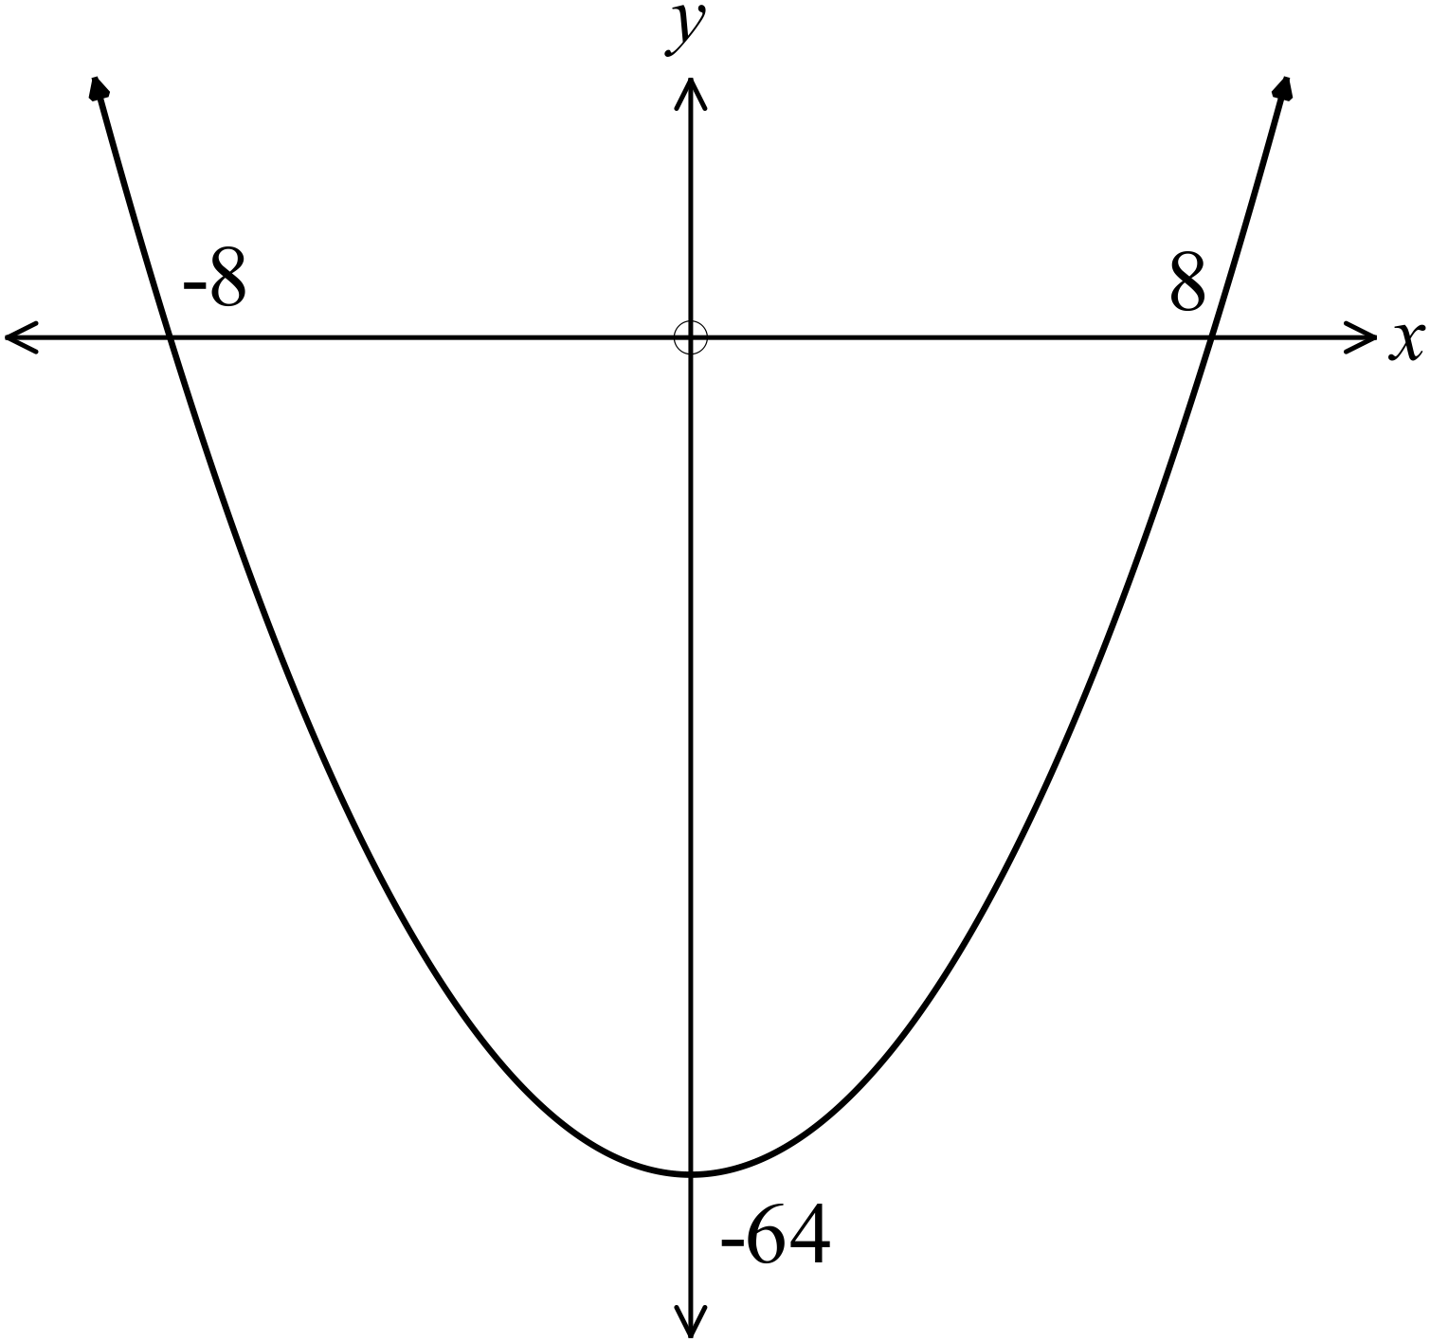Which equation could describe the graph shown?

A. 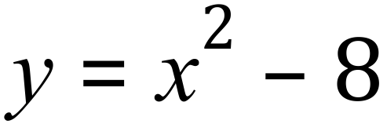
B. 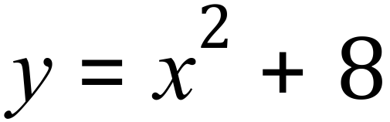
C. 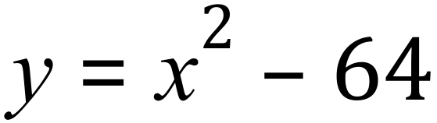
D. 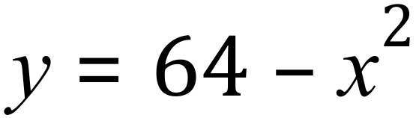

Which graph below could have an equation of 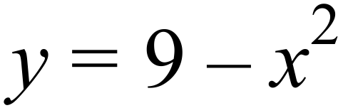 ?
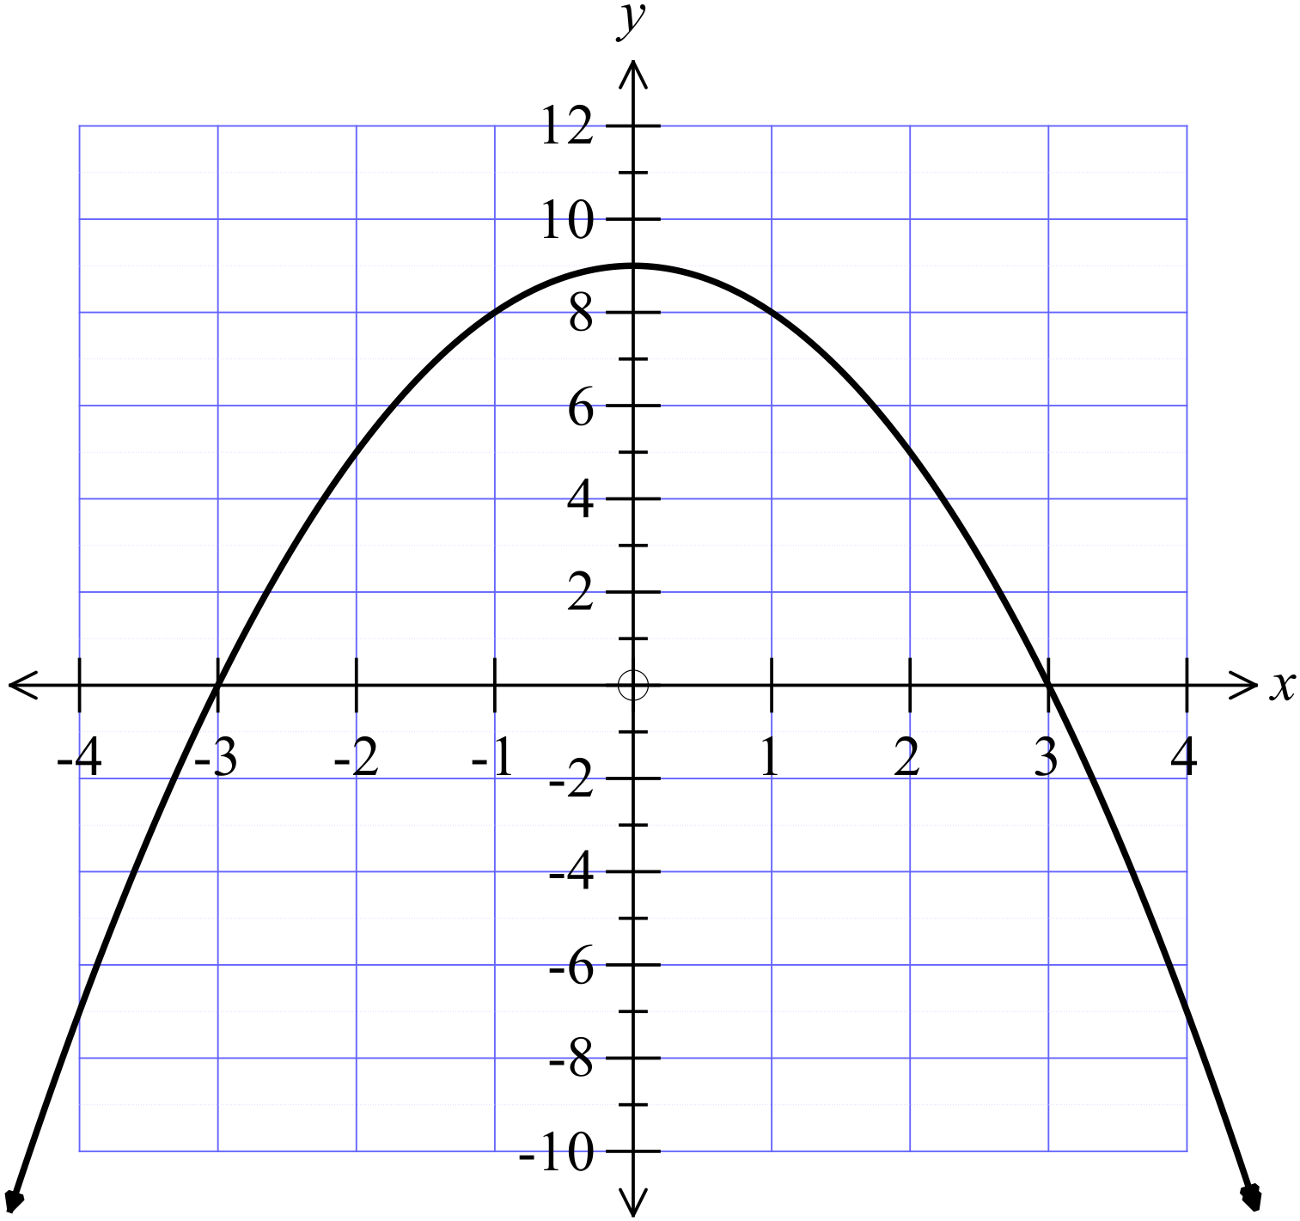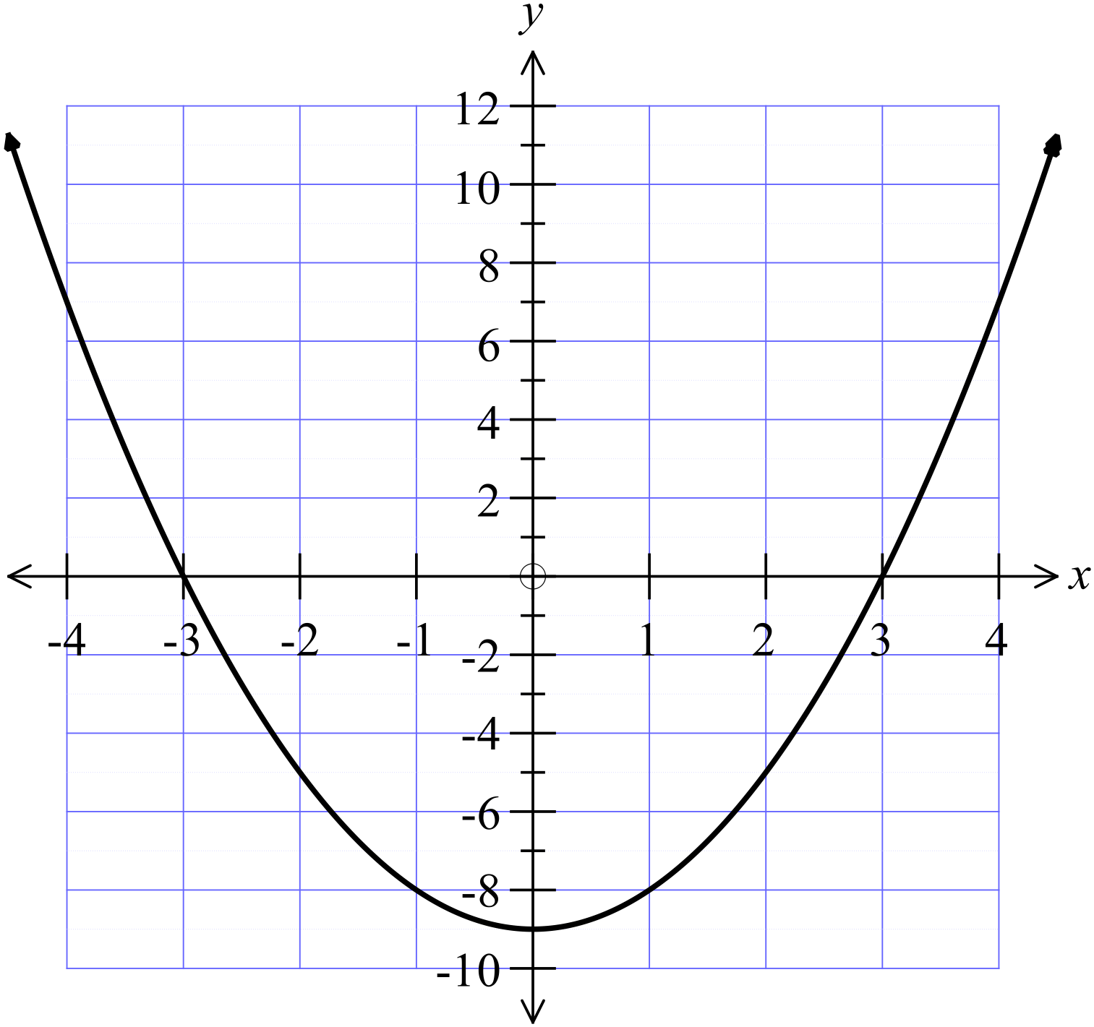A. B.

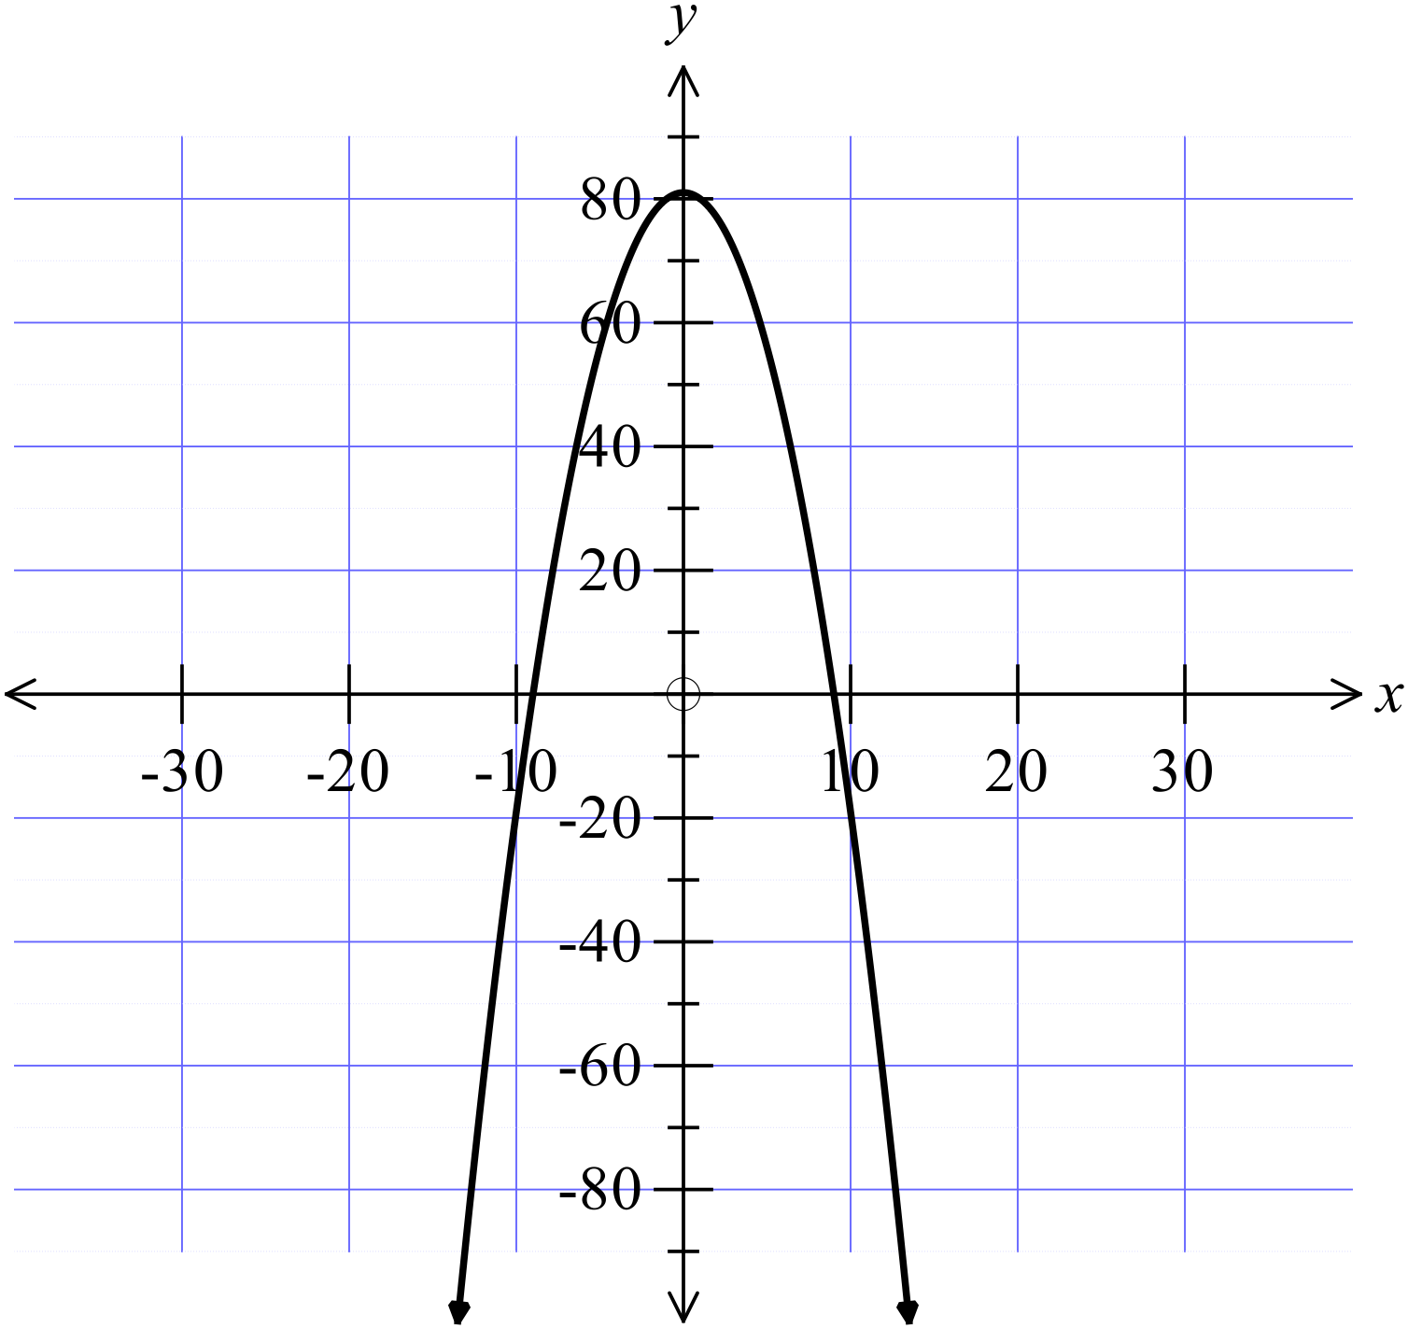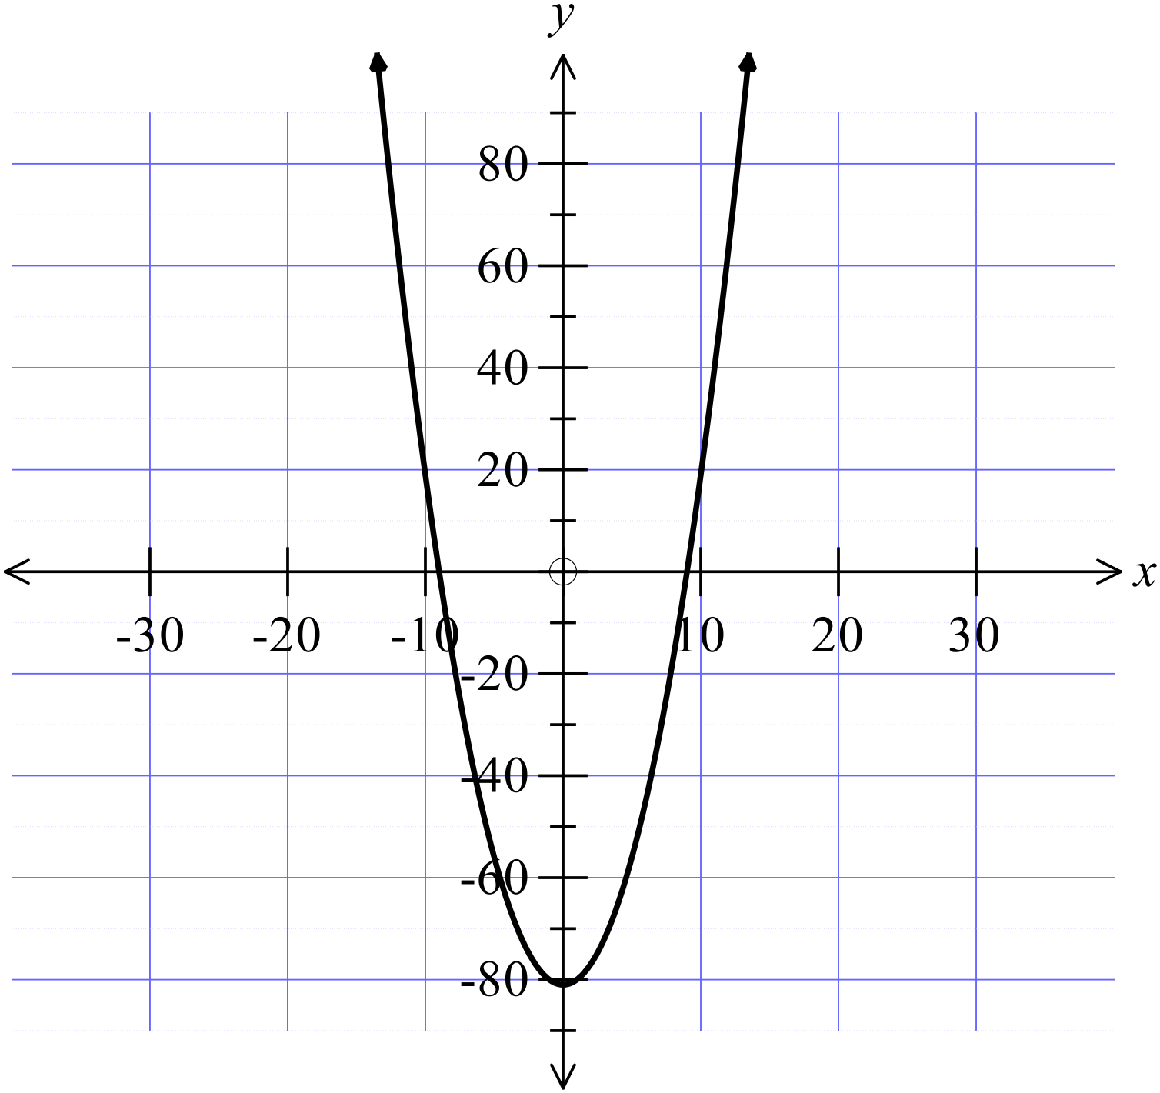C . D.

Which equation below would represent a parabola?

A. 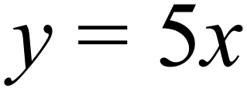 B. 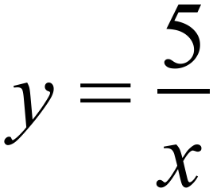 C. 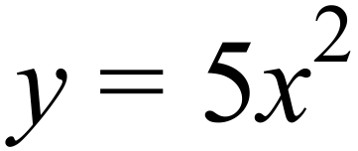 D. 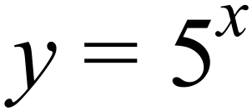
A circle on the number plane with centre at the origin and a radius of 9 units would have as its equation:
A. 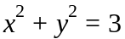.
B. 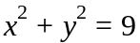.
C. 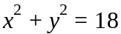.
D. 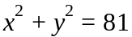.
Which curve has a vertex at 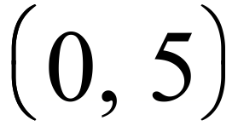?

A. 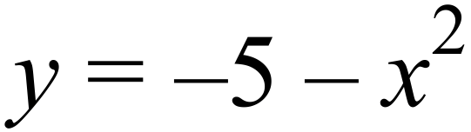 B. 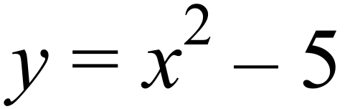 C. 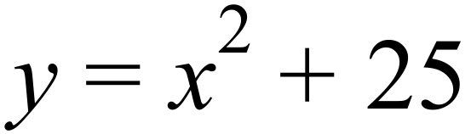 D. 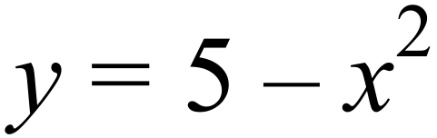

Which diagram below could be the graph of 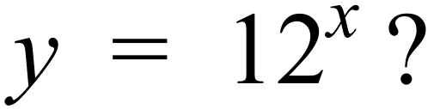

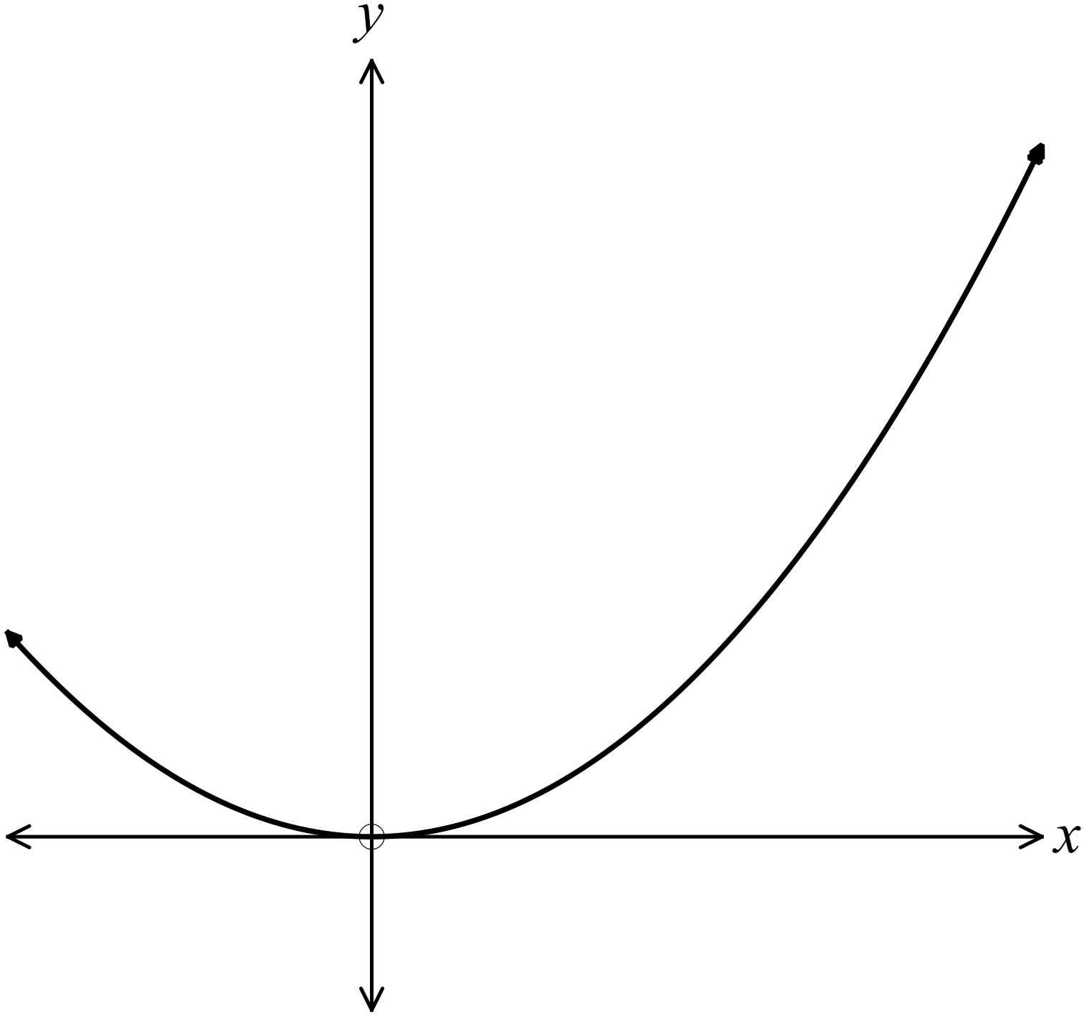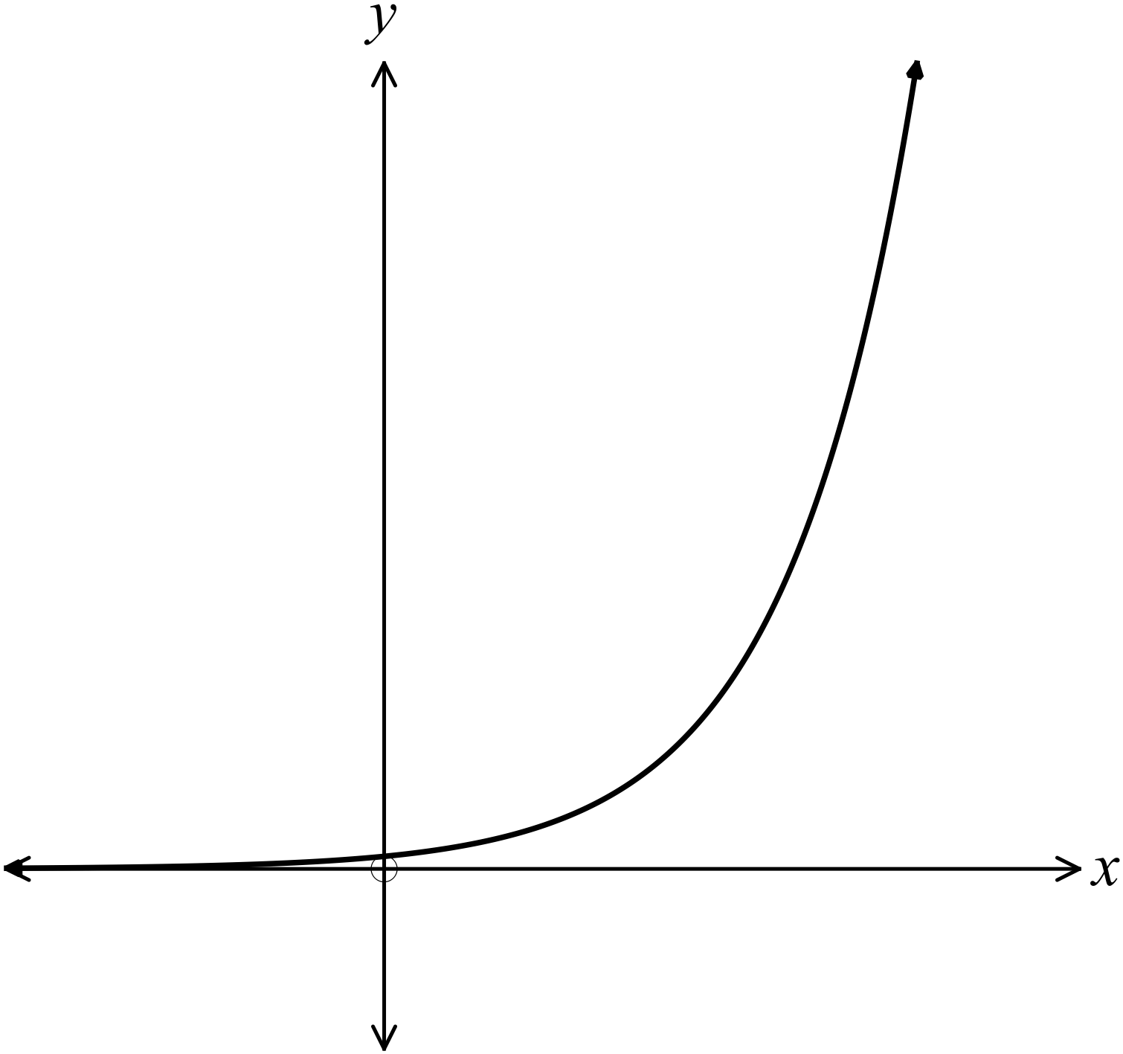A. B.

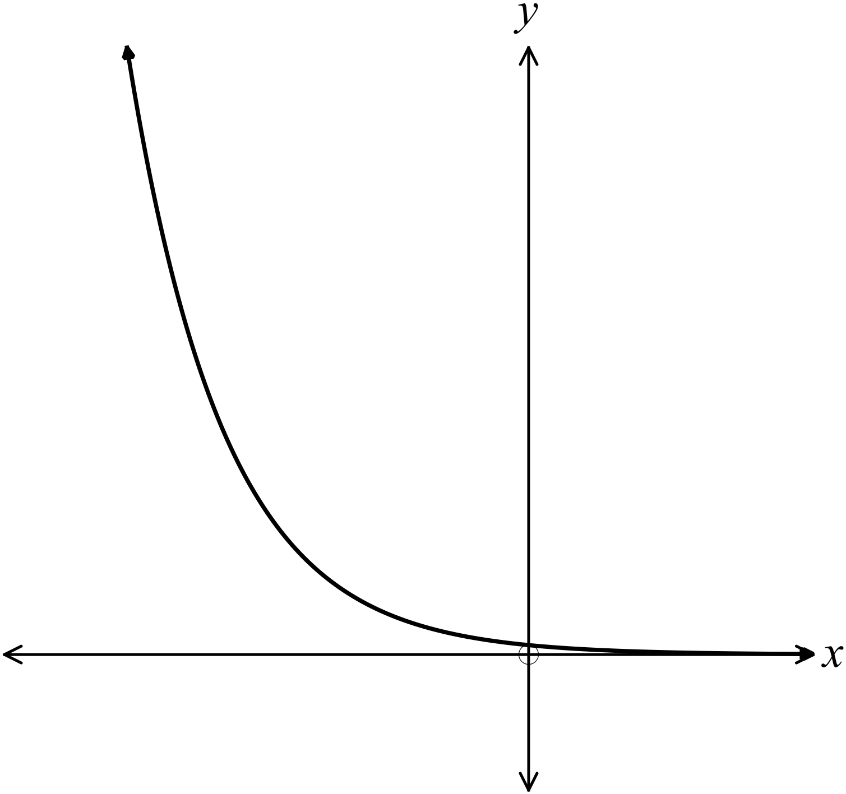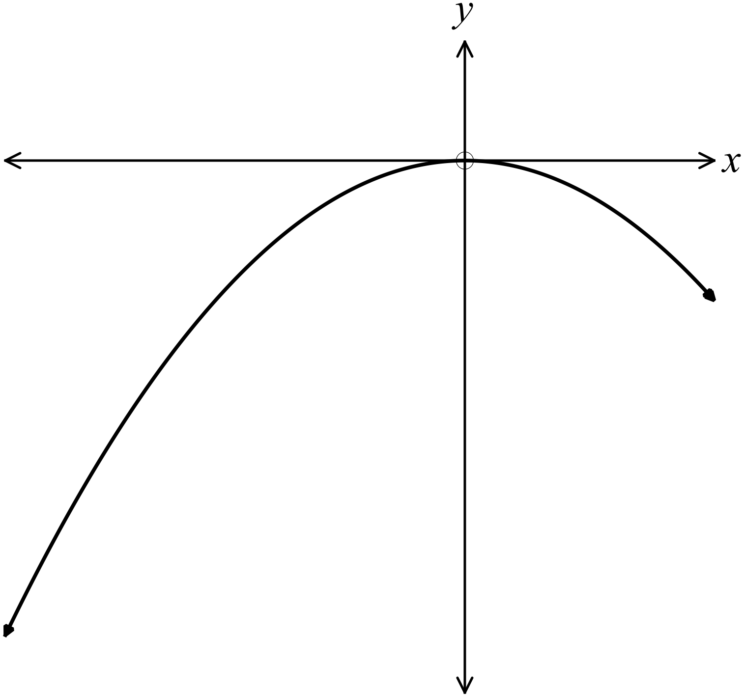C . D.

The graph of 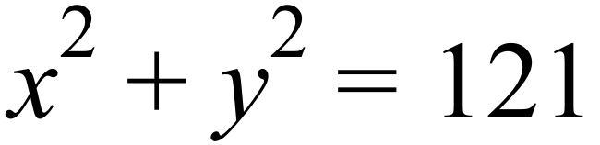 would have y intercepts at:

A. 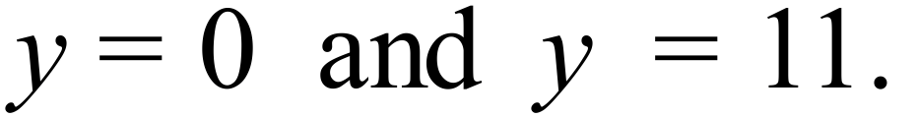 B. 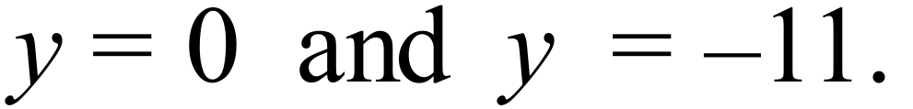

C. 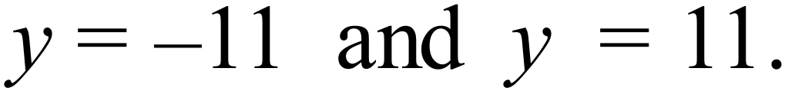 D. 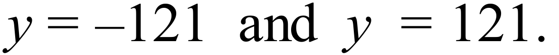

Which diagram shows the graph of 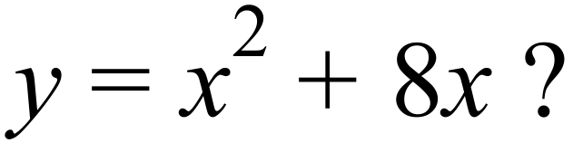
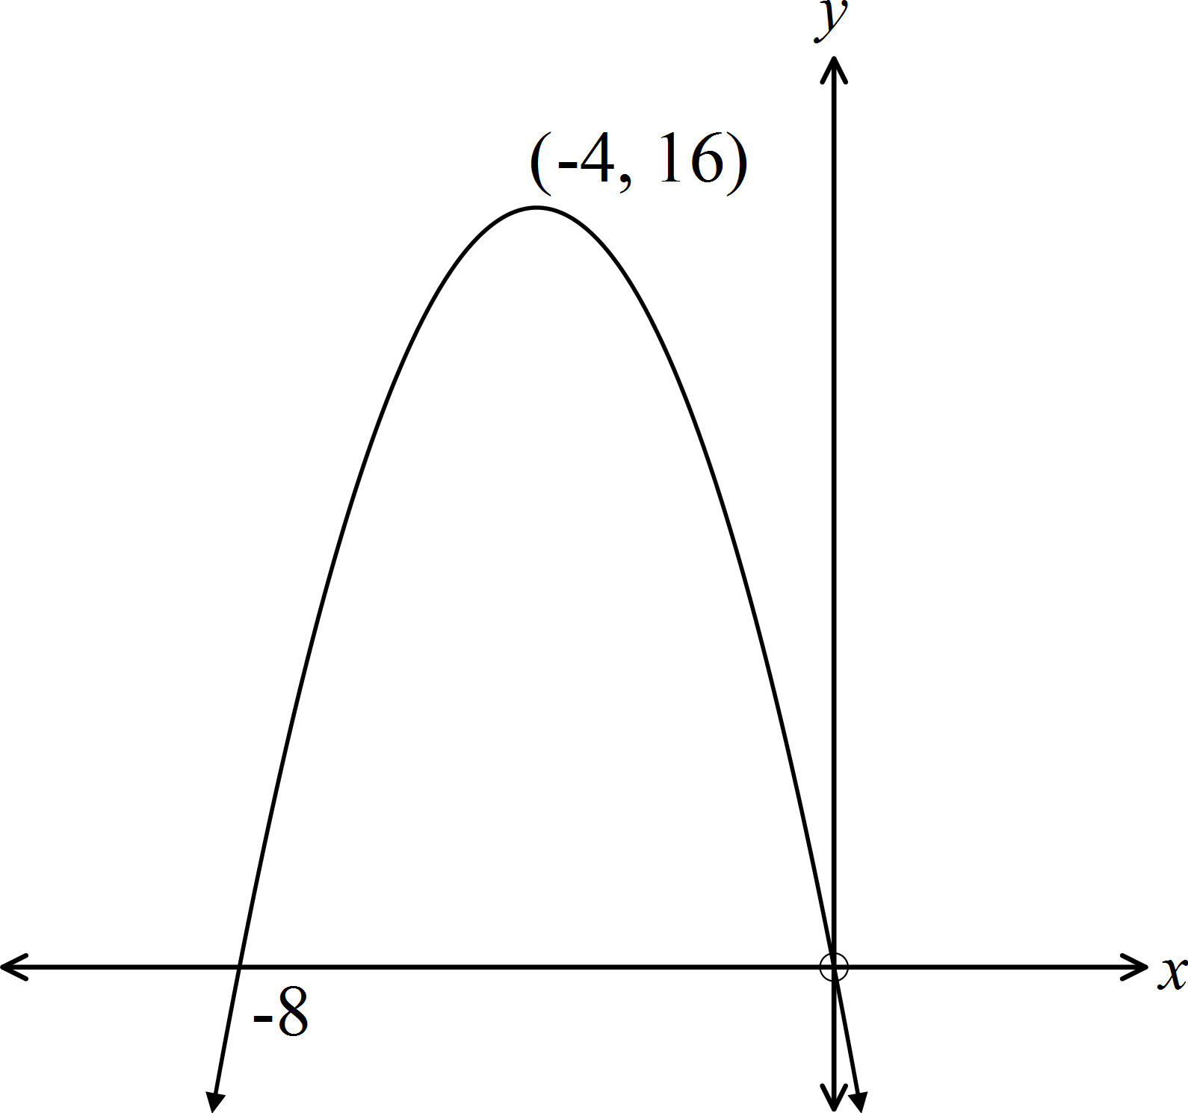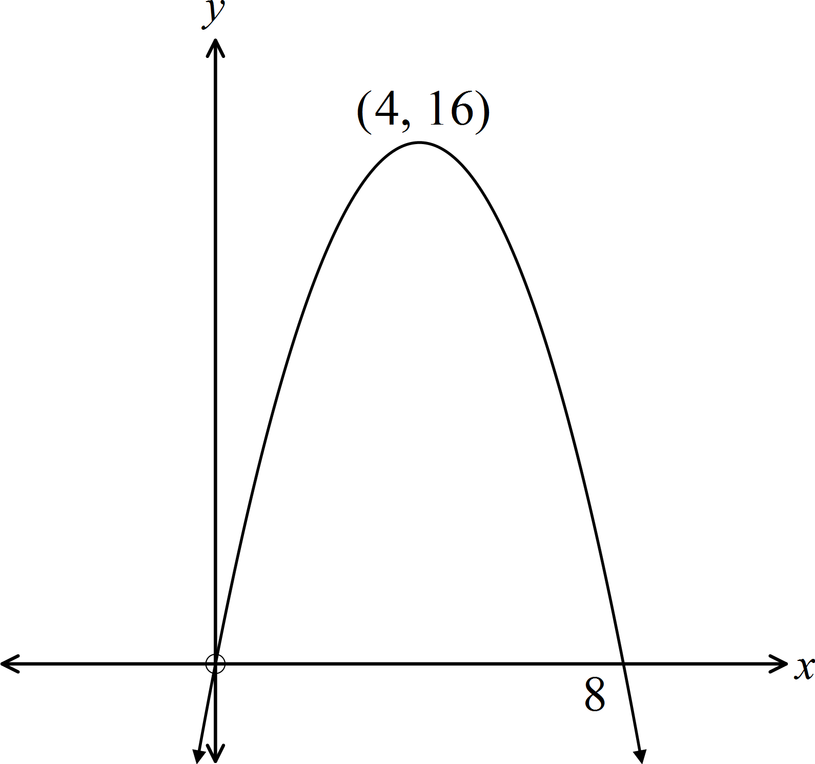
A. B.

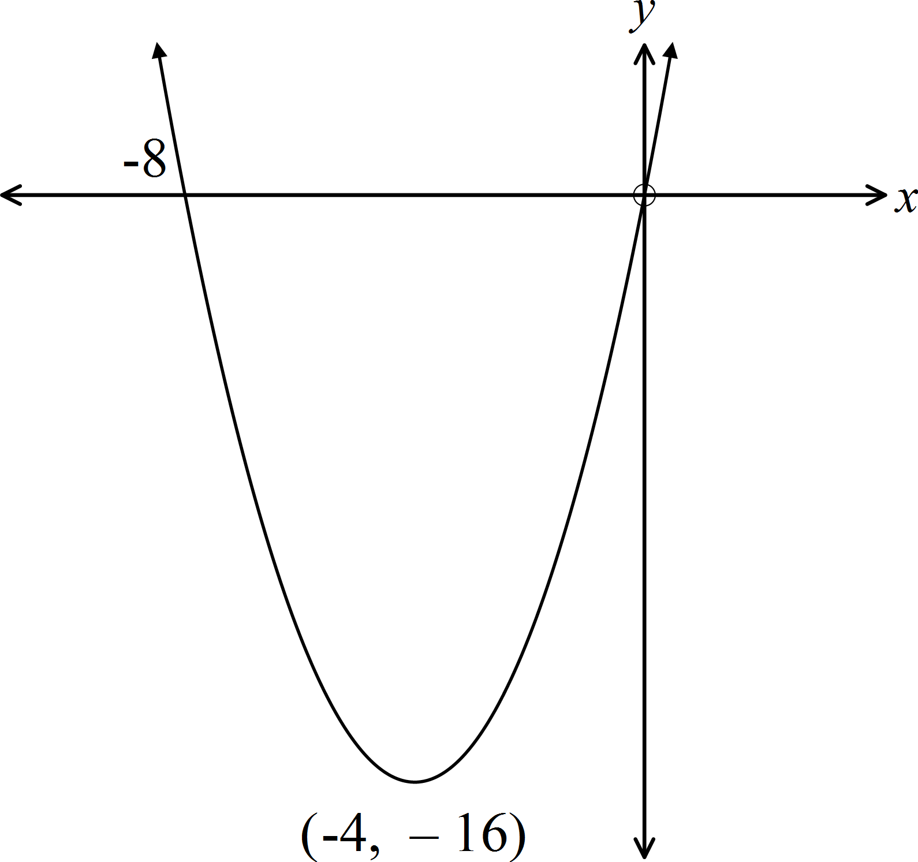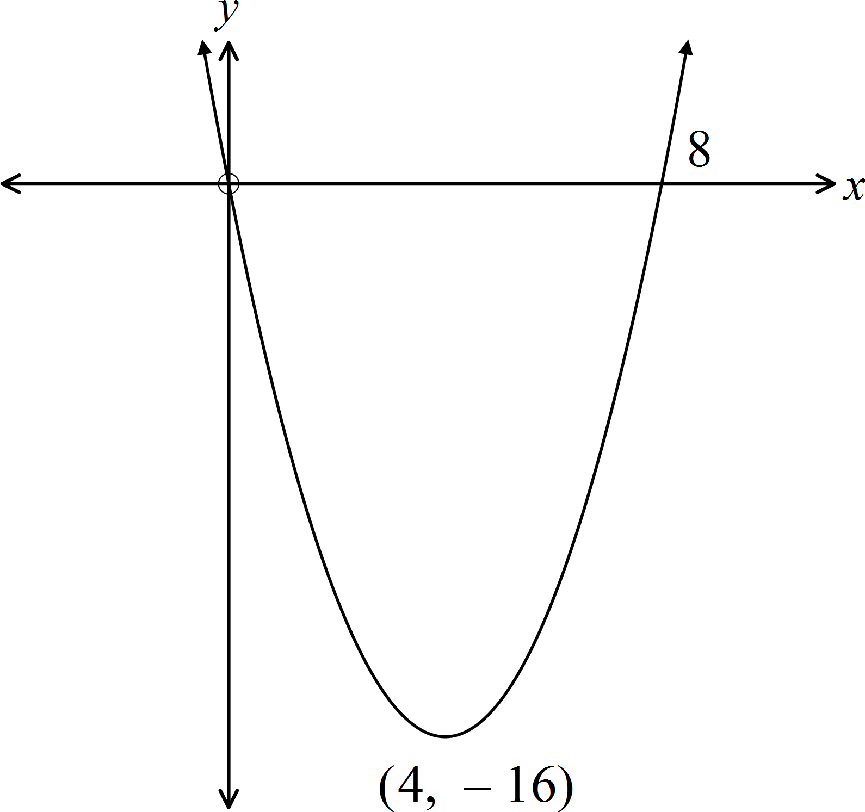 C. D.

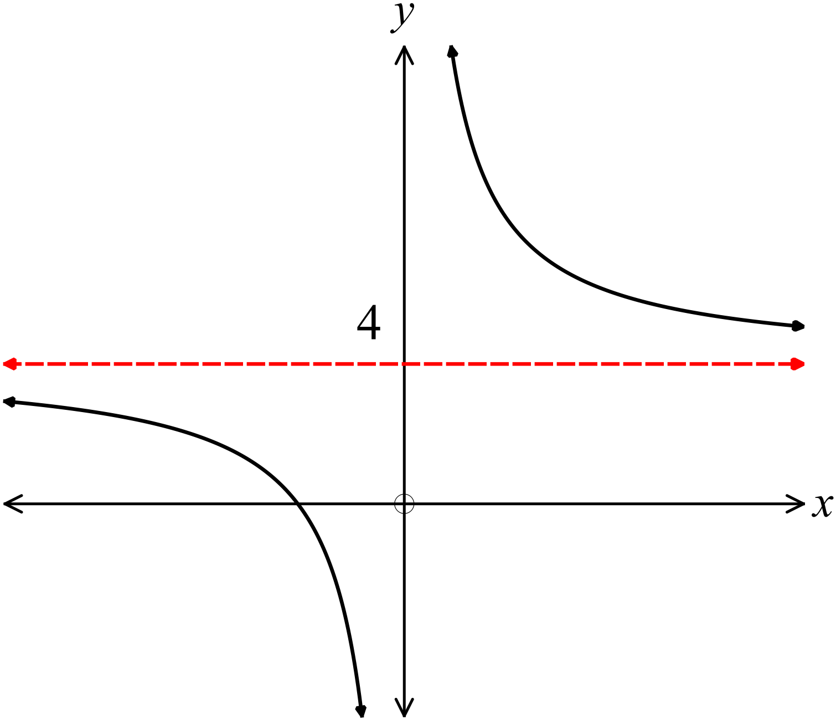Which equation could describe the graph shown?

A. 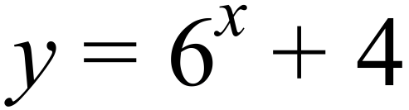

B. 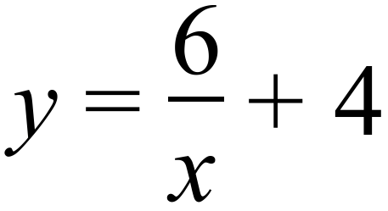

C. 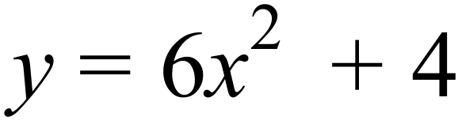

D. 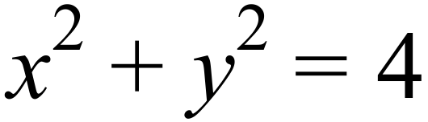

Which diagram shows the graph of 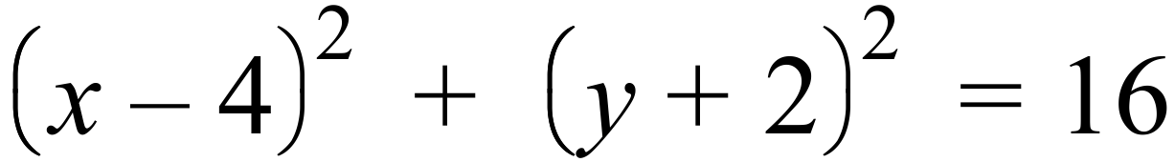?
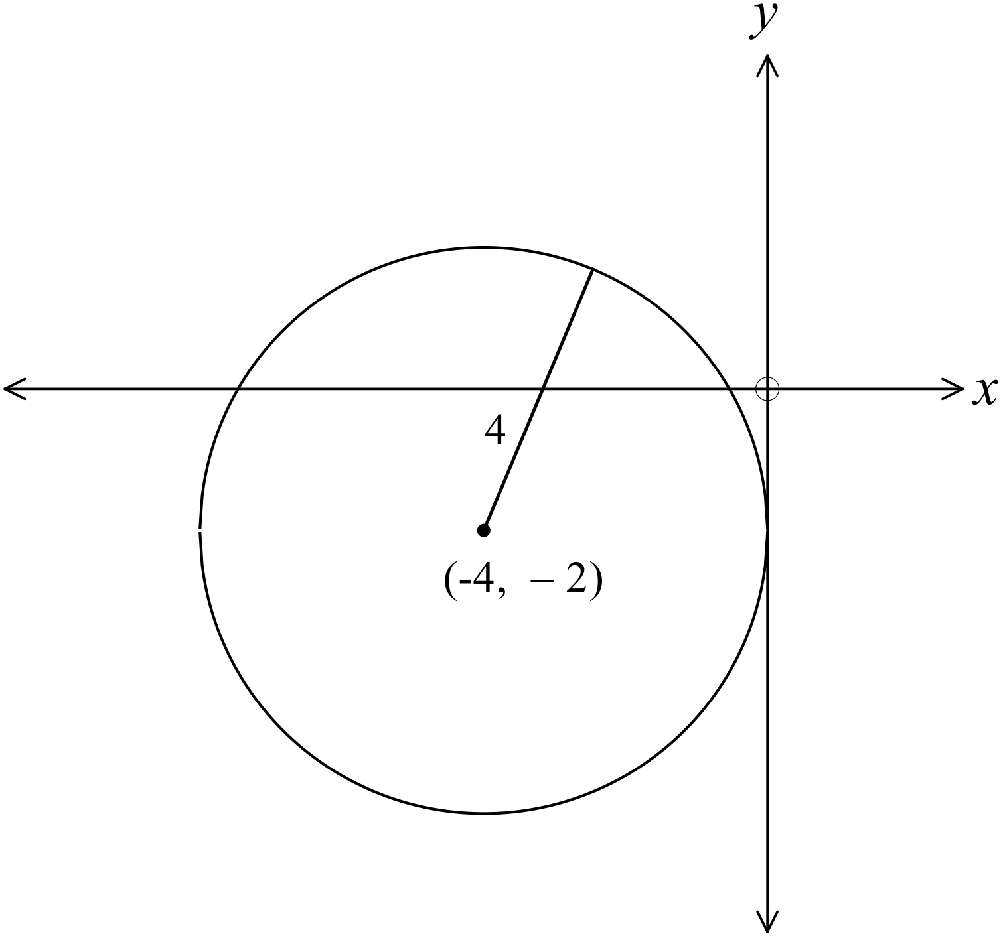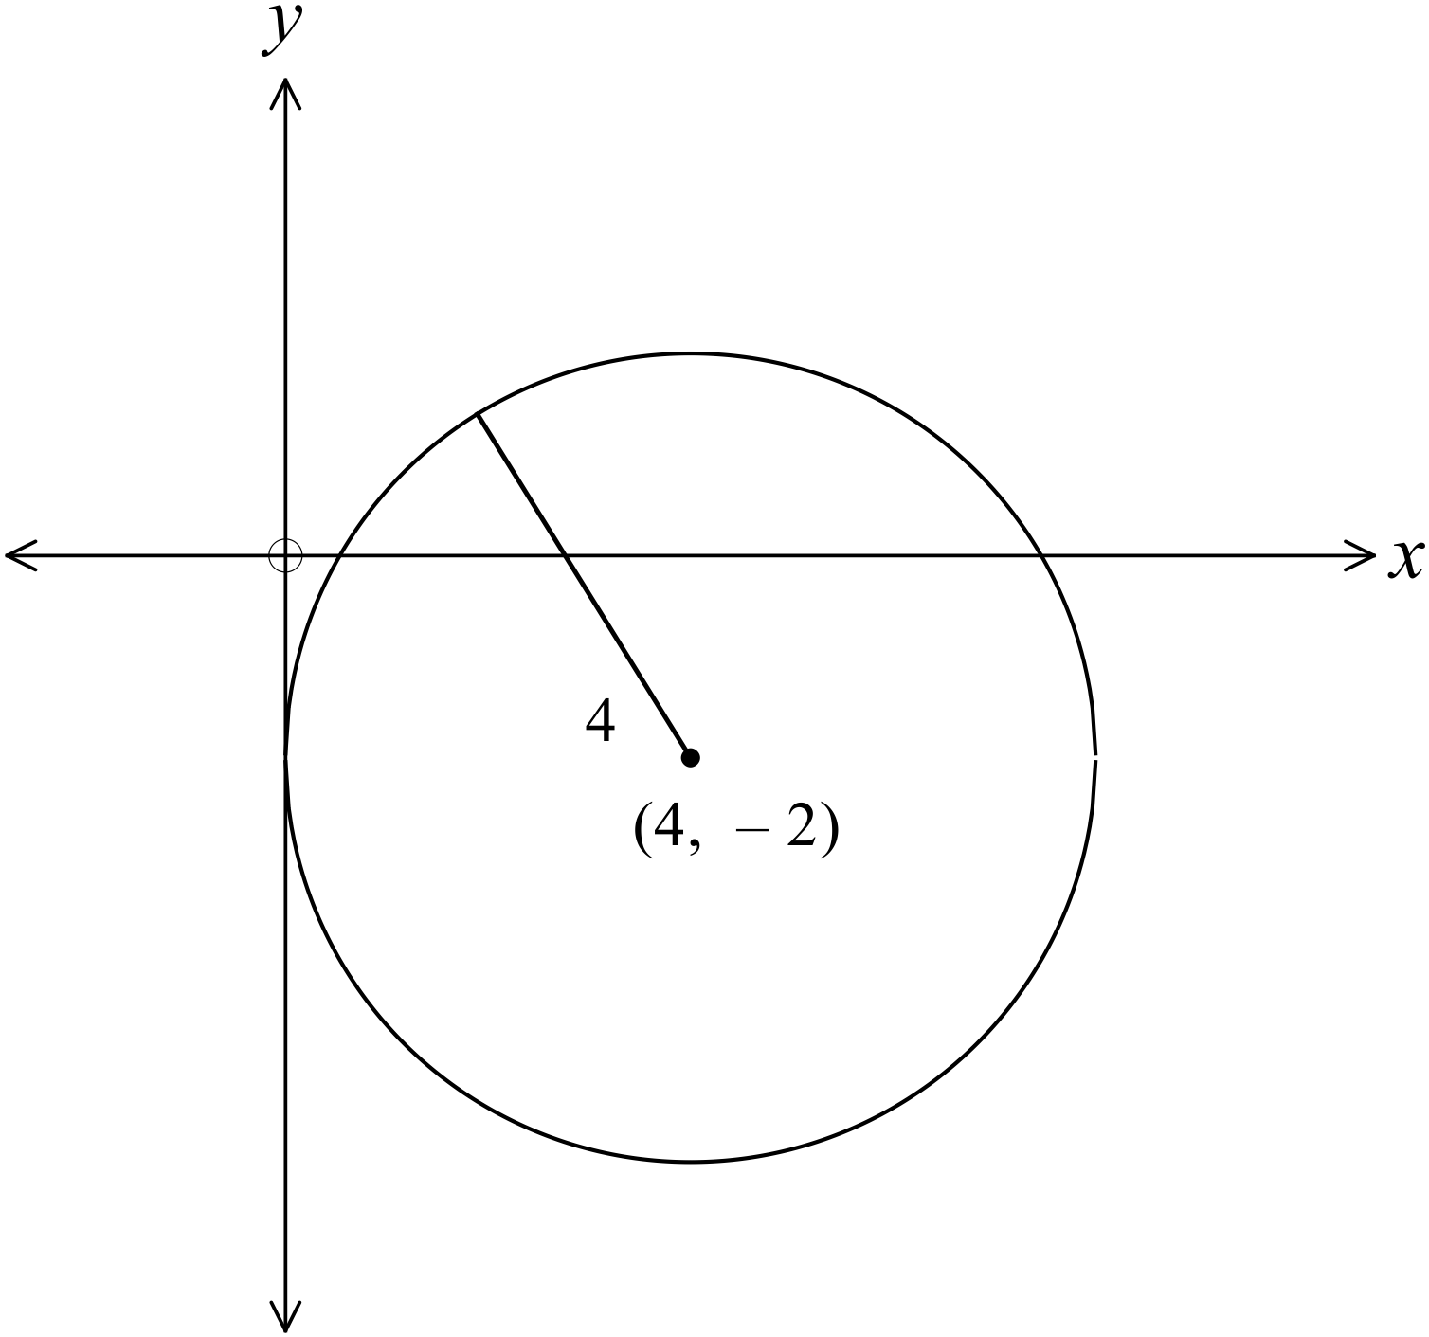
A. B.

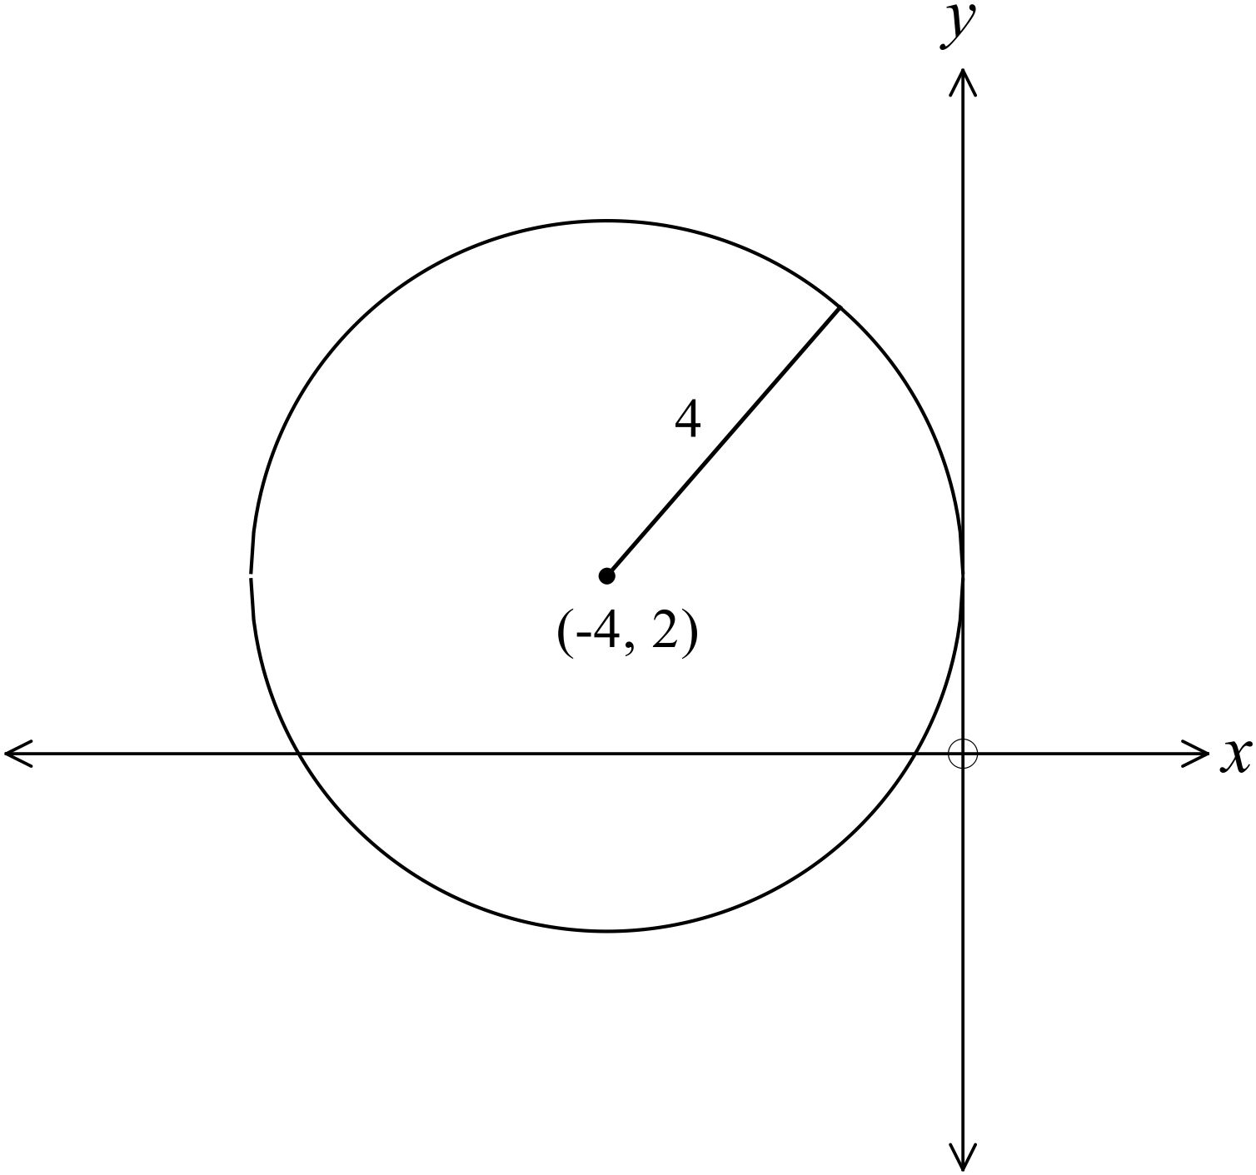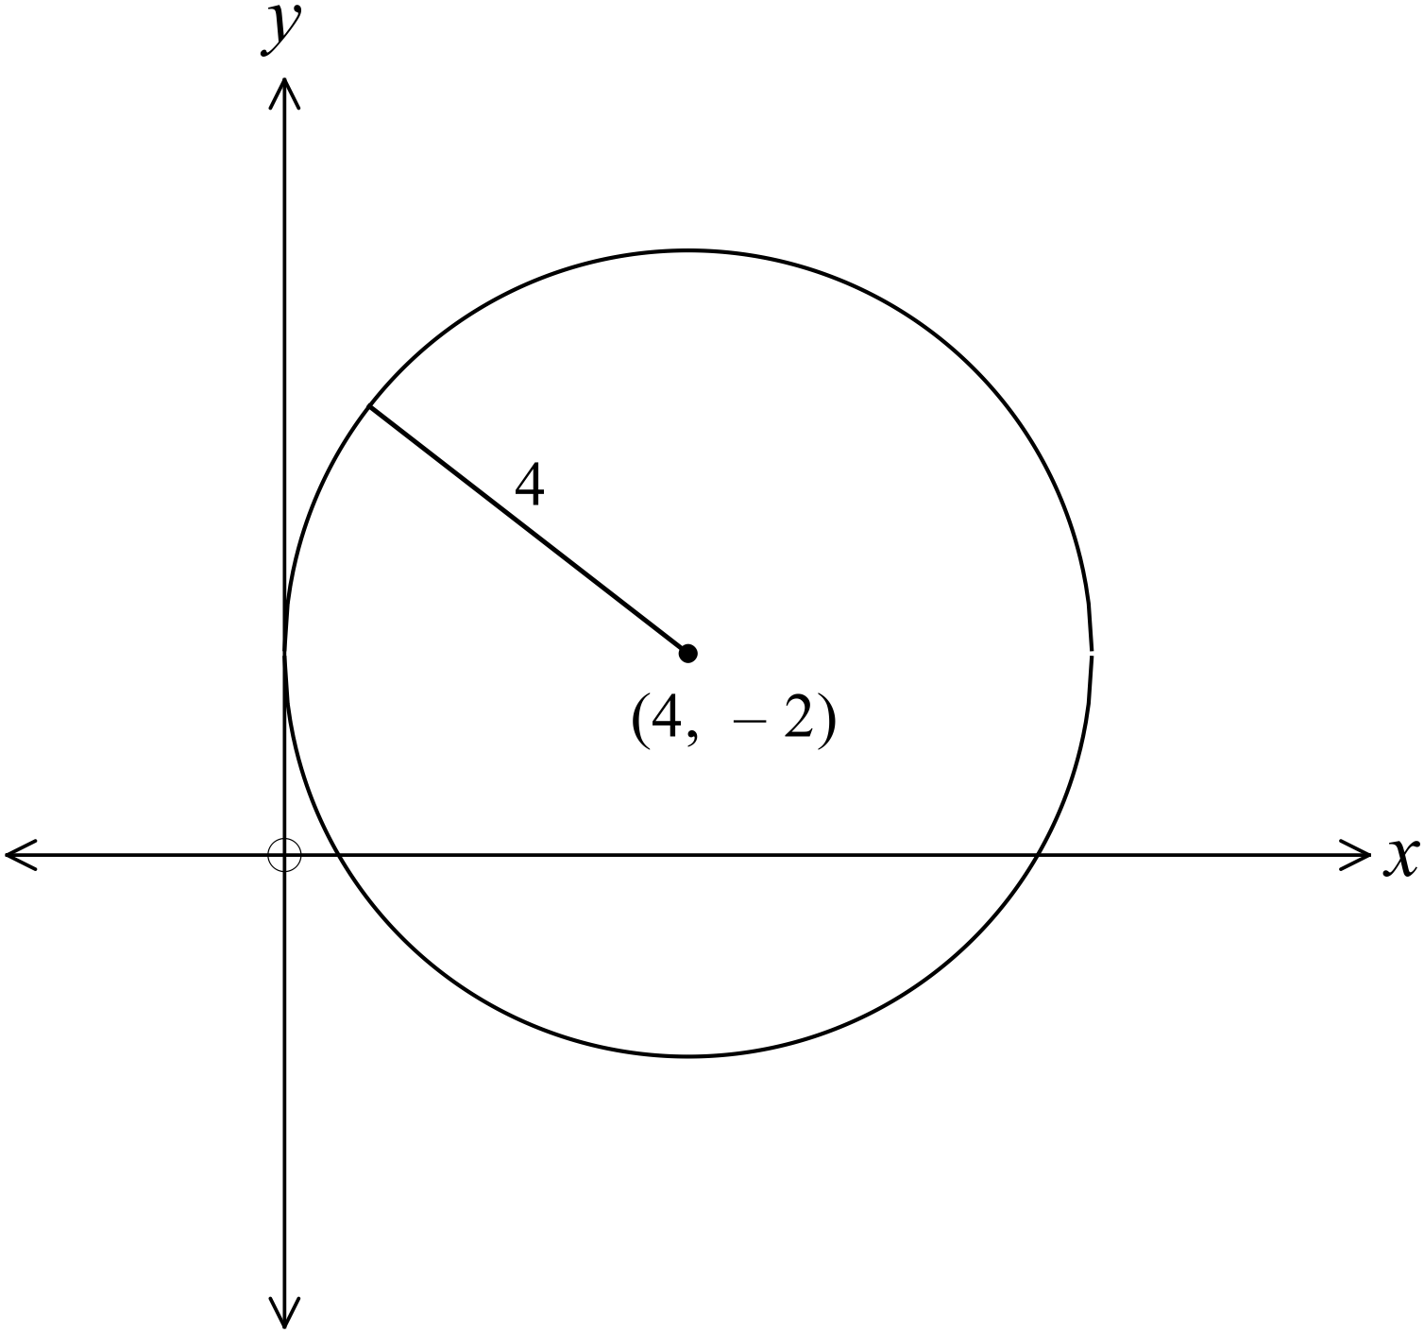 C. D.

Which is the graph of 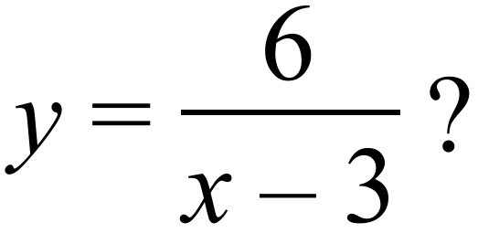

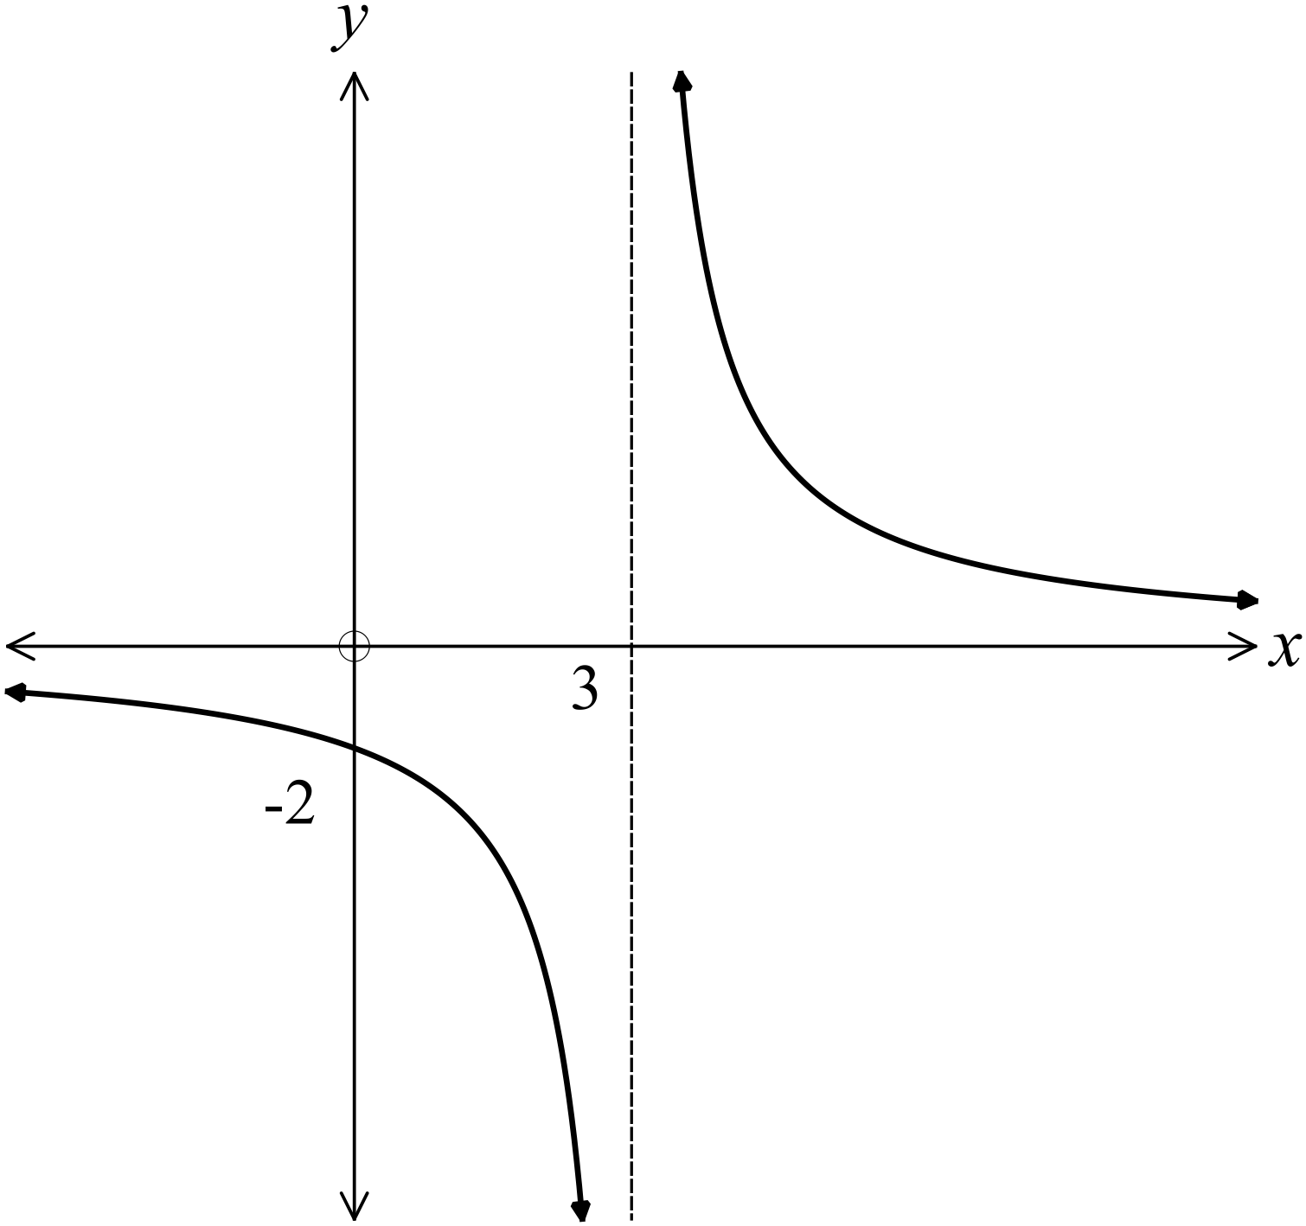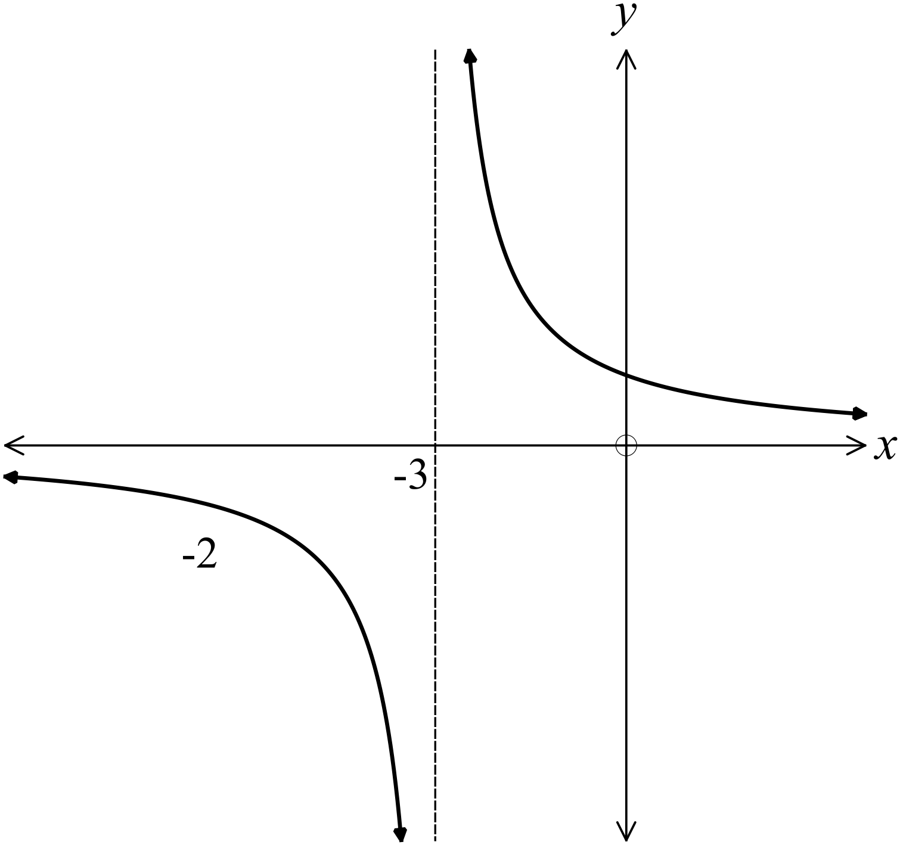A. B.

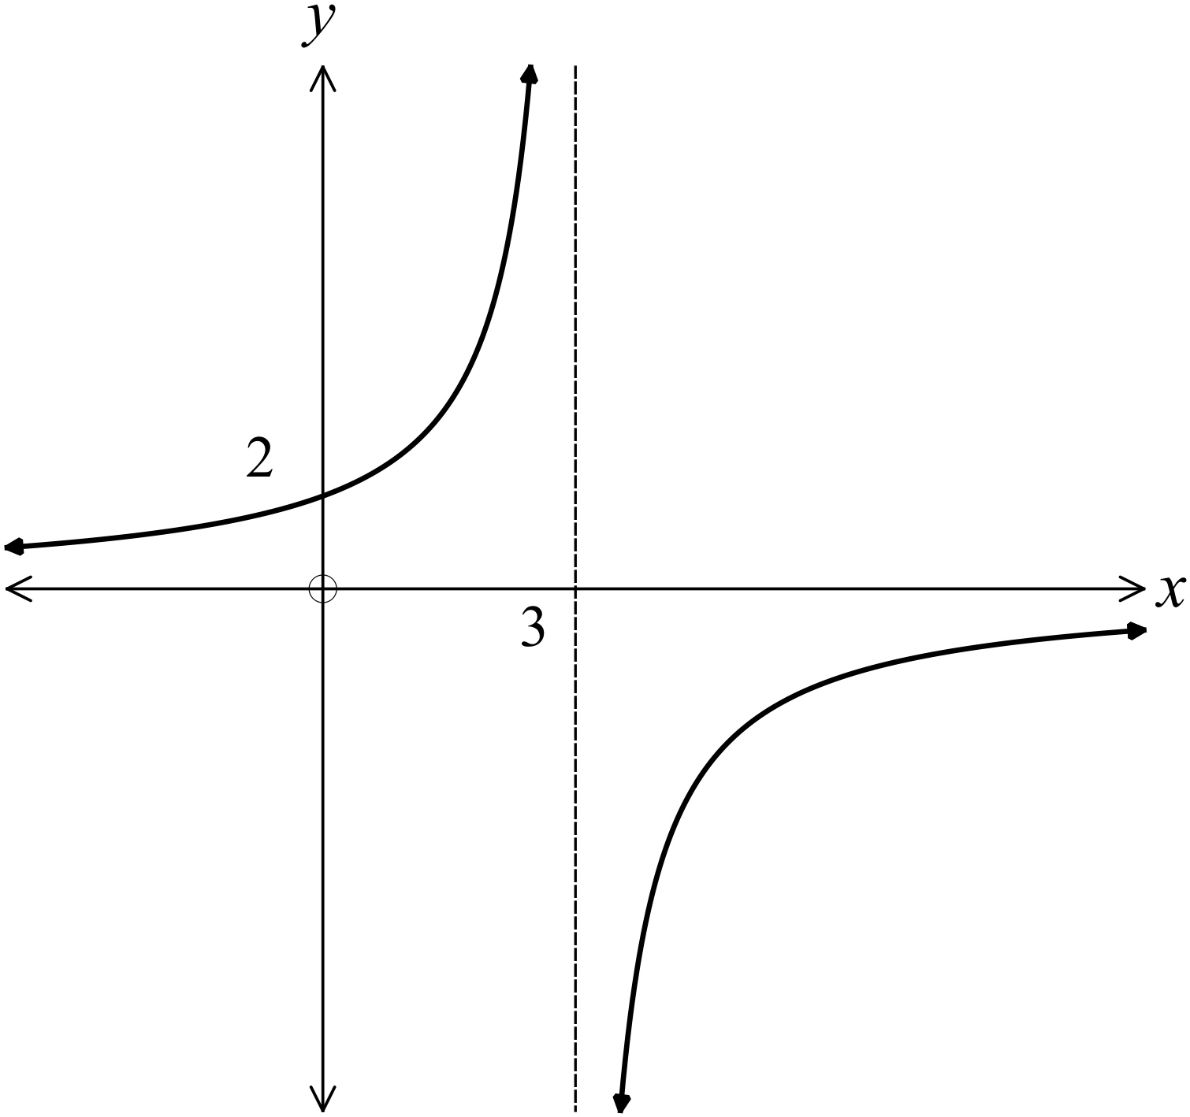
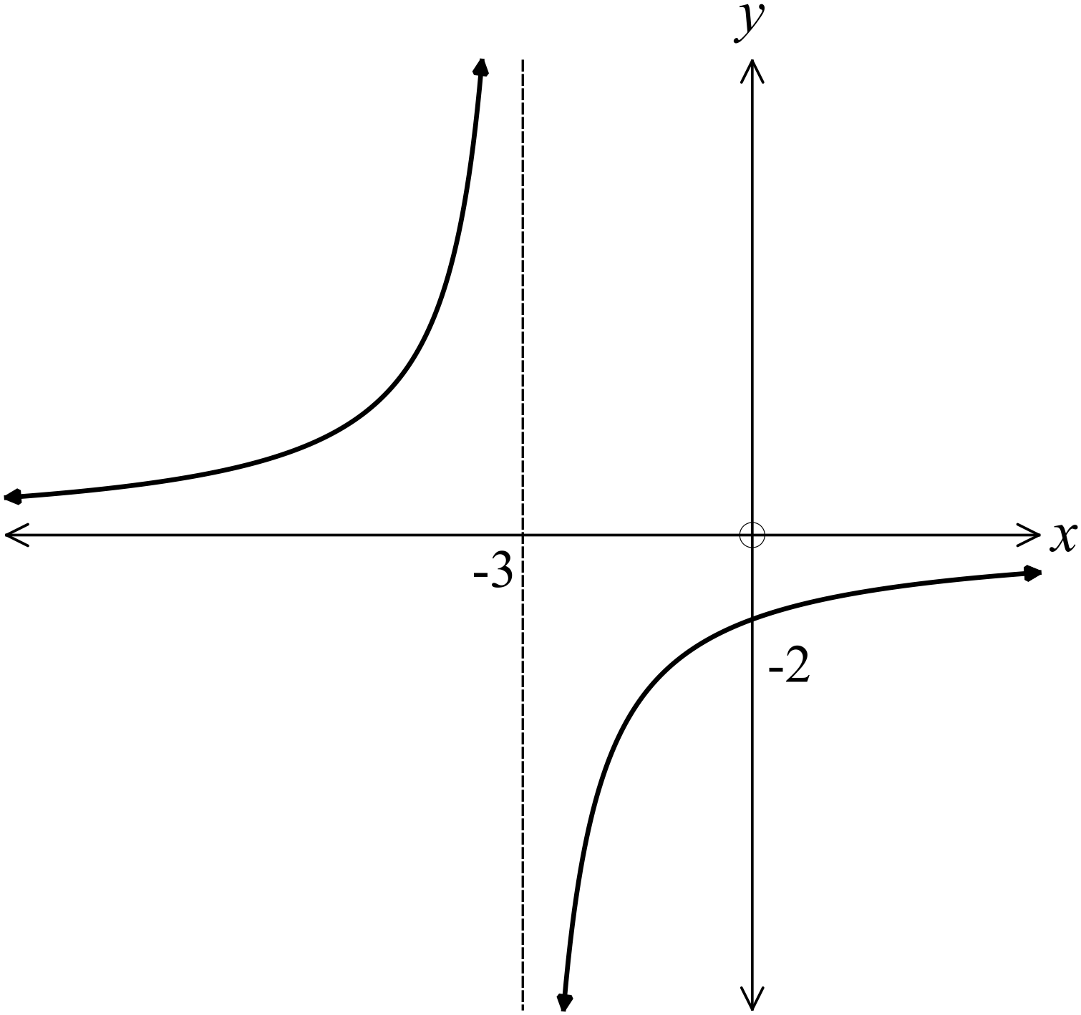C . D.

Which equation describes a circle with centre at 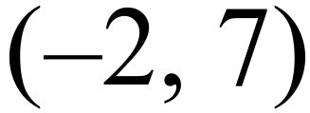 and radius 4 units?

A. 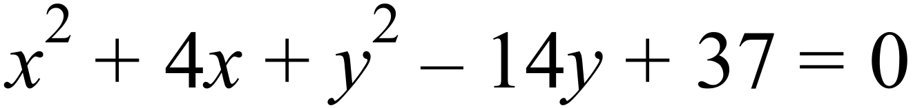 B. 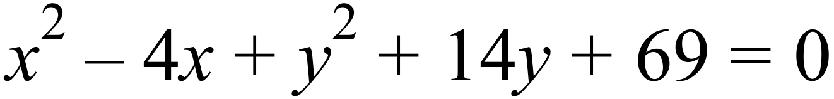

C. D. 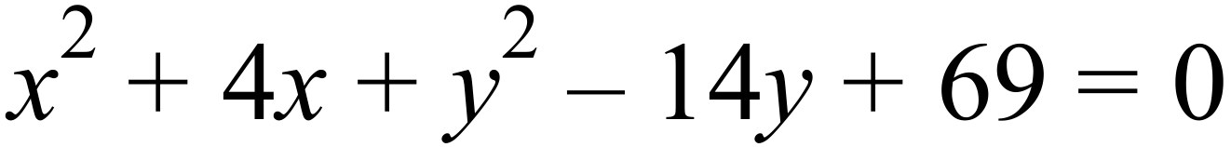

Year 10 | Non Linear Relations | Calculator Allowed
Year 10 | Non Linear Relations | Name___________________
Section 3 Longer Answer Section
Answers should be supported by relevant mathematical reasoning and/or calculations.
Write all working and answers in the spaces provided on this test paper.

 |  | Marks
 | On the axes provided draw neat sketches of 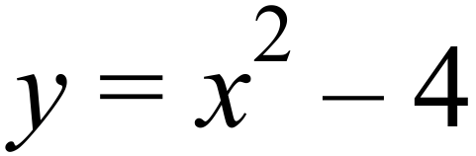 and 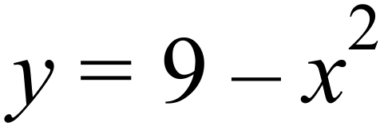.  Clearly mark the x and y intercepts and the vertex of each graph.  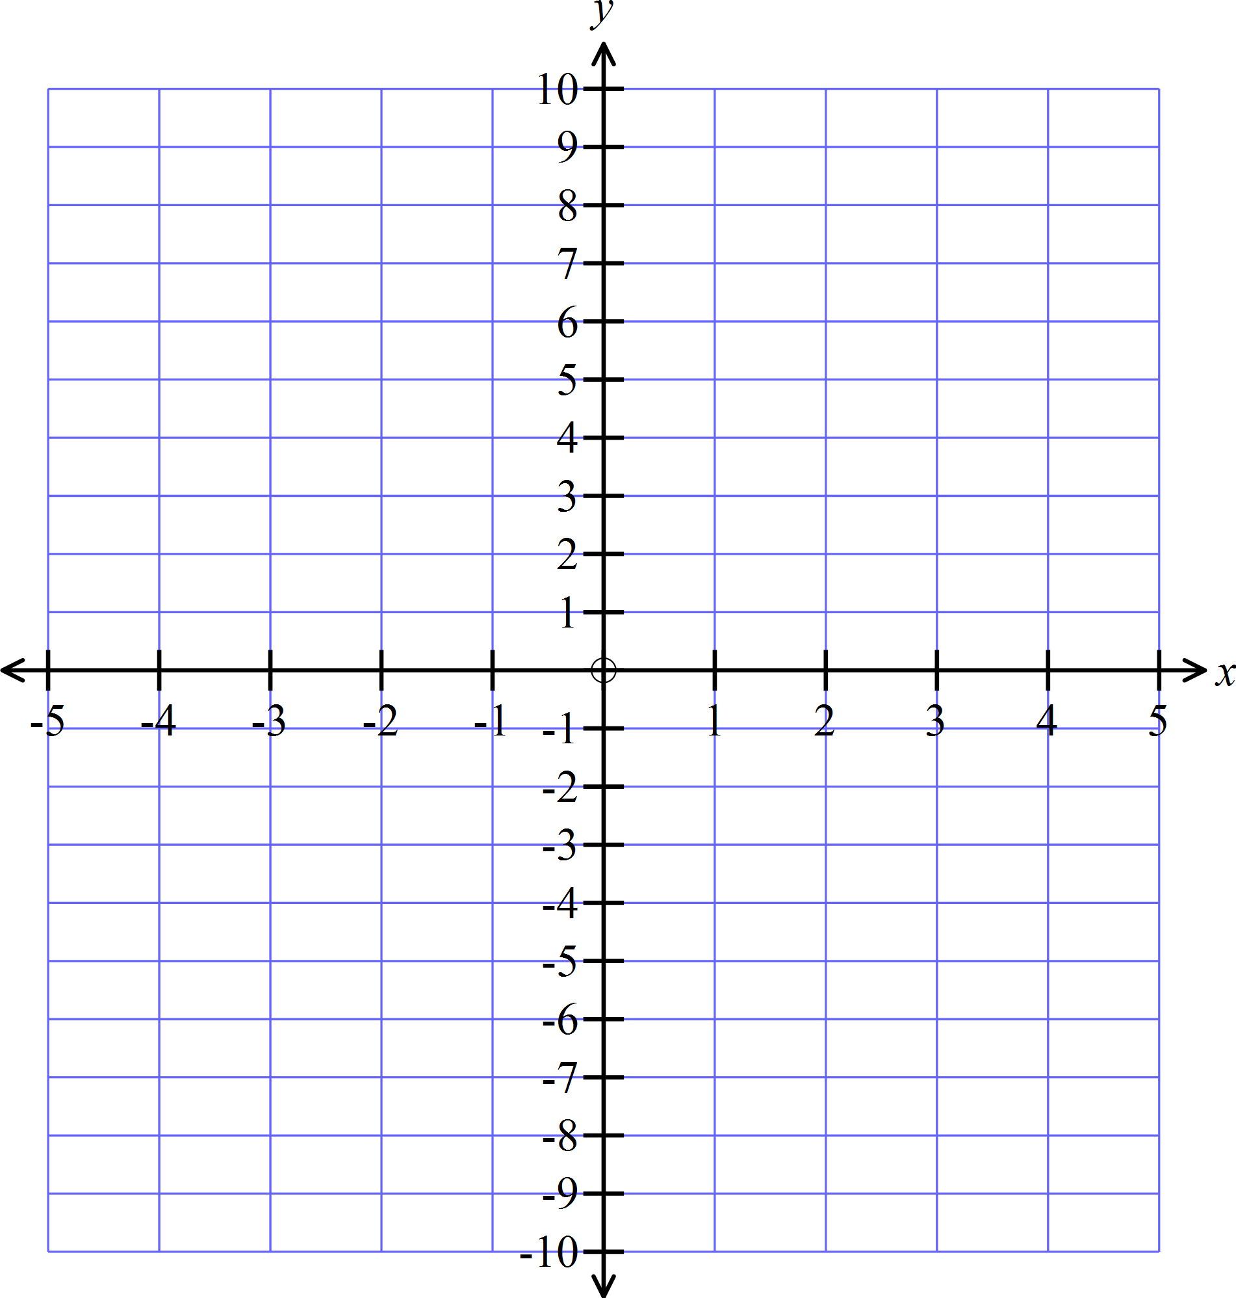 | 4
 | On the axes provided draw neat sketches of 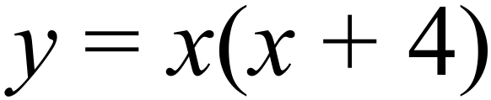 and 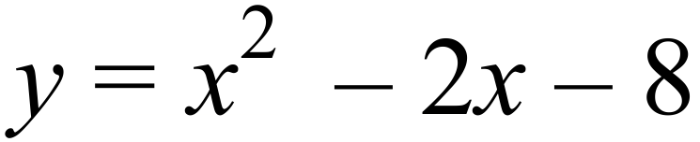.  Clearly mark the x and y intercepts and the vertex of each graph. | 4
 | On the axes provided draw neat sketches of 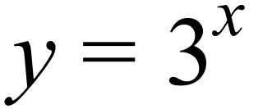 and 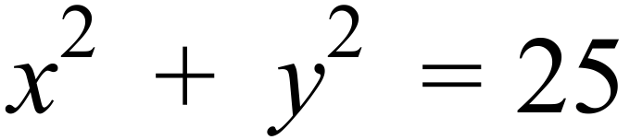.  Clearly mark the x and y intercepts of each graph.  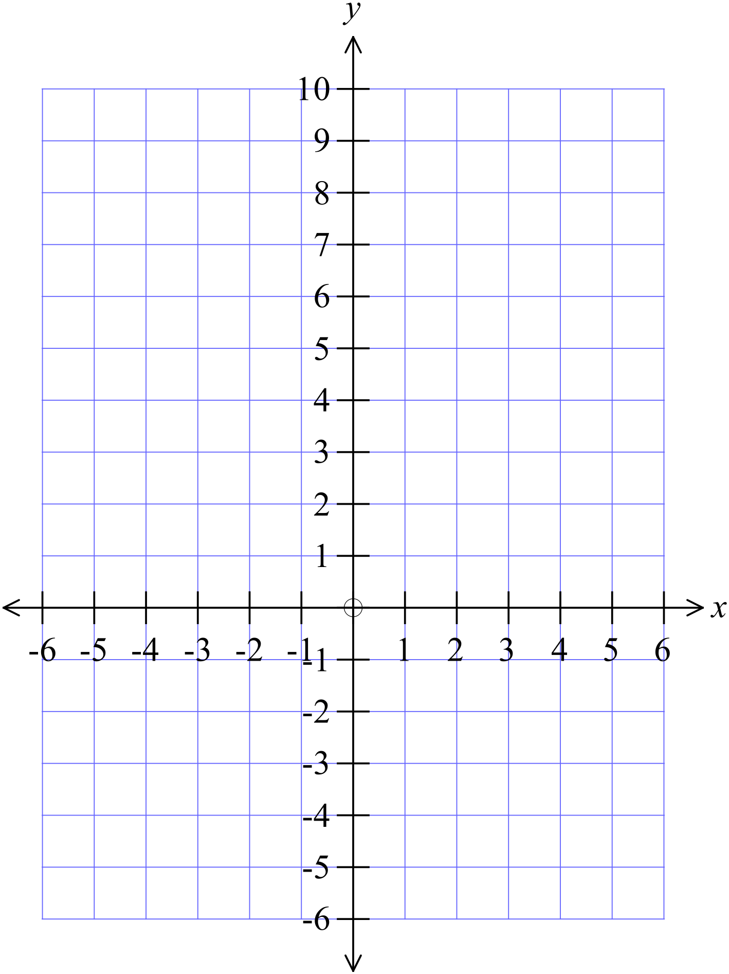 | 4
 | On the axes provided draw neat sketches of 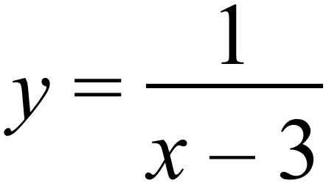 and 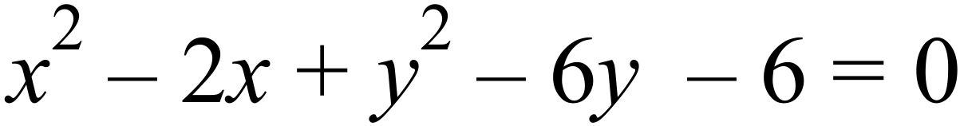.  Clearly mark the x and y intercepts and the vertex of each graph.  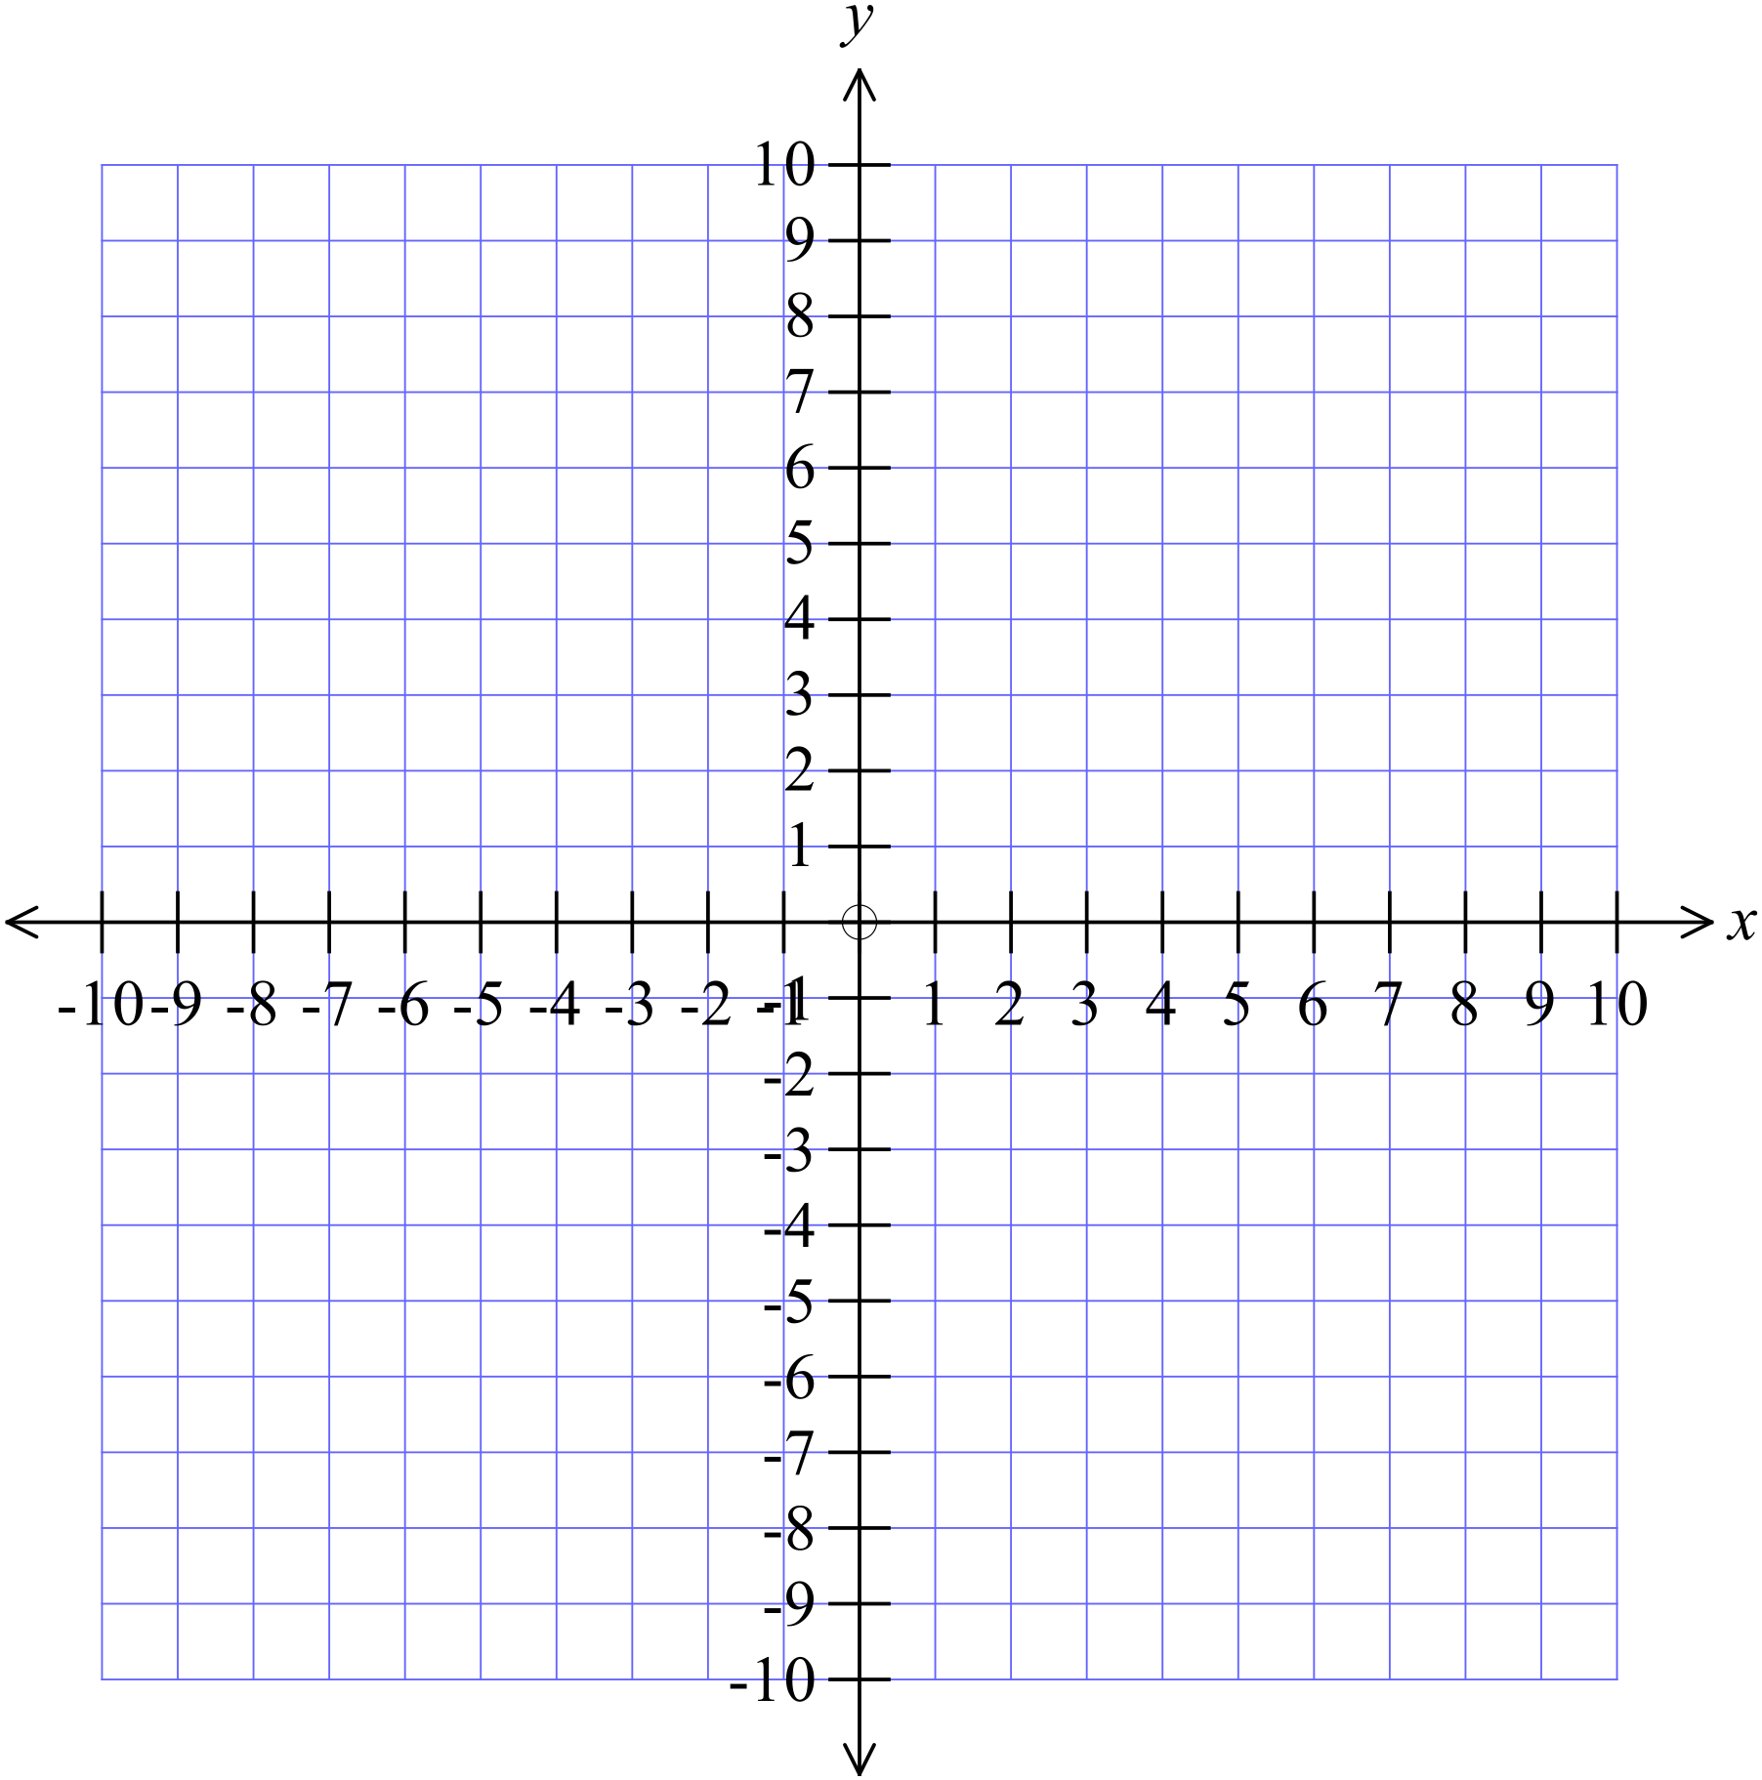 | 4

Non Linear Relations

Multiple Choice Answer Sheet
Name _____________________________________________
Completely fill the response oval representing the most correct answer.

1. A B C D
2. A B C D
3. A B C D
4. A B C D
5. A B C D
6. A B C D
7. A B C D
8. A B C D
9. A B C D
10. A B C D
11. A B C D
12. A B C D

Non Linear Relations

ANSWERS
Section 1 ( 1 mark each)
Working and Answers
Since it crosses the y axis at -25, 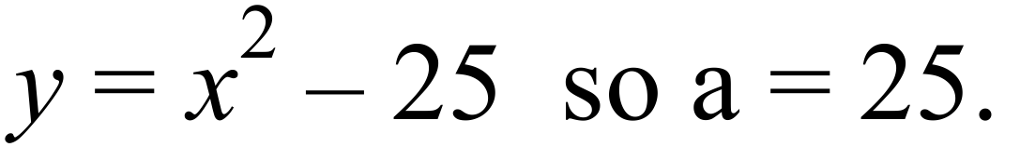
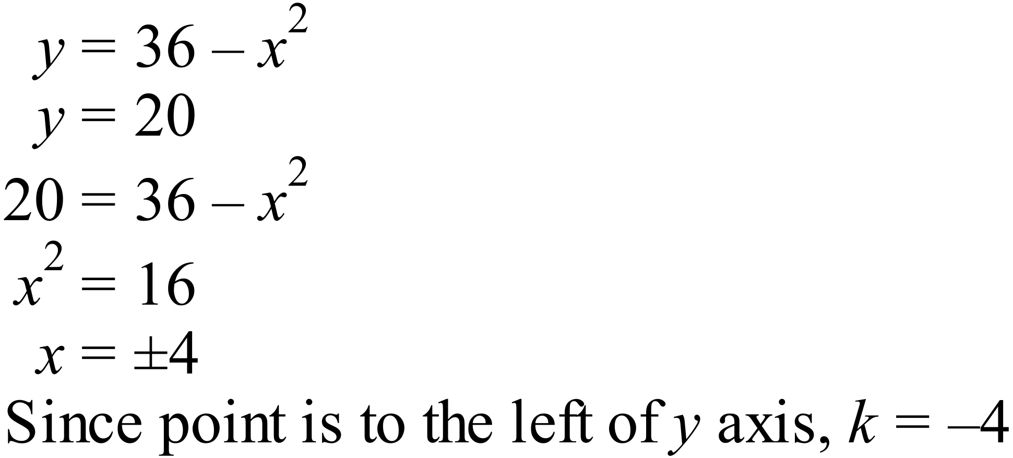
As it is an exponential graph, it crosses the y axis at y = 1.
m=1
Centre at the origin, radius 5.
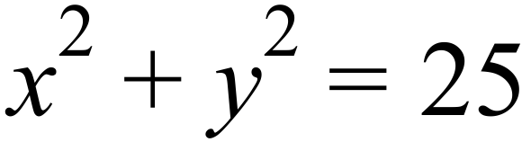
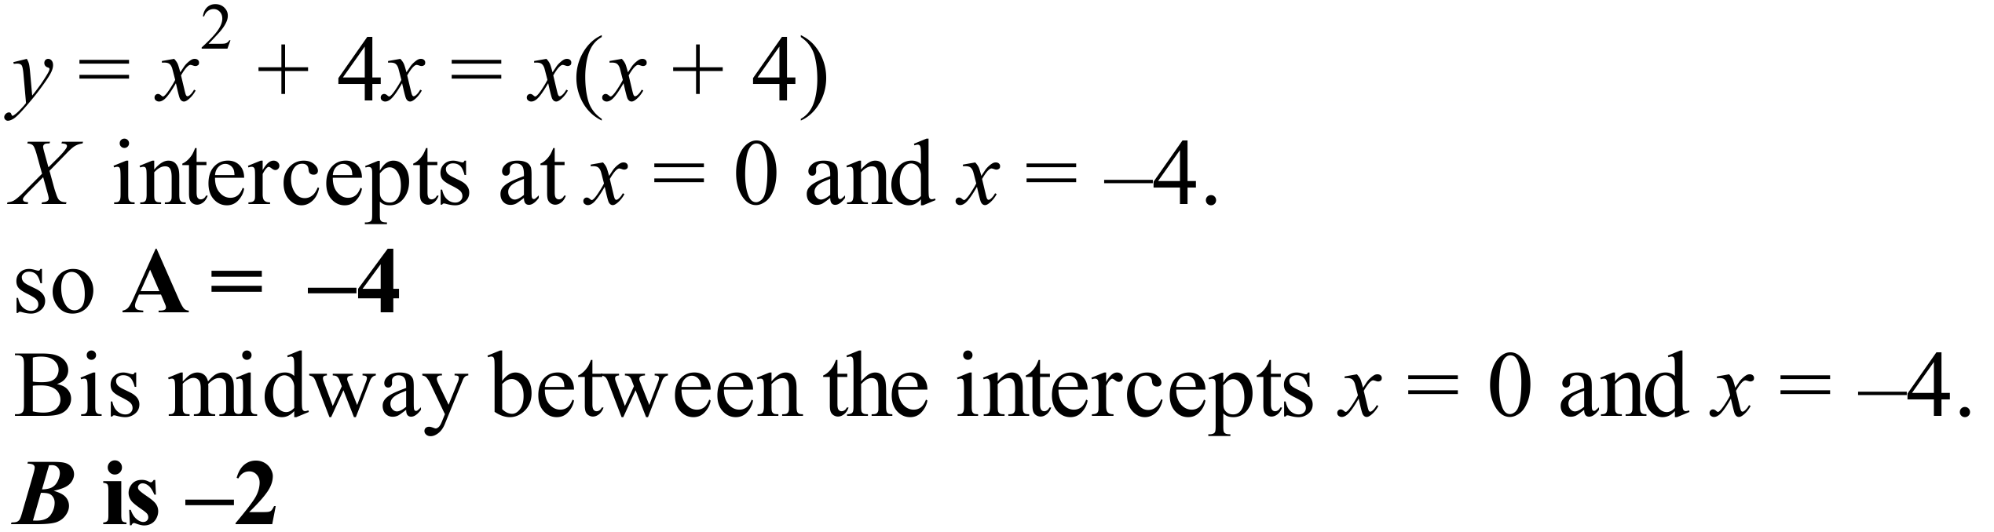
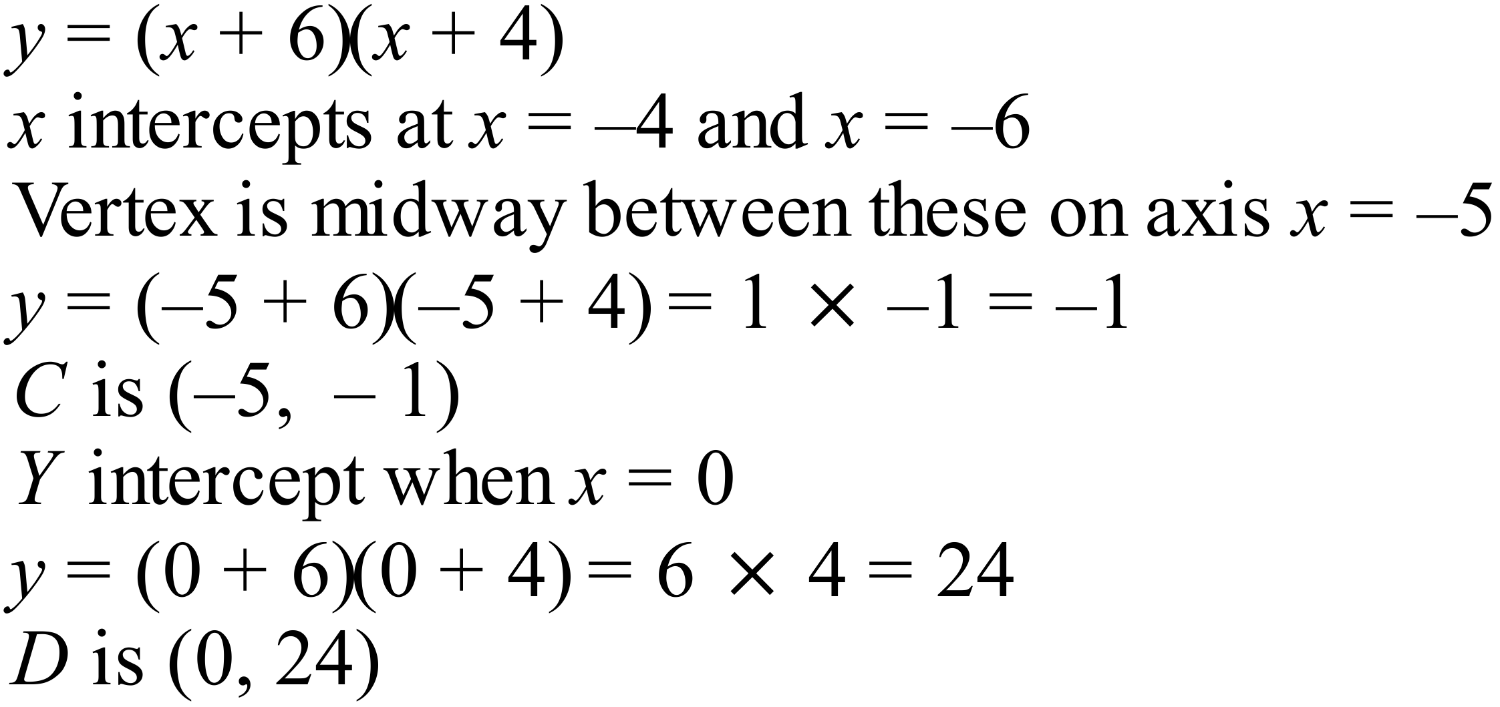
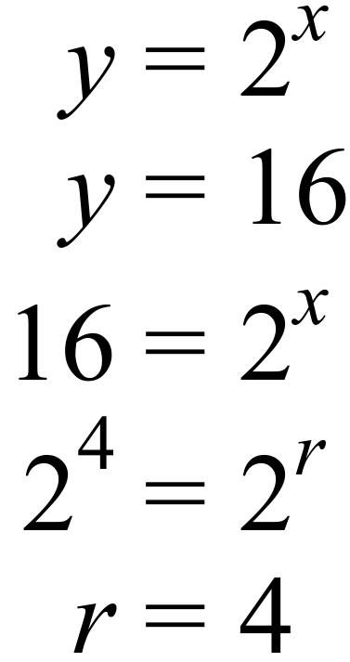
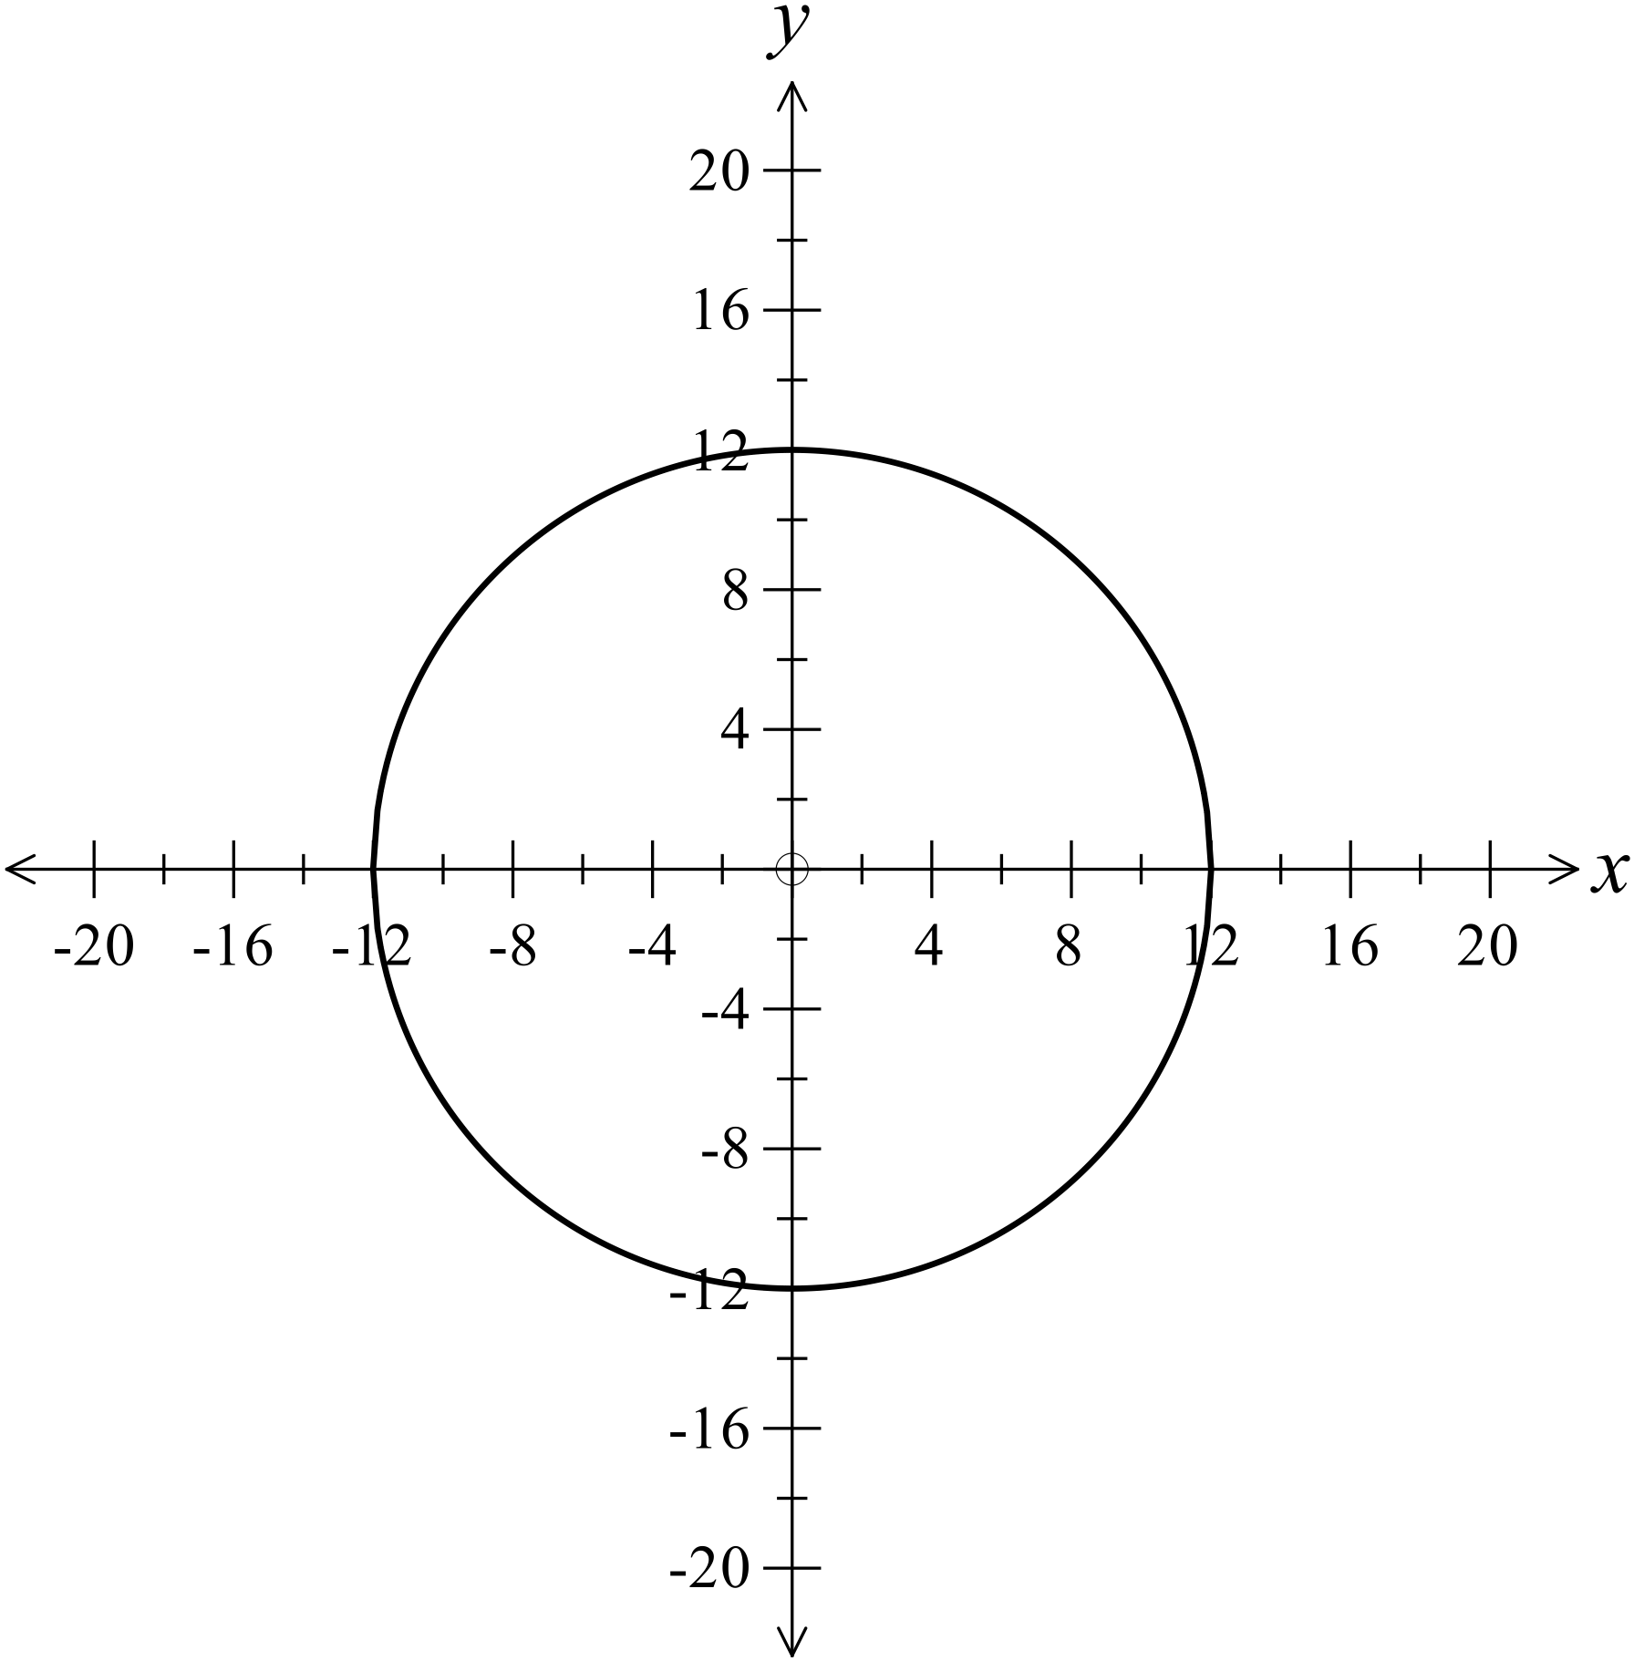

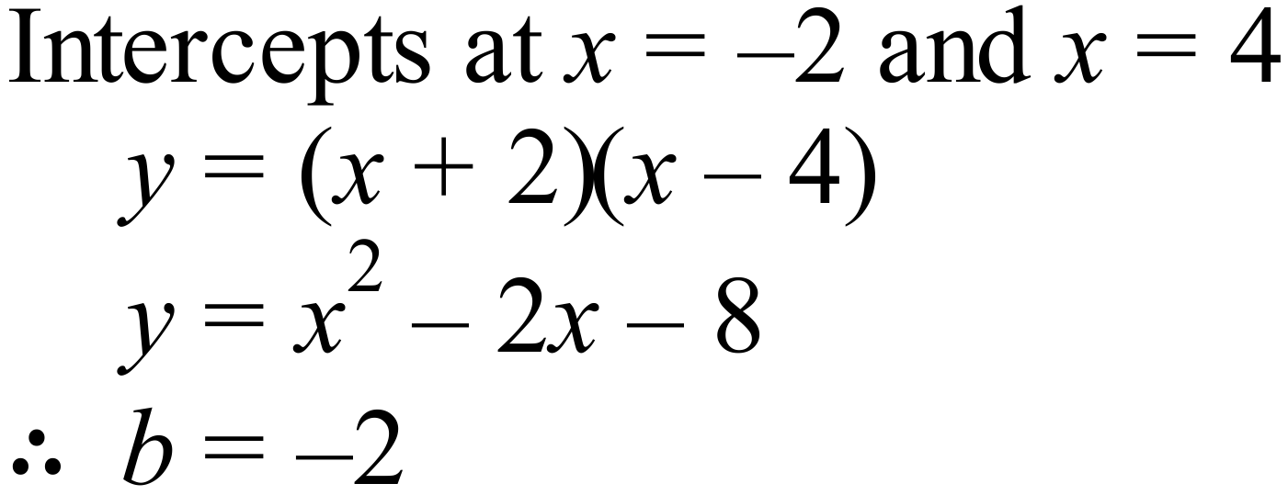
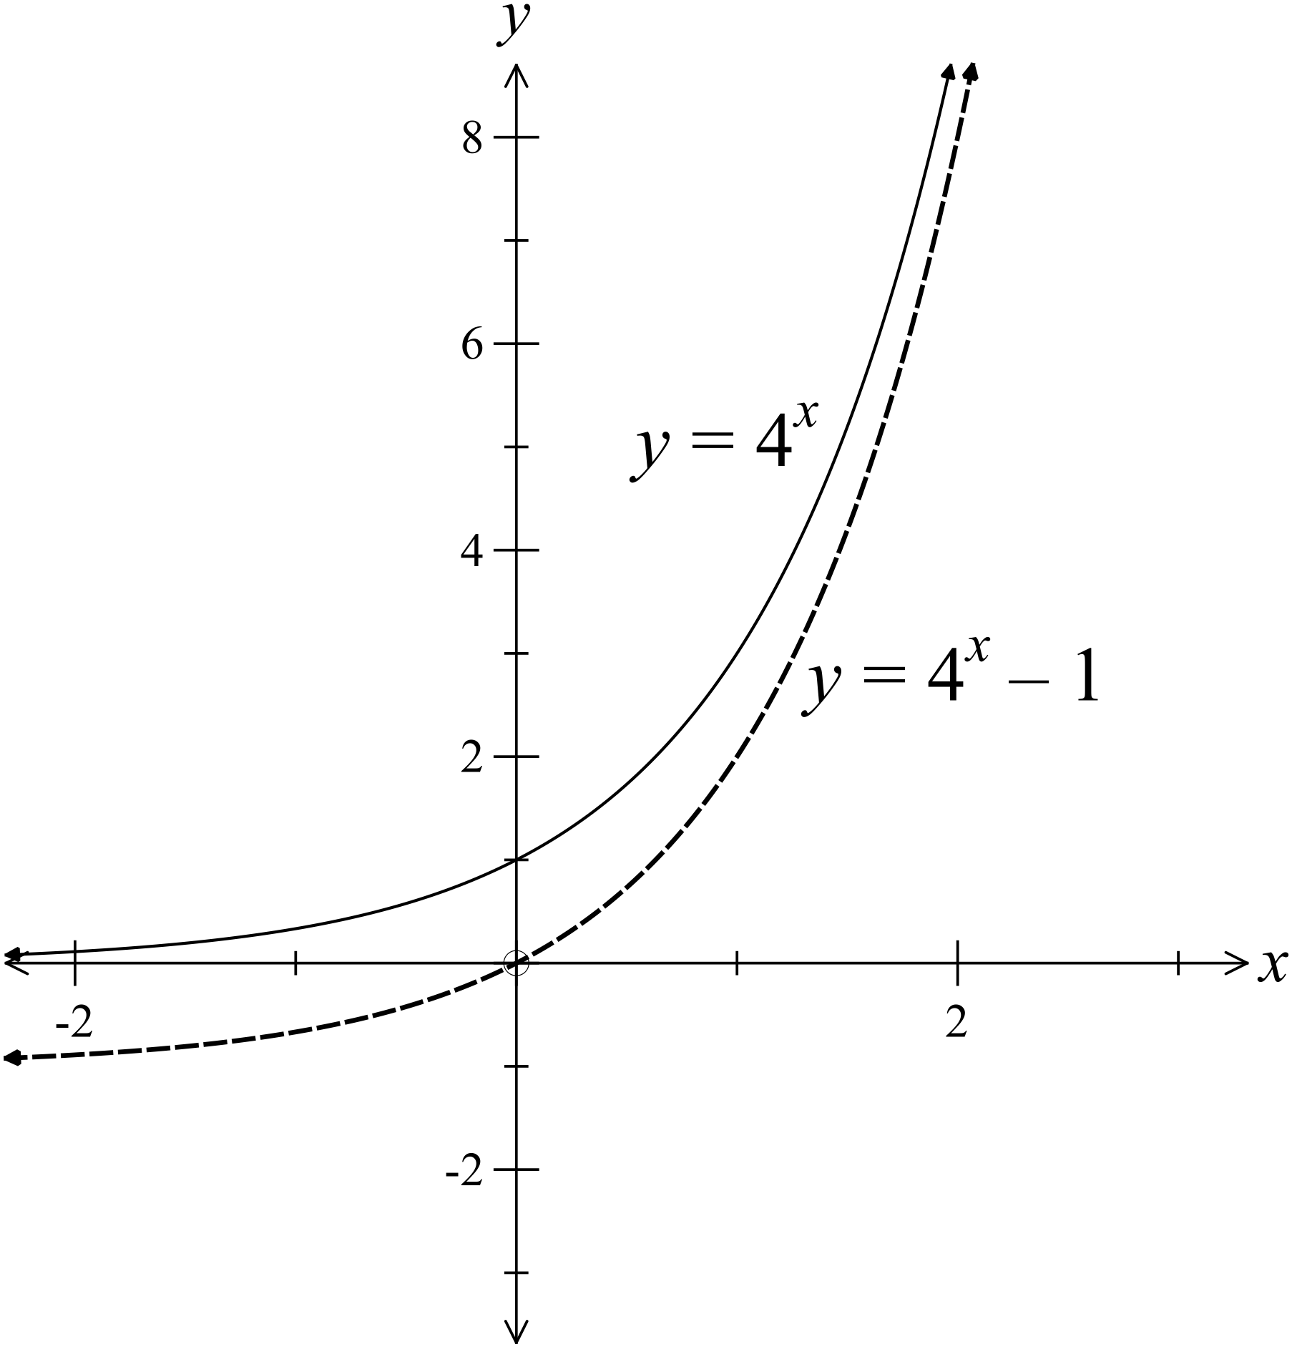

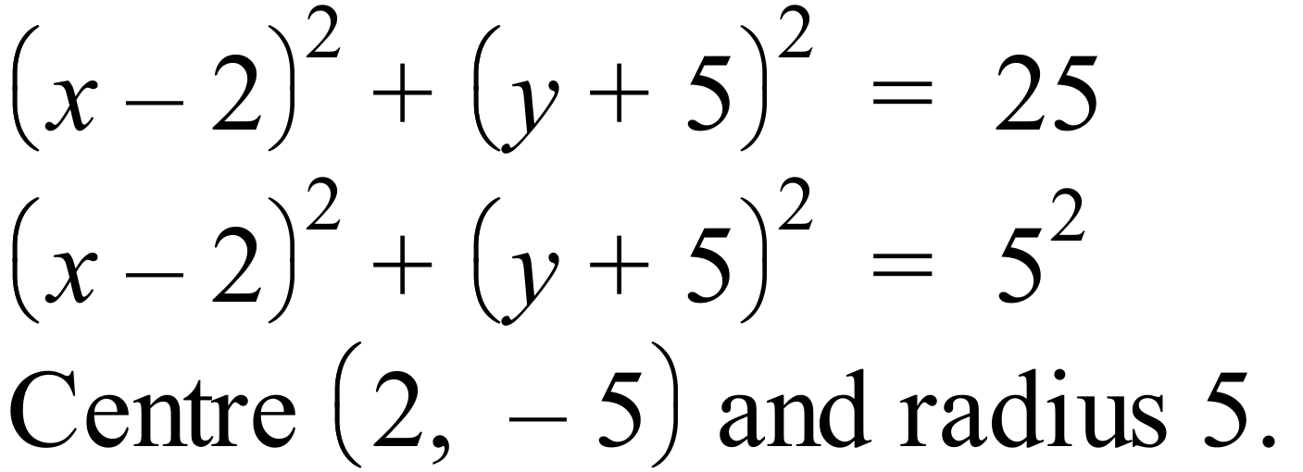
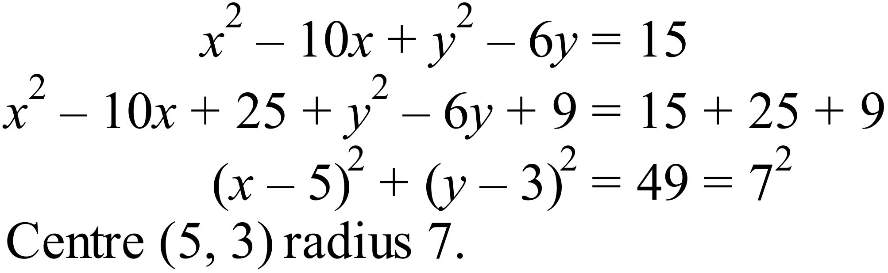

 | -2 | 0 | 1 | 2 | 3 | 4 | 6
 | 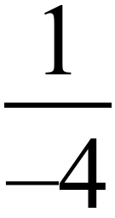 | 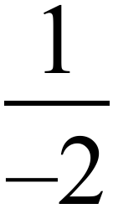 | 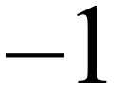 | Undefined | 1 | 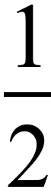 | 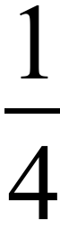

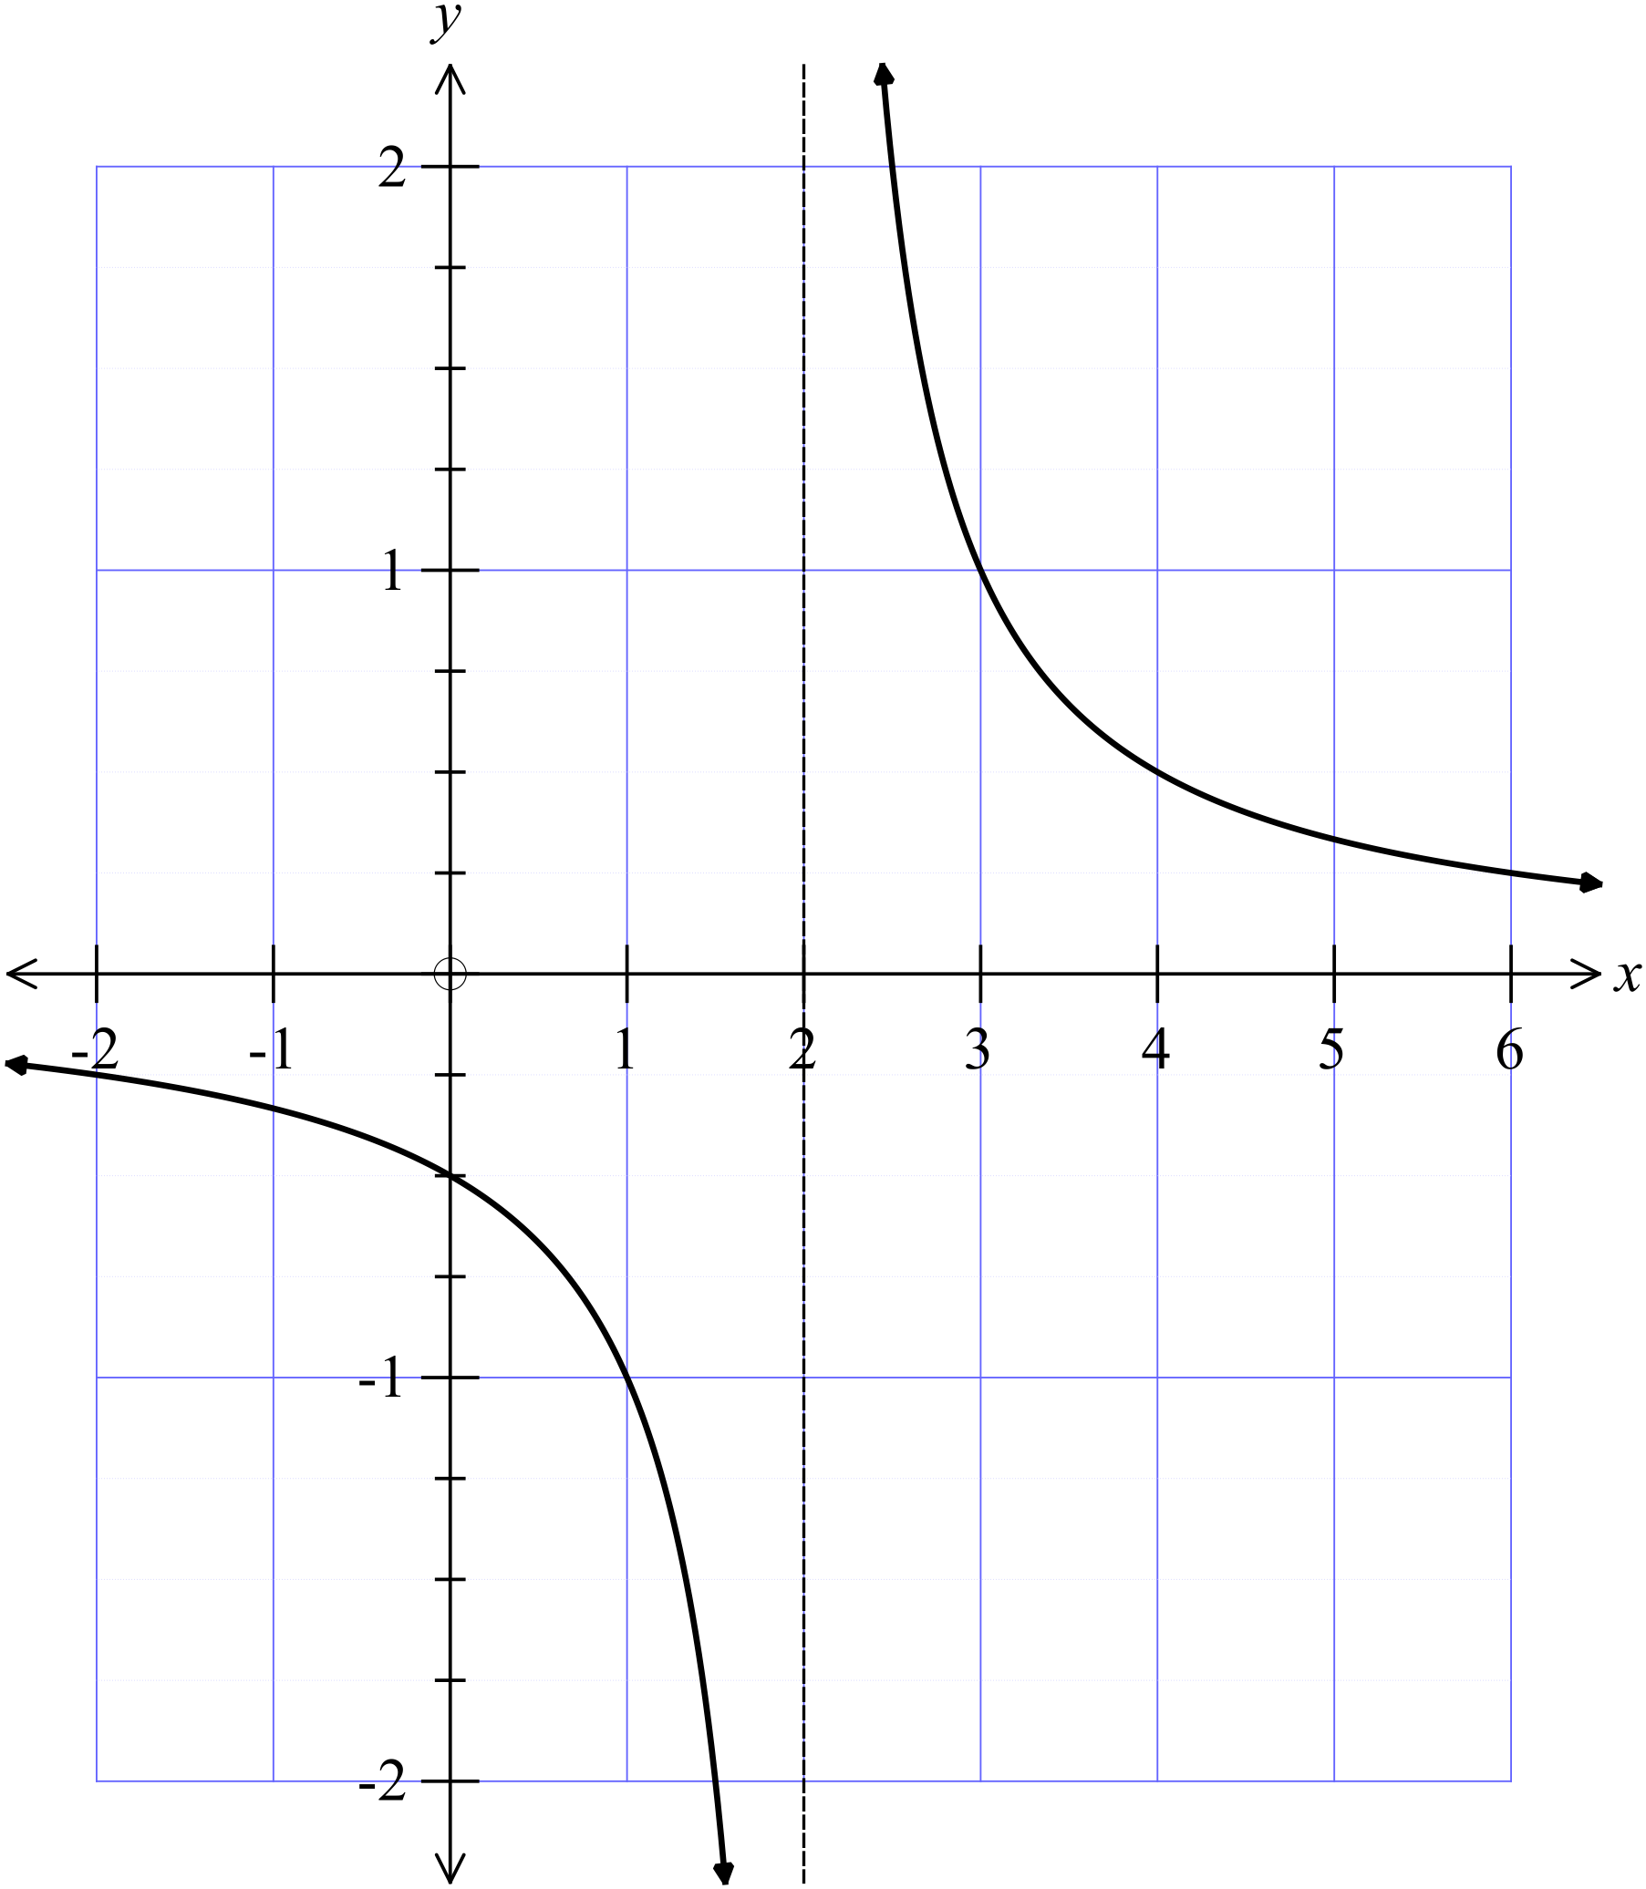

Section 2 (1 mark each)
 | Working | Answers
 | 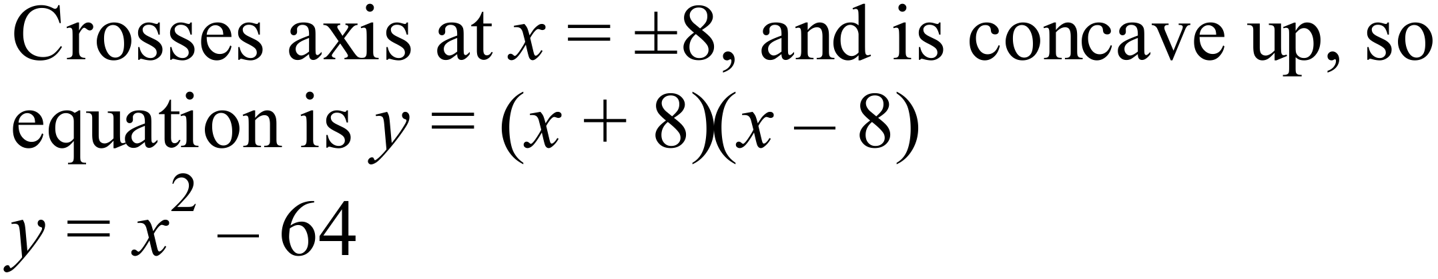 | C
 | 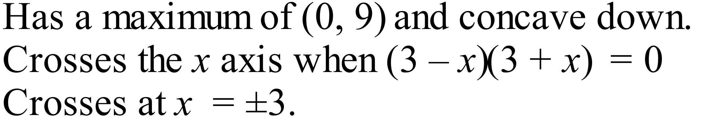  Graph B | B
 | Parabola 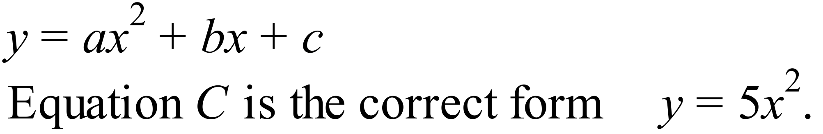 | C
 | 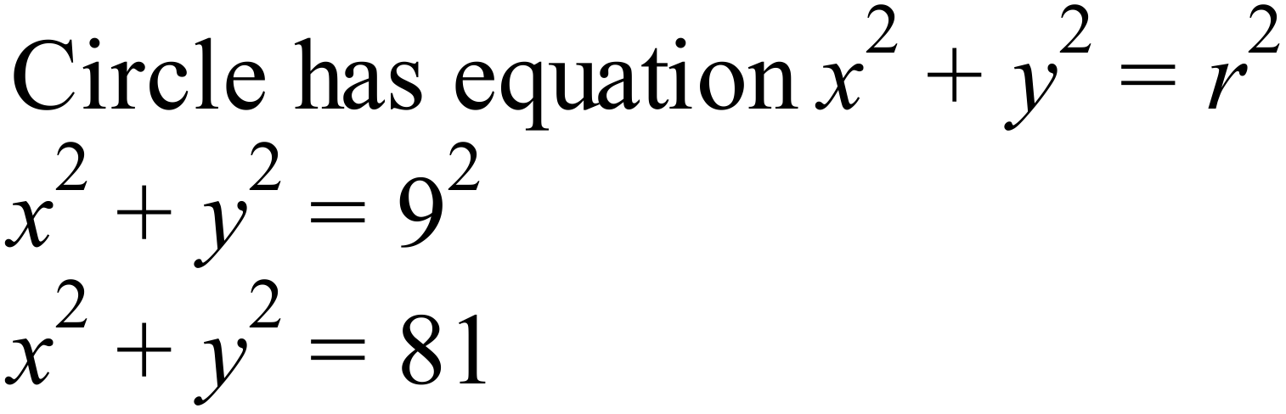 | D
 | has a maximum at (0,5). | D
 | 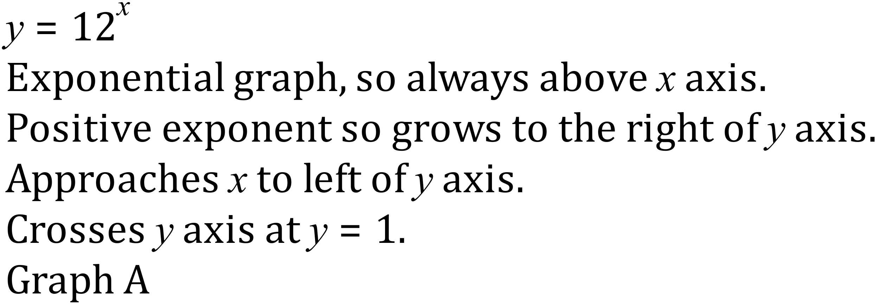 | A
 | 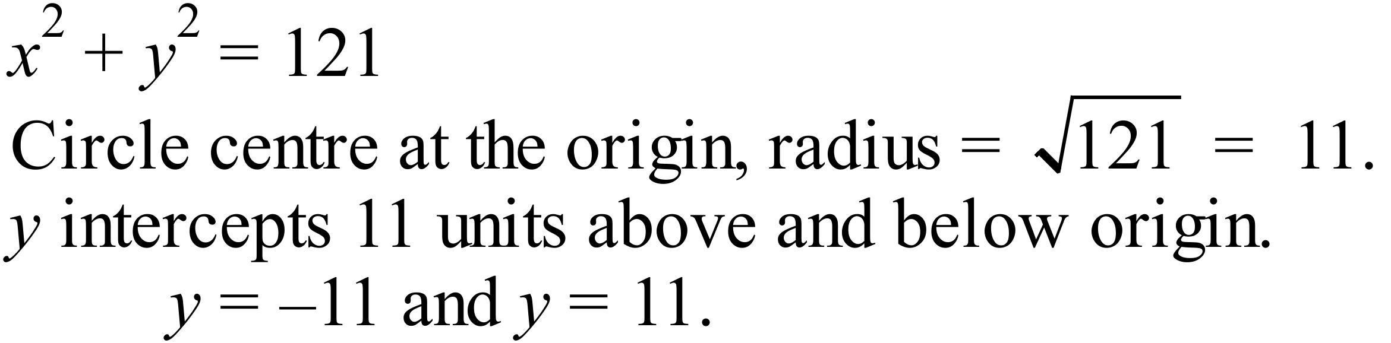 | C
 | 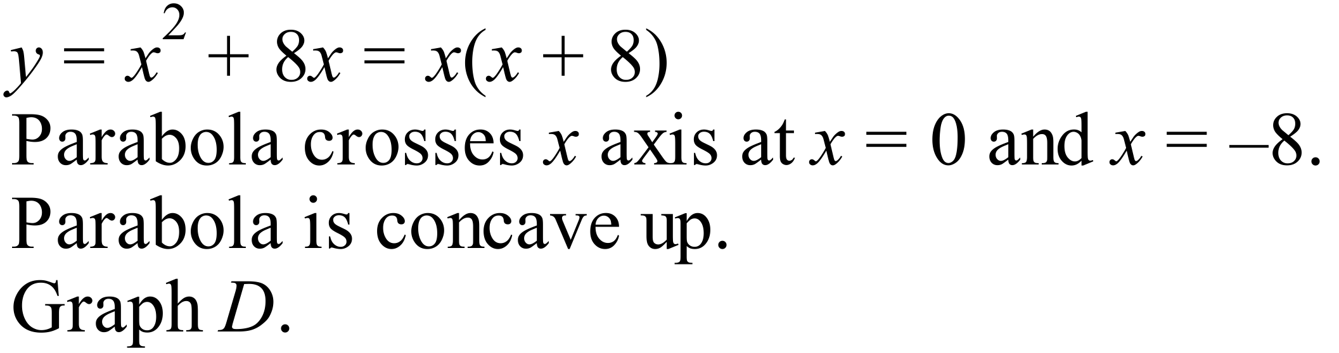 | D
 | Hyperbola with discontinuity at x=0, raised by 4 units.  Equation B is in the form of a hyperbola. | B
 | Centre (4, -2) radius 4. Graph A | A
 | 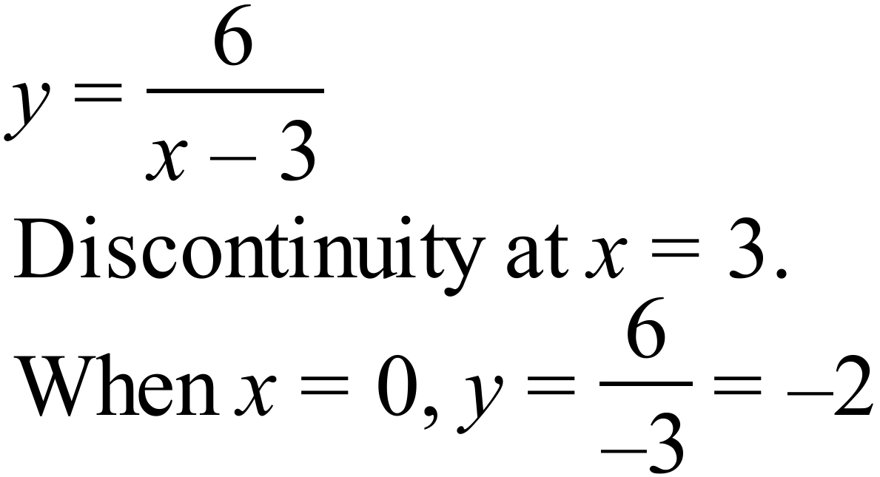 Graph B | B
 | 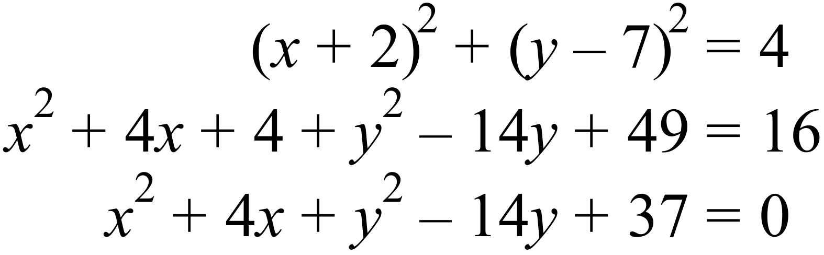 | A

Section 3

1. | On the axes provided draw neat sketches of and .  Clearly mark the x and y intercepts and the vertex of each graph.  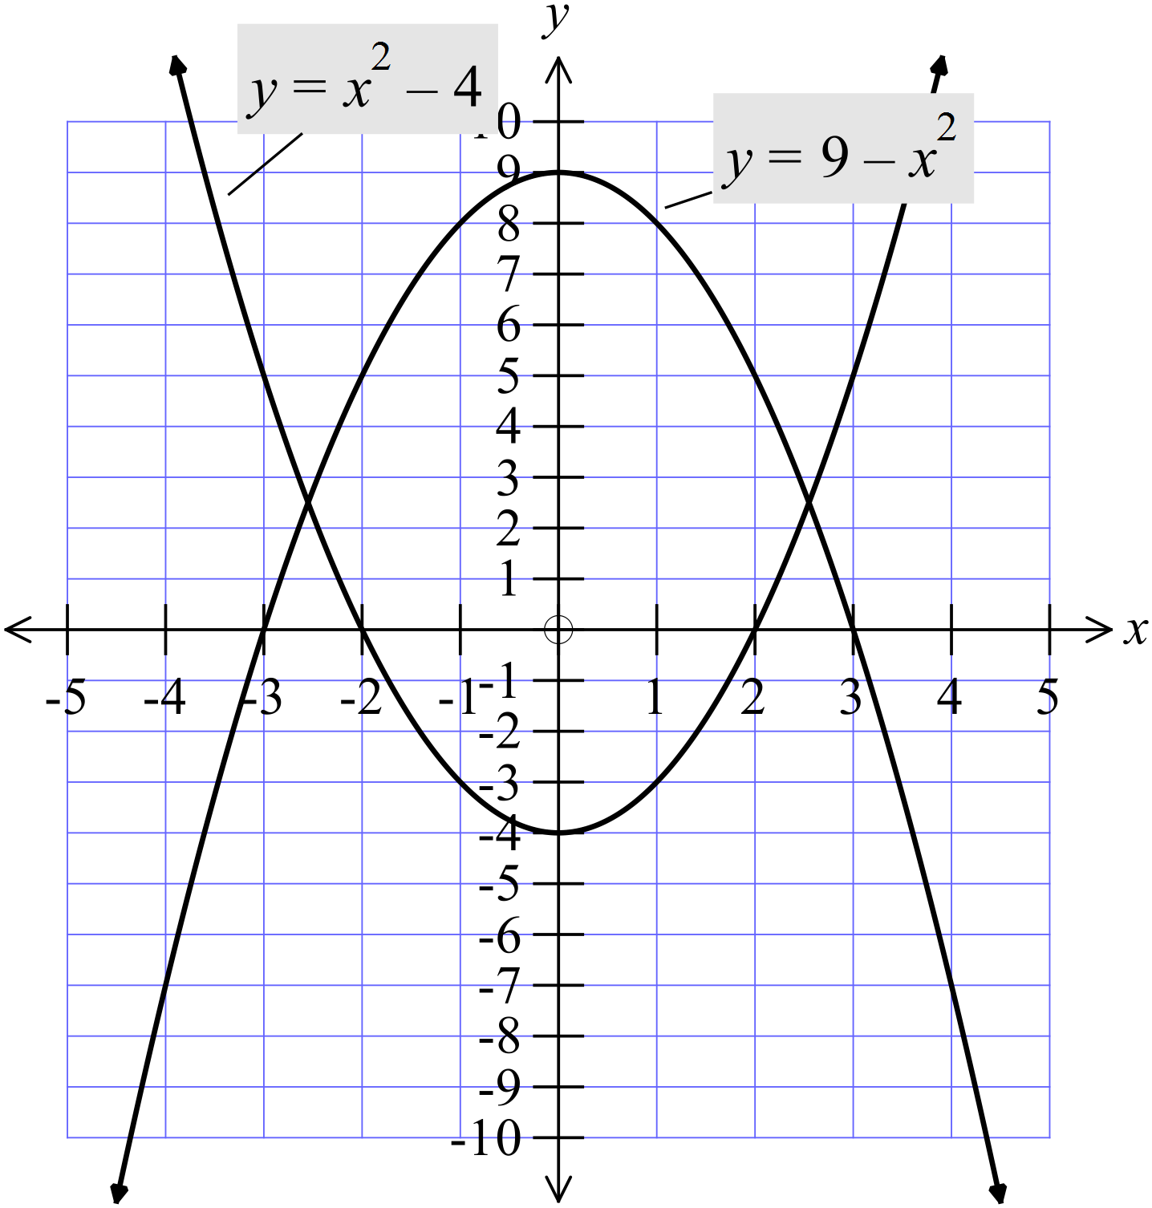 | 2 marks for each graph  Allow 1 for correct shape and 1 for correct details
2. | On the axes provided draw neat sketches of and .  Clearly mark the x and y intercepts and the vertex of each graph.  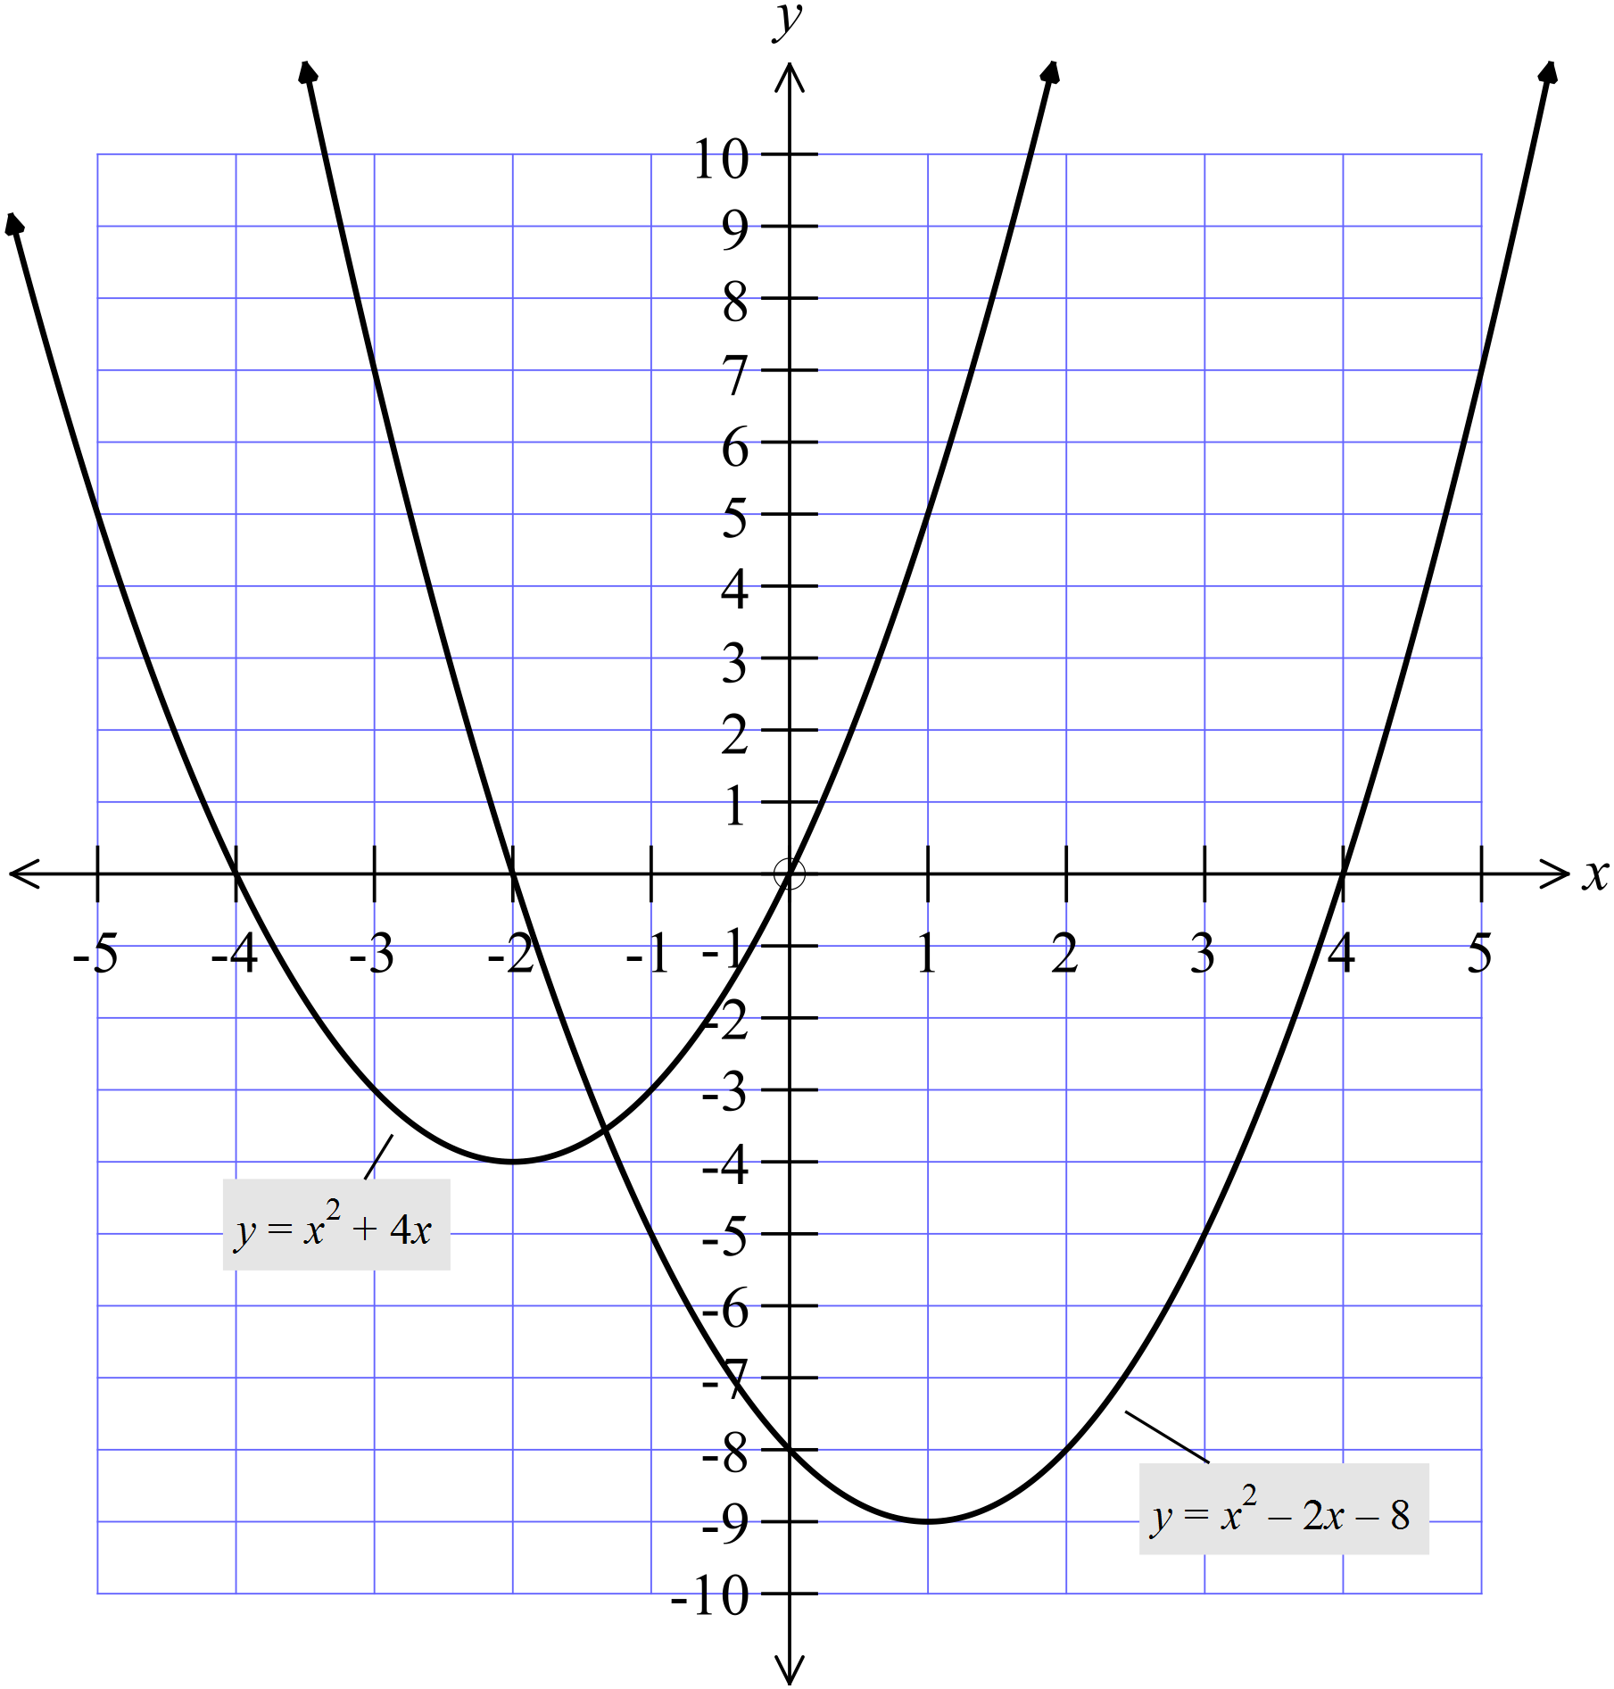 | 2 marks for each graph  Allow 1 for correct shape and 1 for correct details
3. | On the axes provided draw neat sketches of and .  Clearly mark the x and y intercepts of each graph.  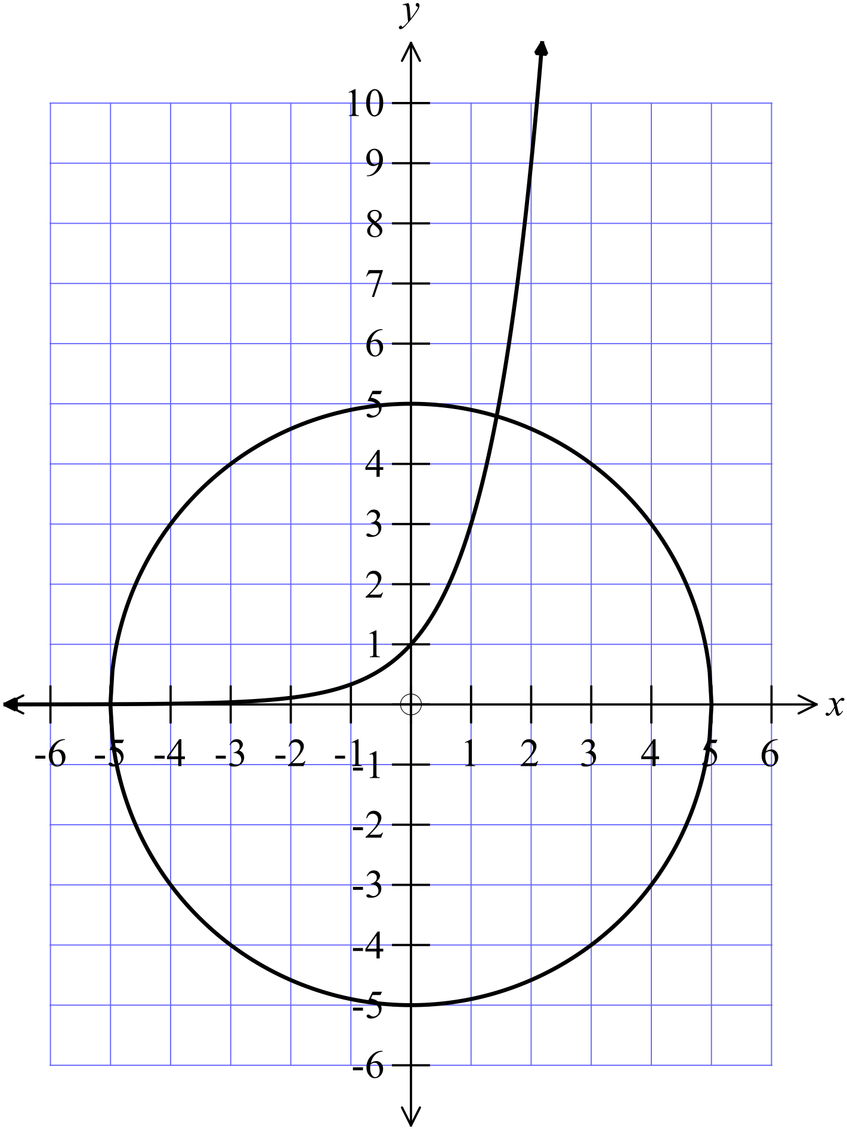 | 2 marks for each graph  Allow 1 for correct shape and 1 for correct details
4. | On the axes provided draw neat sketches of and 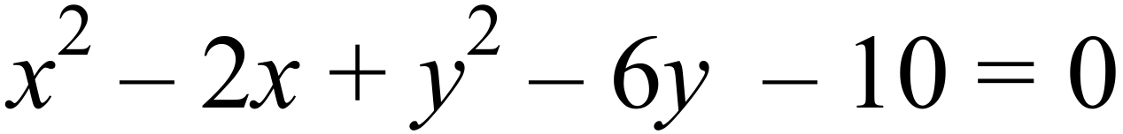.  Clearly mark the x and y intercepts and the vertex of each graph.  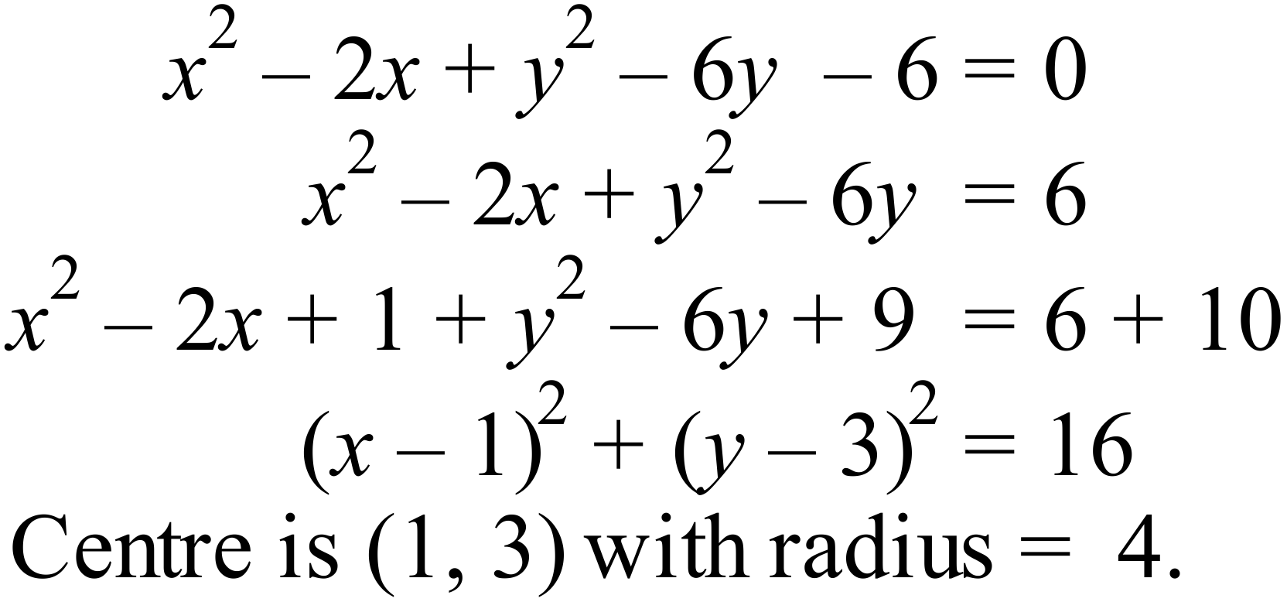  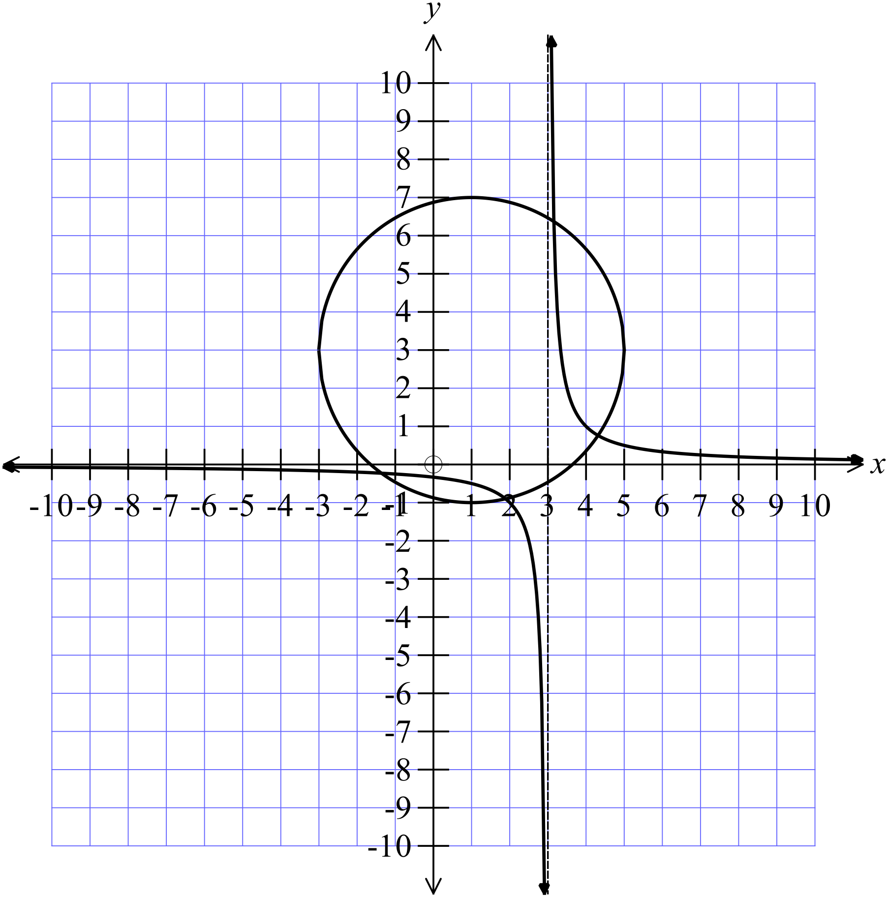 | 2 marks for each graph  Allow 1 for correct shape and 1 for correct details

Non Linear Relations

Multiple Choice Answer Sheet
Name ___ Marking Sheet
Completely fill the response oval representing the most correct answer.

1. A B C D
2. A B C D
3. A B C D
4. A B C D
5. A B C D
6. A B C D
7. A B C D
8. A B C D
9. A B C D
10. A B C D
11. A B C D
12. A B C D

